Intermediate Cypher Queries course notes and links-

Course Overview:

<https://youtu.be/-ogo_gls068>

# Module 1: Filtering Queries

## **Module overview**

There are many ways that you can query a subset or subgraph of the data in the graph.

In this module, you will:

* Review basic query filtering.
* Evaluate strings in your query filtering.
* Retrieve data using patterns in the graph.
* Learn how to specify multiple or optional MATCH clauses.

## **Data model for this course**

This course uses the movie dataset for all the queries you will be running and writing. This is the same dataset that will be used for the application development courses in GraphAcademy.

Here is the graph data model:

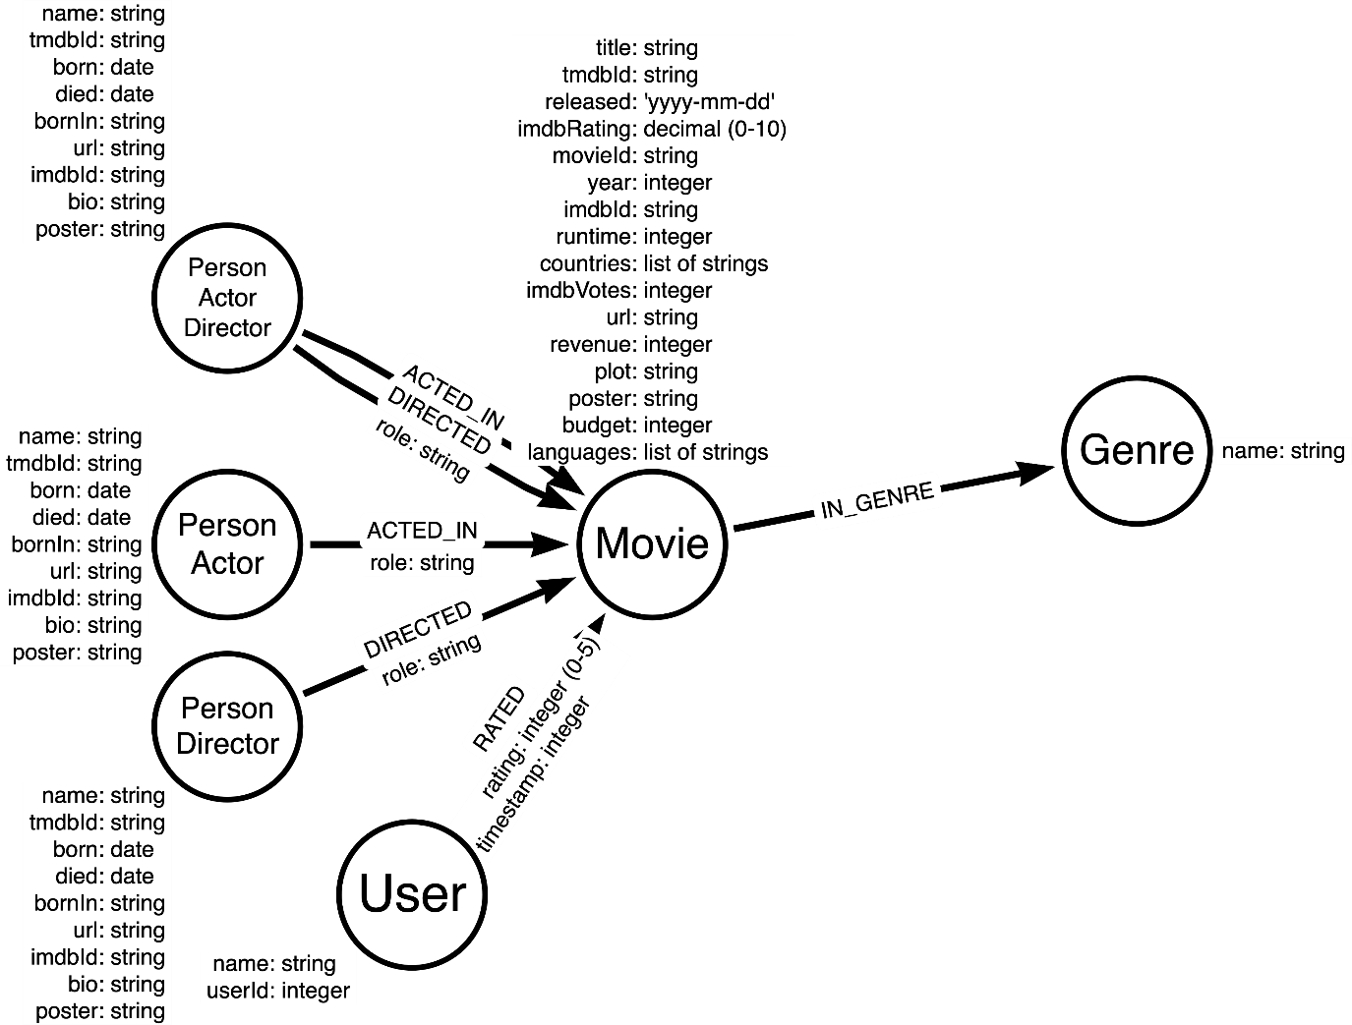

You can view the data model in the sandbox to the right by executing this query:

**cypher**

Copy to ClipboardRun in Sandbox

CALL db.schema.visualization()

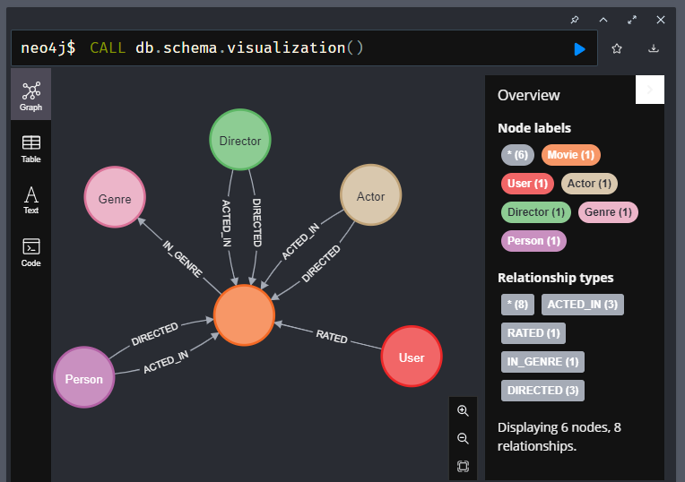

The node labels for the graph include:

* Person
* Actor
* Director
* Movie
* Genre
* User

The relationships for the graph include:

* ACTED_IN (with an optional role property)
* DIRECTED (with an optional role property)
* RATED (with rating and timestamp properties)
* IN_GENRE

Also notice that the nodes have a number of properties, along with the type of data that will be used for each property. It is important that you understand the property types defined in the data model.

You can view the property types for nodes in the graph by executing this query:

**cypher**

Copy to ClipboardRun in Sandbox

CALL db.schema.nodeTypeProperties()

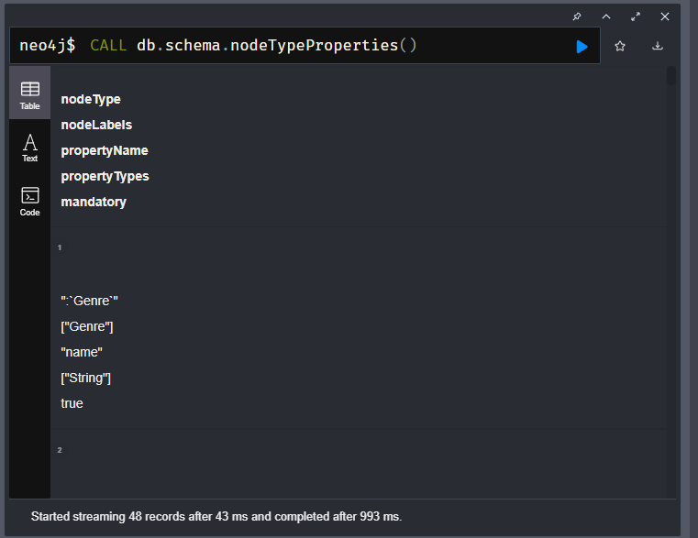

You can view the property types for relationships in the graph by executing this query:

**cypher**

Copy to ClipboardRun in Sandbox

CALL db.schema.relTypeProperties()

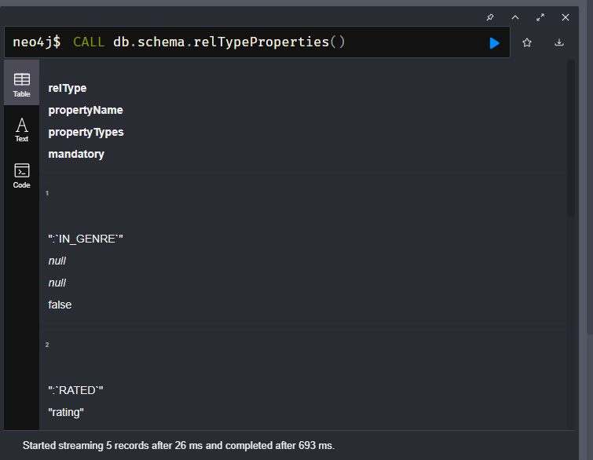

Each node with a given label has a property that uniquely identifies the node. These nodes are indexed in the graph.

* Movie nodes use movieId.
* Person nodes use tmdbId.
* User nodes use userId.
* Genre nodes use name.

You can view the uniqueness constraint indexes in the graph by executing this query:

**cypher**

Copy to ClipboardRun in Sandbox

SHOW CONSTRAINTS

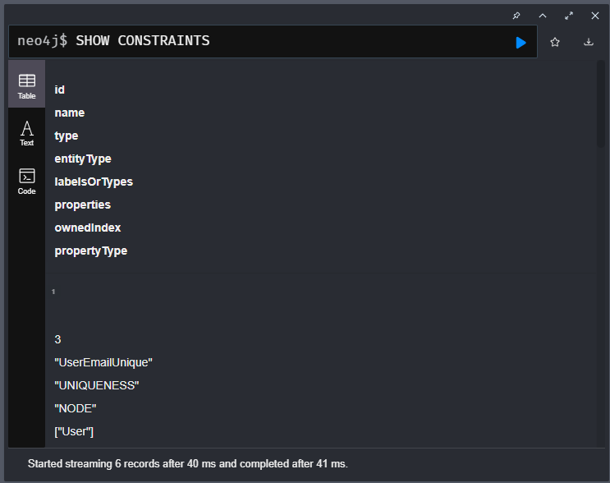

## **Resources**

During this course, you can refer to:

* [**Neo4j Cypher Manual**](https://neo4j.com/docs/cypher-manual/current/).
* [**Neo4j Cypher Refcard**](https://neo4j.com/docs/cypher-refcard/current/).

# Basic Cypher Queries

Youtube video: <https://youtu.be/Po4k7vXGBIE>

Transcript-

## **Filtering with WHERE**

In the course, [**Cypher Fundamentals**](https://graphacademy.neo4j.com/courses/cypher-fundamentals/), you learned some basic querying where you use the WHERE clause to filter queries where you test equality.

### **Testing Equality**

Execute this query:

**cypher**

Copy to ClipboardRun in Sandbox

MATCH (p:Person)-[:ACTED_IN]->(m:Movie)

WHERE p.name = 'Tom Hanks'

AND m.year = 2013

RETURN m.title

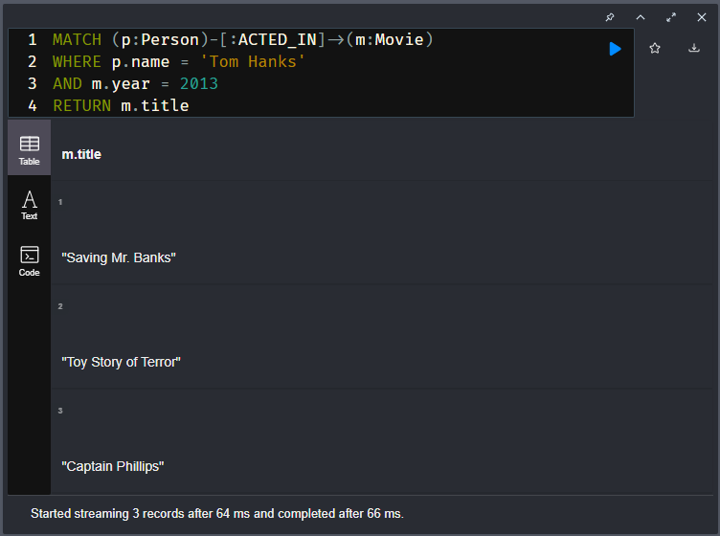

In this query, we:

1. Find all :Person nodes with the name, Tom Hanks.
2. We then traverse the :ACTED_IN relationships to all :Movie nodes and filter for movies with a year property equal to 2013.
3. Return the movie titles.

We are specifying the pattern to traverse through the graph, and then filtering on what data is retrieved within that pattern. We then return the title property for the three movie titles that satisfy the query.

Your queries will execute faster if the graph has indexes on property values. This course does not cover creating indexes. You typically create indexes for property values that cover your application’s most important queries.

### **Testing Inequality**

You can also test inequality of a property using the <> predicate.

**cypher**

Copy to ClipboardRun in Sandbox

MATCH (p:Person)-[:ACTED_IN]->(m:Movie)

WHERE p.name <> 'Tom Hanks'

AND m.title = 'Captain Phillips'

RETURN p.name

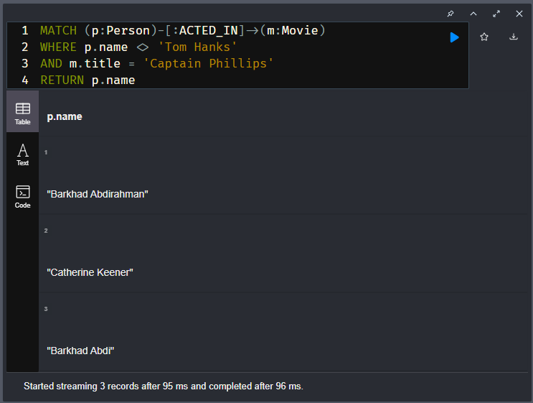

This query returns the names of all actors that acted in the movie Captain Phillips where Tom Hanks is excluded. It returns the names of the three actors that satisfy the filtering criteria.

### **Testing less than or greater than**

You can test both numbers and strings for values less than (<) or greater than (>) a value. Adding the equals sign will include the specified number within the predicate.

**cypher**

Copy to ClipboardRun in Sandbox

MATCH (m:Movie) WHERE m.title = 'Toy Story'

RETURN

m.year < 1995 AS lessThan, *// Less than (false)*

m.year <= 1995 AS lessThanOrEqual, *// Less than or equal(true)*

m.year > 1995 AS moreThan, *// More than (false)*

m.year >= 1995 AS moreThanOrEqual *// More than or equal (true)*

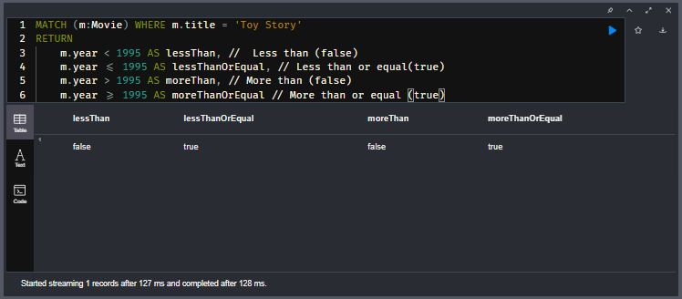

### **Testing Ranges**

To test for property values within a range, you can use a combination of less than and greater than.

Here we test a range of values:

**cypher**

Copy to ClipboardRun in Sandbox

MATCH (p:Person)-[:ACTED_IN]->(m:Movie)

WHERE p.name = 'Tom Hanks'

AND 2005 <= m.year <= 2010

RETURN m.title, m.released

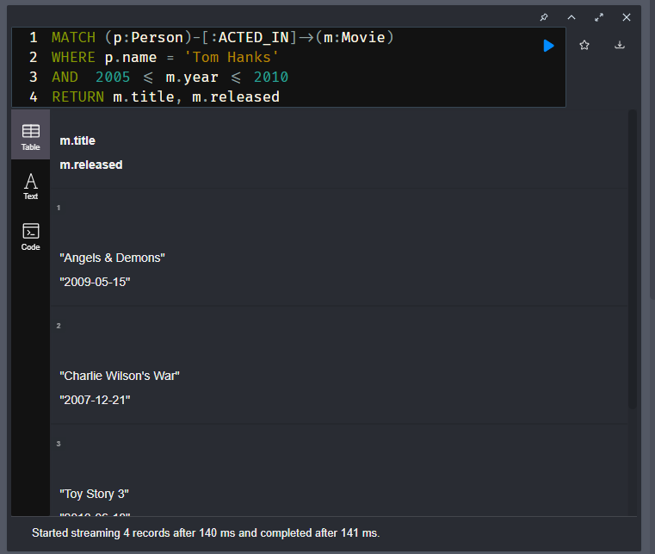

This query returns the four movies that Tom Hanks acted in between 2005 and 2010, inclusive.

We can also use OR to expand the filtering to return more data as follows:

**cypher**

Copy to ClipboardRun in Sandbox

MATCH (p:Person)-[:ACTED_IN]->(m:Movie)

WHERE p.name = 'Tom Hanks'

OR m.title = 'Captain Phillips'

RETURN p.name, m.title

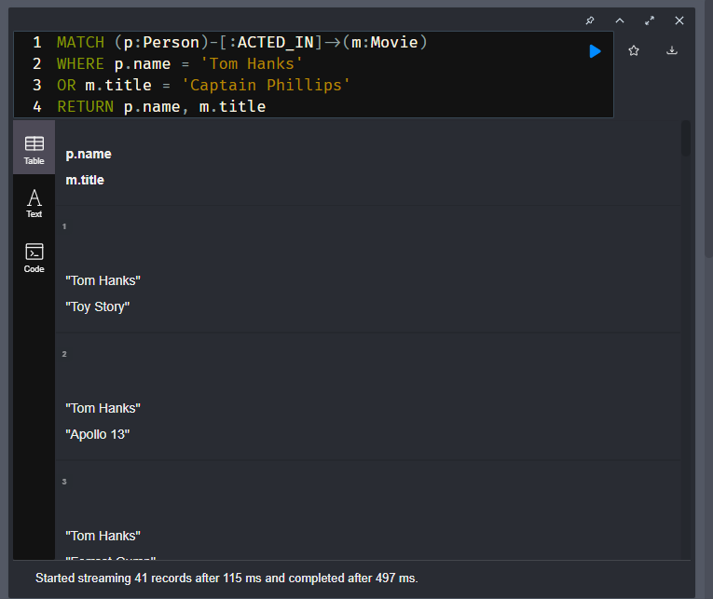

This query returns rows containing the name and title. Each row represents an actor who acted in Captain Phillips or has the name of Tom Hanks. In this result you will see multiple rows for Tom Hanks and each movie he acted in. You will also see multiple rows for each of the actors who acted in the movie, Captain Phillips.

Later in this course you will learn how to group data that is returned so that there are not multiple rows for Tom Hanks or multiple rows for the movie, Captain Phillips.

### **Testing null property values**

A property for a node or relationship is null if it does not exist. You can test the existence of a property for a node using the IS NOT NULL predicate.

**cypher**

Copy to ClipboardRun in Sandbox

MATCH (p:Person)

WHERE p.died IS NOT NULL

AND p.born.year >= 1985

RETURN p.name, p.born, p.died

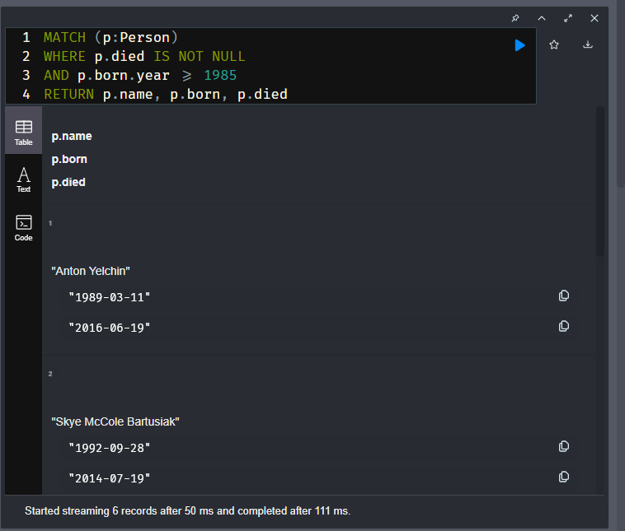

This query returns the names, born, and died properties for all people who have a value for their died property and who were born after 1985. In this graph, it returns 6 rows.

And we can test if a property exists using the IS NULL predicate:

**cypher**

Copy to ClipboardRun in Sandbox

MATCH (p:Person)

WHERE p.died IS NULL

AND p.born.year <= 1922

RETURN p.name, p.born, p.died

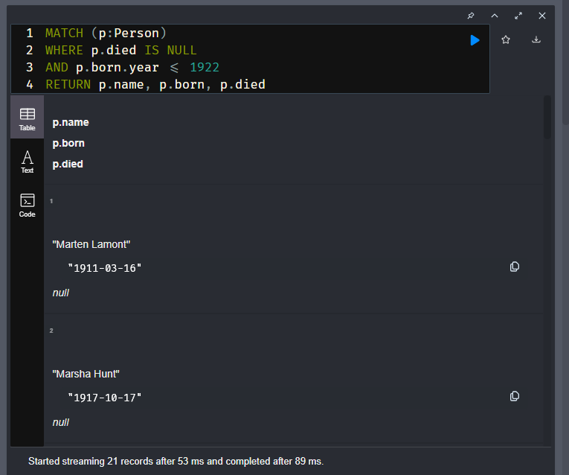

This query returns all people born before 1923 who do not have a died property value. It returns 21 rows for our dataset.

### **Testing labels or patterns?**

Depending on your data model, it may be useful to test that a node has a label. This is particularly useful when a node may have multiple labels.

You can test for a label’s existence on a node using the {alias}:{label} syntax.

**cypher**

Copy to ClipboardRun in Sandbox

MATCH (p:Person)

WHERE p.born.year > 1960

AND p:Actor

AND p:Director

RETURN p.name, p.born, labels(p)

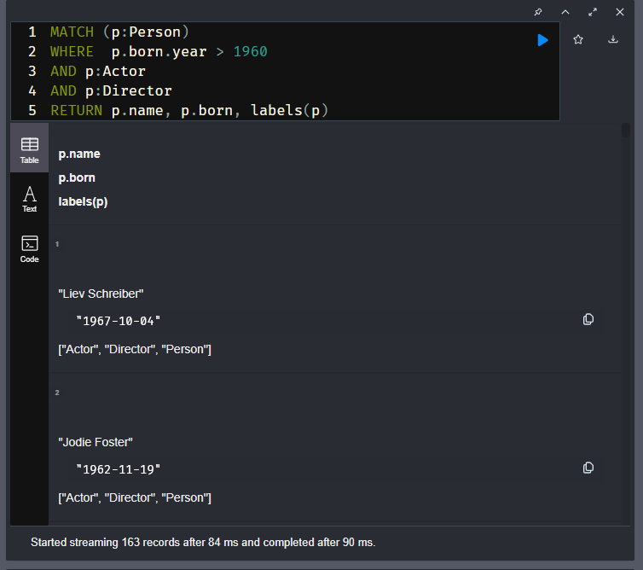

This query will retrieve all Person nodes with the label Actor and Director that were born after 1960. The labels() function returns the list of labels for a node. It returns 163 rows.

Here is a variation of the previous query. Rather than using the Actor or Director labels, it uses the relationship types :ACTED_IN and :DIRECTED to imply that the node at the other end of the relationship has the correct label:

**cypher**

Copy to ClipboardRun in Sandbox

MATCH (p:Person)-[:ACTED_IN]->(m:Movie)<-[:DIRECTED]-(p)

WHERE p.born.year > 1960

RETURN p.name, p.born, labels(p), m.title

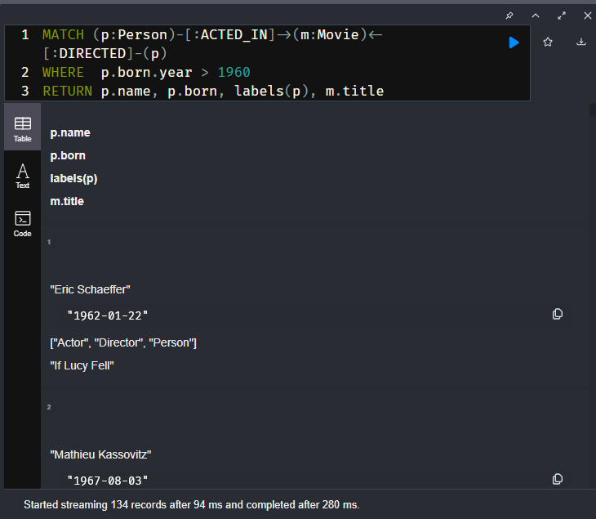

This query retrieves all people born after 1960 (assigned to the alias p), who also acted in a movie and directed the same movie. This query is more specific in that the same person both directed and acted in the movie. In the previous query, we were only looking at labels and not relationships to movies. This query returns 134 rows, but notice that some people directed and acted in multiple movies, for example, Jodie Foster.

### **Discovering relationship types**

A query with a pattern need not specify the relationship type in the query:

**cypher**

Copy to ClipboardRun in Sandbox

MATCH (p:Person)-[r]->(m:Movie)

WHERE p.name = 'Tom Hanks'

RETURN m.title AS movie, type(r) AS relationshipType

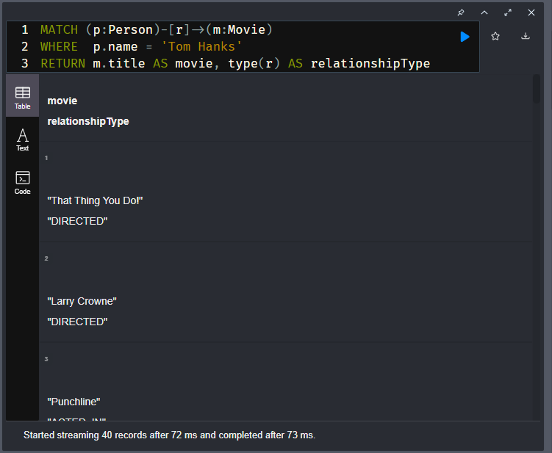

This query retrieves all Movie nodes that are related to Tom Hanks. Each row returned is a movie title and the type of relationship that Tom Hanks has to that movie. We use the type() function to return the type of the relationship, r. Notice that for this query, Tom Hanks has both an ACTED_IN and DIRECTED relationship to the movie, Larry Crowne.

### **Testing list inclusion**

You can test if a value is in a list property:

**cypher**

Copy to ClipboardRun in Sandbox

MATCH (m:Movie)

WHERE "Israel" IN m.countries

RETURN m.title, m.languages, m.countries

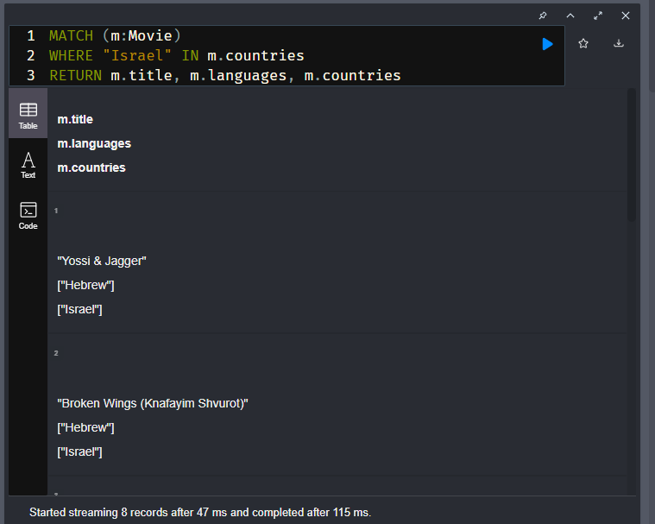

This query returns the titles, languages, countries of all movies that have Israel in their list of countries.

# Testing Equality (challenge)

## Horror Movie Directors

Write and execute a query to return the names of directors of horror movies released in the year 2000. Use the year property of the Movie node to do the comparison as well as the name of "Horror" for the Genre node.

Once you executed, enter the number of rows returned

## Solution-

MATCH (d:Director)-[:DIRECTED]->(m:Movie)-[:IN_GENRE]->(g:Genre)

WHERE m.year = 2000 AND g.name = "Horror"

RETURN d.name

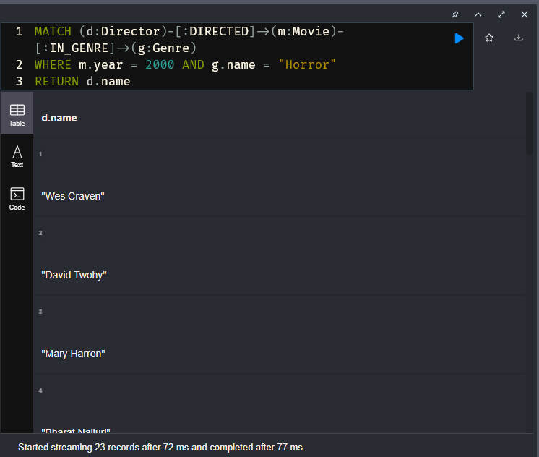

# Querying for Null Values (challenge)

During this course and in the embedded sandbox to the right, you can type :history to see past commands and Cypher code you have executed.

## **Check for no tmdbId values**

Using the sandbox on the right…​.

Write and execute a query to return all Movie nodes in the graph that do not have a tmdbId property.

How many Movie nodes are returned?

## Solution-

MATCH (m:Movie)

WHERE m.tmdbId IS NULL

RETURN m

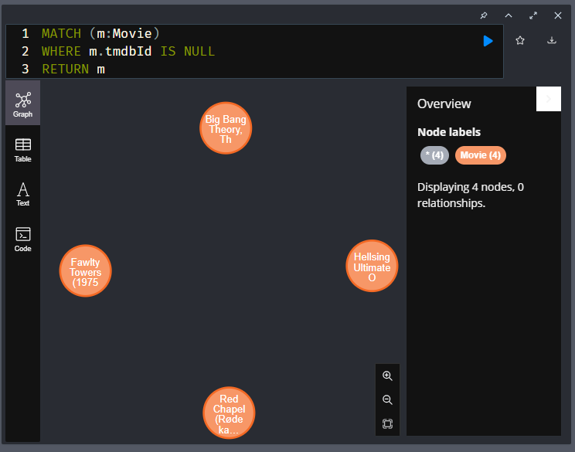

# Checking for Null Values (challenge)

## How many movies have no poster?

Write and execute a query to return the titles of all movies that do not have a poster.

Once you executed, enter the number of rows returned

## Solution-

MATCH (m:Movie)

WHERE m.poster IS NULL

RETURN m.title

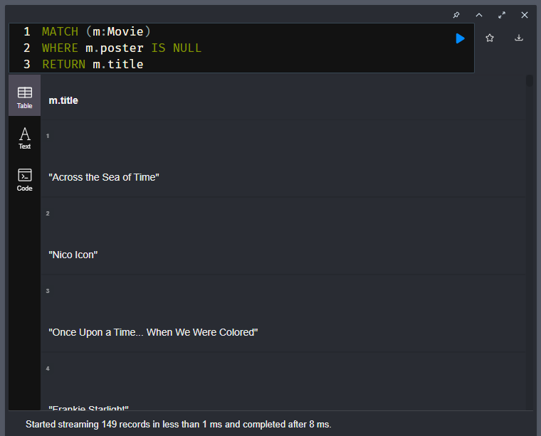

# Range Query (challenge)

## **Find People Born in the Fifties**

Using the sandbox on the right, write and execute a query to return people born in the 1950’s (1950 - 1959) that are both Actors and Directors.

How many Person nodes are returned?

## Solution-

MATCH (p:Person)

WHERE p:Actor AND p:Director

AND  1950 <= p.born.year < 1960

RETURN p.name, labels(p), p.born

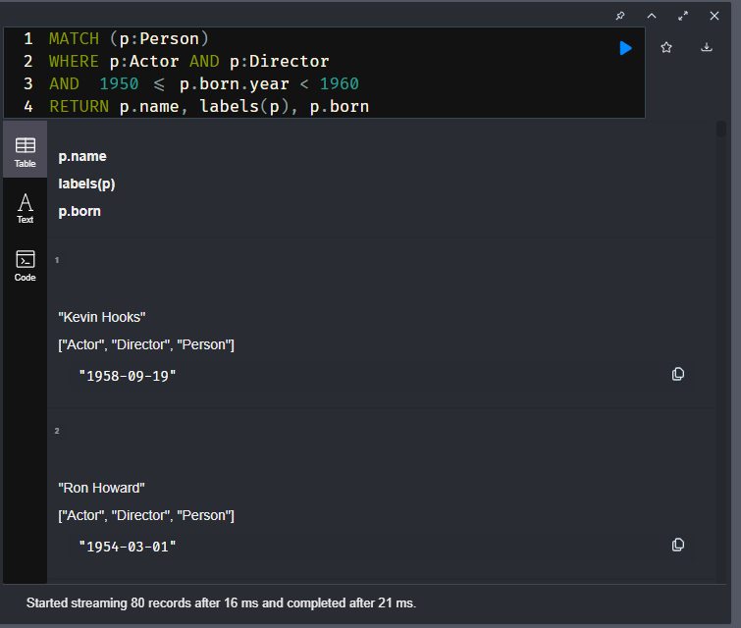

# Testing List Inclusion (challenge)

Neo4j supports storing a single value or an array of values of the same type within a property.

In our data model, every :Movie node has a languages property which contains an array of strings. For example ['English', 'German', 'Italian'].

## Finding German Language Movies

Write and execute a query to return movies released in the "German" language.

**Note**: You only need to search for "German"; there are elements in the database that have " German" as a language. You do not need to count these.

How many Movie node names are returned?

## Solution-

MATCH (m:Movie)

WHERE "German" IN m.languages

RETURN m.title

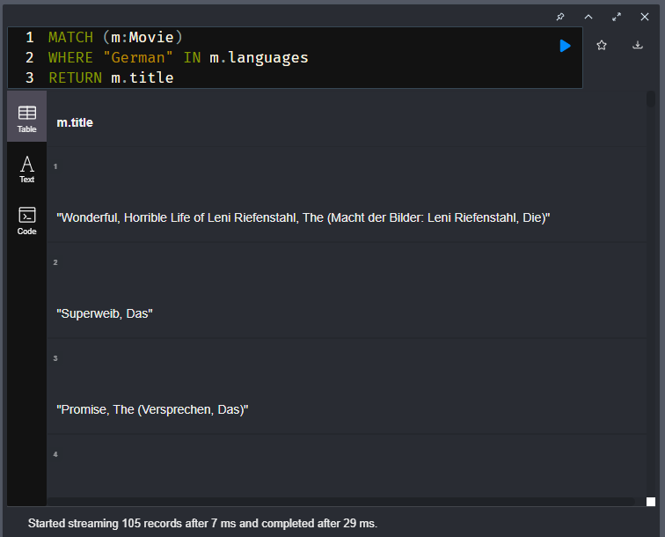

# Testing Strings

Youtube video: <https://youtu.be/hGVCvTCVujQ>

Transcript-

When the property is a string type, you can filter by the starting characters in the string:

**cypher**

Copy to ClipboardRun in Sandbox

MATCH (m:Movie)

WHERE m.title STARTS WITH 'Toy Story'

RETURN m.title, m.released

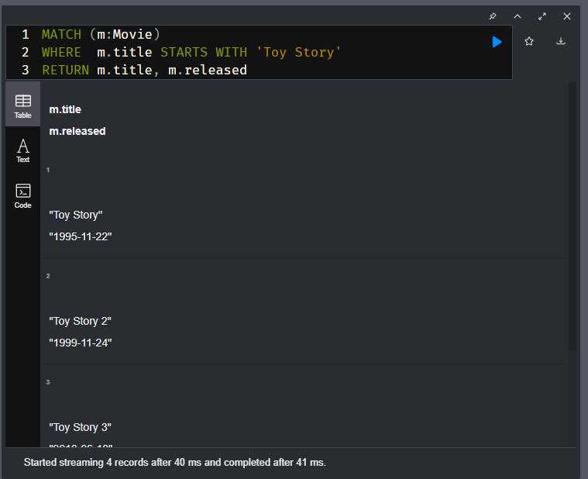

This query returns the four title and released dates for all movies whose title begins with Toy Story.

And you can filter queries whose properties end with a set of characters:

**cypher**

Copy to ClipboardRun in Sandbox

MATCH (m:Movie)

WHERE m.title ENDS WITH ' I'

RETURN m.title, m.released

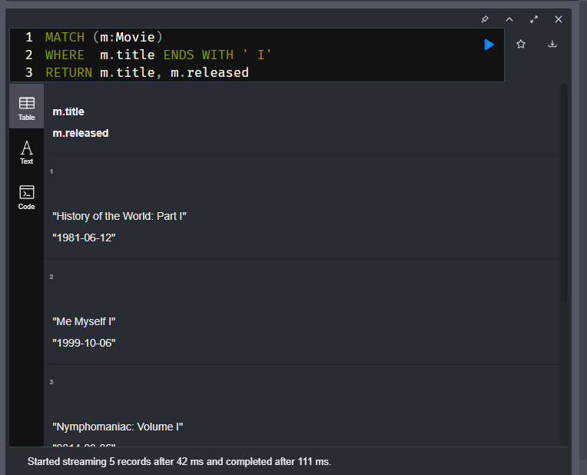

This query returns five rows that meet the filtering criteria.

Additionally, you can test if a substring is contained in a property:

**cypher**

Copy to ClipboardRun in Sandbox

MATCH (m:Movie)

WHERE m.title CONTAINS 'River'

RETURN m.title, m.released

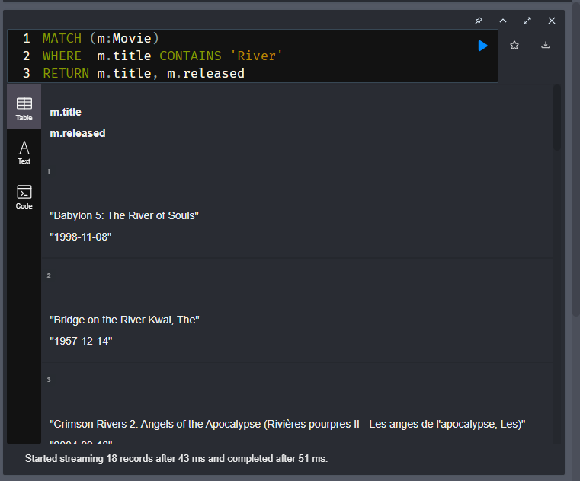

## Case-sensitive strings

String matching in Cypher is case-sensitive. If string values could be mis-interpreted if the letters do not match in case, your queries may miss data in the graph. For example, the user may enter a mixed-case value, [**emil@Neo4j.com**](mailto:emil@Neo4j.com), which is not the same for matching purposes to [**emil@neo4j.com**](mailto:emil@neo4j.com).

Here is an example query where case is significant:

**cypher**

Copy to ClipboardRun in Sandbox

MATCH (p:Person)

WHERE toLower(p.name) ENDS WITH 'demille'

RETURN p.name

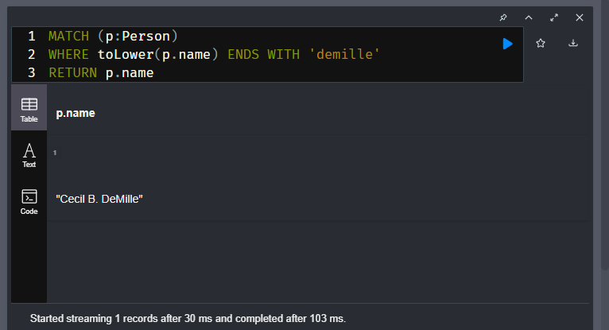

We do not know if the data in the graph for a name is DeMille, Demille, or deMlle. To ensure we match all Person nodes that could be one of these, we transform the property value to lower-case, so we can perform the test. This query returns one name, Cecille B. DeMille.

Conversely, we can do the same test with upper-case:

**cypher**

Copy to ClipboardRun in Sandbox

MATCH (p:Person)

WHERE toUpper(p.name) ENDS WITH 'DEMILLE'

RETURN p.name

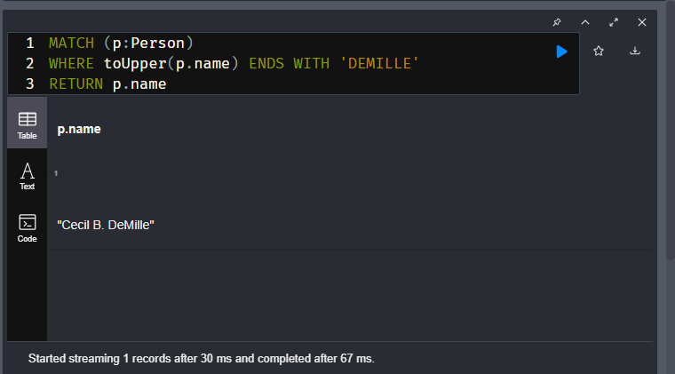

This query returns the same name.

Here is an example using CONTAINS:

**cypher**

Copy to ClipboardRun in Sandbox

MATCH (p:Person)

WHERE toUpper(p.name) CONTAINS ' DE '

RETURN p.name

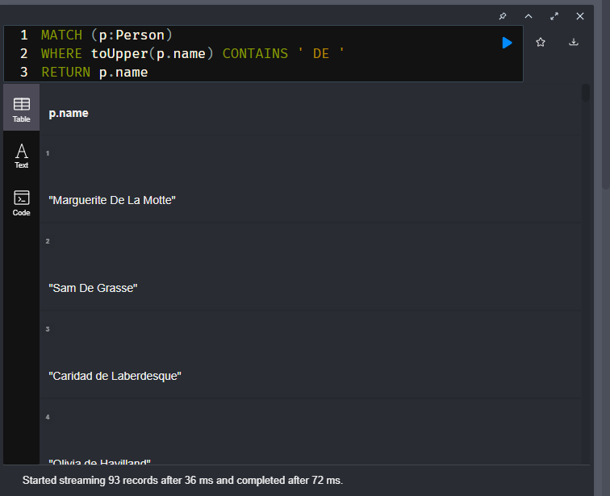

In this query, we find all people that have " de", " De", or " DE" in their names.

## About indexes for queries

If you transform a string property during a query, such as toUpper() or toLower(), the query engine turns off the use of the index.

With any query, you can always check if an index will be used by prefixing the query with **EXPLAIN**.

**cypher**

Copy to ClipboardRun in Sandbox

EXPLAIN MATCH (m:Movie)

WHERE m.title STARTS WITH 'Toy Story'

RETURN m.title, m.released

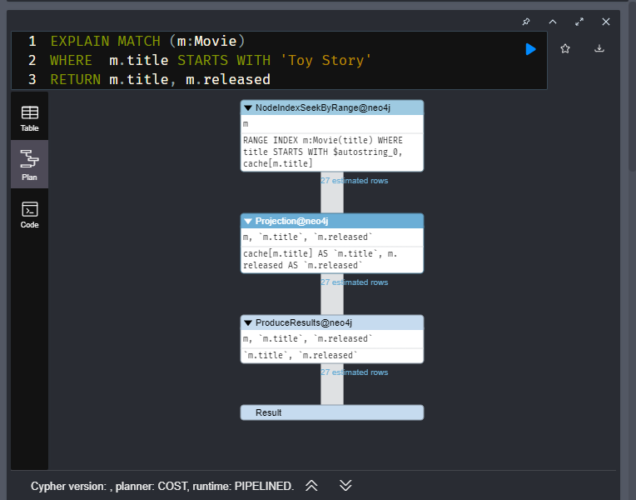

This query produces the execution plan where the first step is NodeIndexSeekByRange. In this case an index will be used because it is defined in the graph.

But with this query the index will not be used, even if present in the graph, because toLower() is used:

**cypher**

Copy to ClipboardRun in Sandbox

EXPLAIN MATCH (p:Person)

WHERE toLower(p.name) ENDS WITH 'demille'

RETURN p.name

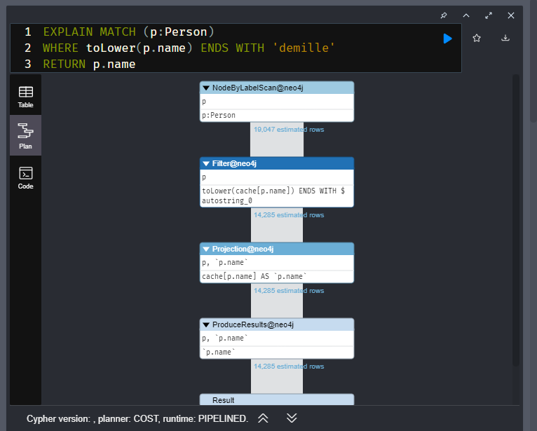

A best practice for handling property values that need to be evaluated as upper, lower, or mixed case is to use fulltext schema indexes.

Managing indexes is beyond the scope of this course, but you can read about indexes in the [**Neo4j Cypher Manual**](https://neo4j.com/docs/cypher-manual/current/indexes-for-search-performance/#administration-indexes-types).

In addition, you can take the course [**Cypher Indexes and Constraints**](https://graphacademy.neo4j.com/courses/cypher-indexes-constraints/).

## About EXPLAIN-

Basically, EXPLAIN does not execute the query, but does return the query or execution plan that will show if an index will be used. Its also a good way for understanding the sequence of operarations in a query.

# Case Insensitive Search (challenge)

## Check movie titles

Write and execute a query to return all Movie titles in the graph that have a title that begins with "Life is". There may be titles that do not adhere to capitalization as such so you must ensure that all titles will match. That is, it will retrieve any case of the string, such as "Life is", "LIFE IS", "life is", "Life Is".

How many Movie nodes are returned?

## Solution-

MATCH (m:Movie)

WHERE toUpper(m.title) STARTS WITH 'LIFE IS'

RETURN m.title

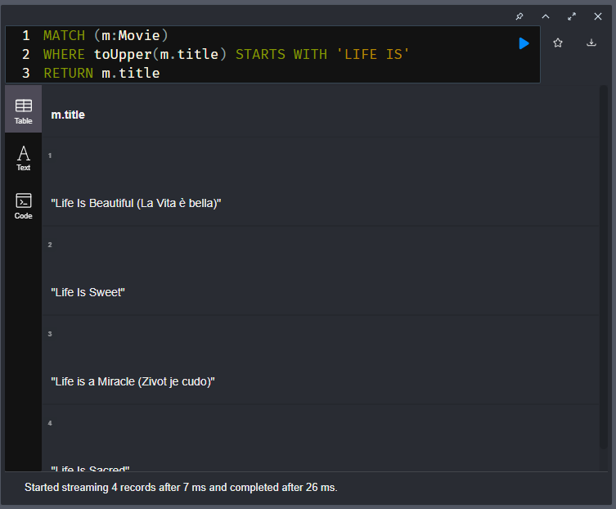

# Using the CONTAINS Predicate (challenge)

## Roles containing dog?

Write and execute a query to return the name of the person, their role, and the movie title where the role played by the actors or director had a value that included 'dog' (case-insensitive)? That is, the role could contain "Dog", "dog", or even "DOG".

Once you executed, enter the number of rows returned below

## Solution-

MATCH (p:Person)-[r]->(m:Movie)

WHERE toLower(r.role) CONTAINS "dog"

RETURN p.name, r.role, m.title

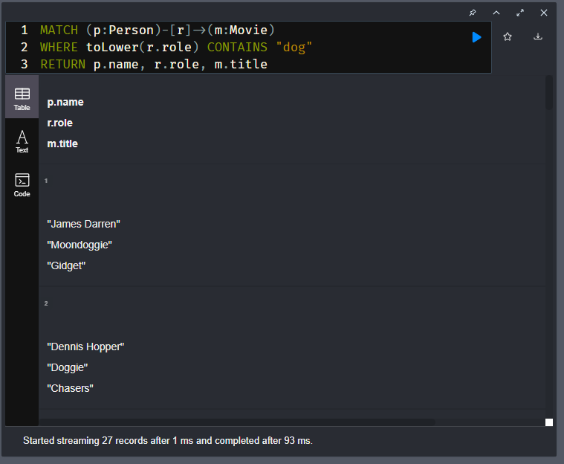

# Query Patterns and Performance

Youtube video: <https://youtu.be/EBO3GKgxgkY>

Transcript-

## **Patterns in the graph**

The Neo4j graph engine is implemented to traverse relationships very quickly. As you become more experienced with Cypher queries, you will soon learn that there are multiple ways to write a query that returns the same results. The difference in queries is typically its traversal performance. In this lesson, you will begin learning about graph traversal and query performance.

A pattern is a combination of nodes and relationships that is used to traverse the graph at runtime. You can write queries that test whether a pattern exists in the graph.

Here is an example:

**cypher**

Copy to ClipboardRun in Sandbox

MATCH (p:Person)-[:ACTED_IN]->(m:Movie)

WHERE p.name = 'Tom Hanks'

AND exists {(p)-[:DIRECTED]->(m)}

RETURN p.name, labels(p), m.title

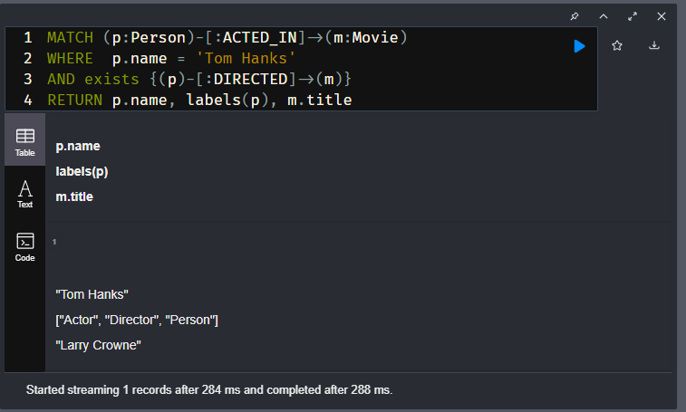

This query:

1. Retrieves the anchor of the query, the Tom Hanks :Person node.
2. It then follows the :ACTED_IN relationship to a :Movie node.
3. Then, for the Movie node and Person node, it tests whether these nodes are related by the DIRECTED relationship.
4. If they are, then the row is returned.

This exists { } test is done for every Movie node related to Tom Hanks as an actor. This query returns the single movie that Tom Hanks directed and acted in.

## Profiling queries

You can use the PROFILE keyword to show the total number of rows retrieved from the graph in the query.

**cypher**

Copy to ClipboardRun in Sandbox

PROFILE MATCH (p:Person)-[:ACTED_IN]->(m:Movie)

WHERE p.name = 'Tom Hanks'

AND exists {(p)-[:DIRECTED]->(m)}

RETURN m.title

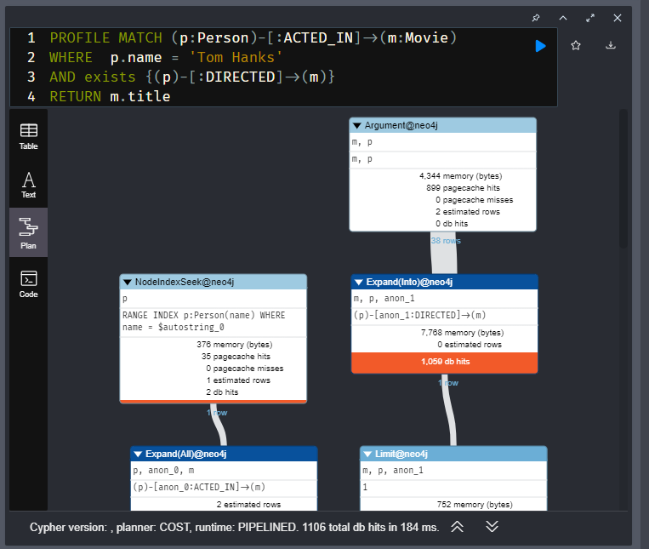

In the profile, you can see that the initial row is retrieved, but then 38 rows are retrieved for each Movie that Tom Hanks acted in. Then the test is done for the :DIRECTED relationship.

This is a better way to do the same query. This is a query that you have seen before.

**cypher**

Copy to ClipboardRun in Sandbox

PROFILE MATCH (p:Person)-[:ACTED_IN]->(m:Movie)<-[:DIRECTED]-(p)

WHERE p.name = 'Tom Hanks'

RETURN m.title

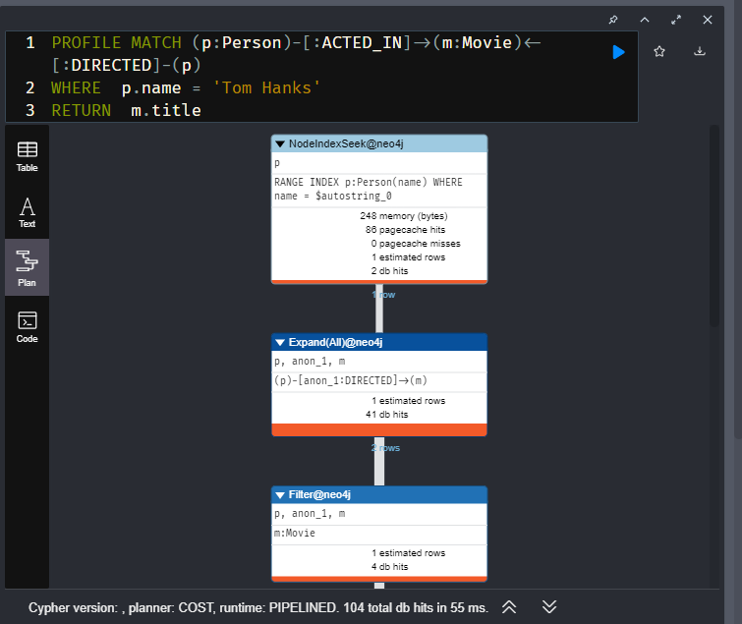

The query:

1. Retrieves the anchor (the Tom Hanks Person node).
2. It then finds a Movie node where Tom Hanks is related to with the ACTED_IN relationship.
3. It then traverses all DIRECTED relationships that point to the same Tom Hanks node.

This traversal is very efficient because the graph engine can take the [internal] relationship cardinalities into account. If you execute this query, it returns the same result as the previous query; the movie title Larry Crowne.

Notice, however that this query is much more efficient. It retrieves one row then two rows; much less data than the first query. Note that the performance of queries that use patterns will depend upon the data model for your graph and also the number of nodes in the traversal.

## Difference between EXPLAIN and PROFILE

The difference between using EXPLAIN and PROFILE is that EXPLAIN provides estimates of the query steps where PROFILE provides the exact steps and number of rows retrieved for the query. Providing you are simply querying the graph and not updating anything, it is fine to execute the query multiple times using PROFILE. In fact, as part of query tuning, you should execute the query at least twice as the first execution involves the generation of the execution plan which is then cached. That is, the first PROFILE of a query will always be more expensive than subsequent queries.

Query tuning is beyond the scope of this course, but it is important to profile your queries so that you can optimize the queries of your application. The metric that is typically a good measure of query performance is the number db hits.

## Finding non-patterns

You’ve just seen that using a pattern and testing the existence of a pattern in our graph for this course is not optimal. This may or may not be the case, depending on your data model. There is a scenario where using exists { } for a pattern is useful. You use NOT exists { } to exclude patterns in the graph.

We want to find all the movies that Tom Hanks acted in, but did not direct.

Here is the best way to do this:

**cypher**

Copy to ClipboardRun in Sandbox

MATCH (p:Person)-[:ACTED_IN]->(m:Movie)

WHERE p.name = 'Tom Hanks'

AND NOT exists {(p)-[:DIRECTED]->(m)}

RETURN m.title

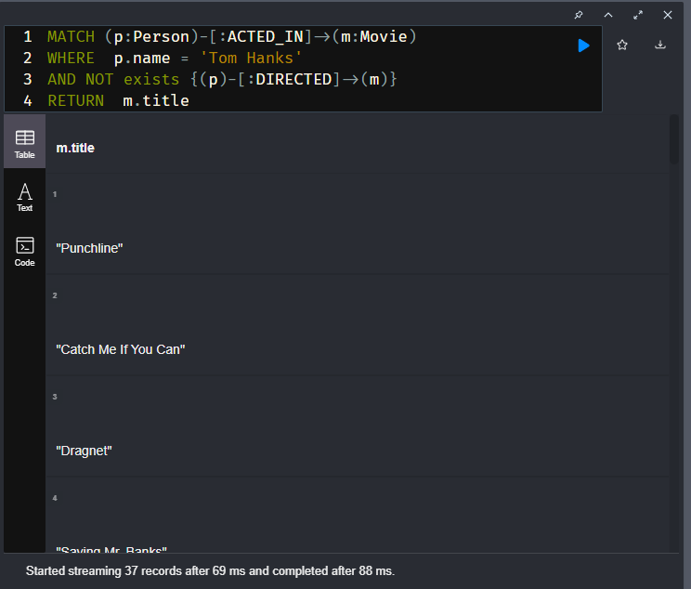

Here we want to exclude the :DIRECTED relationships to movies for Tom Hanks. If you profile this query, you will find that it is not performant, but it is the only way to perform this query.

About PROFILE-

It provides both the execution plan and the db hits when the query executes.

## Quiz

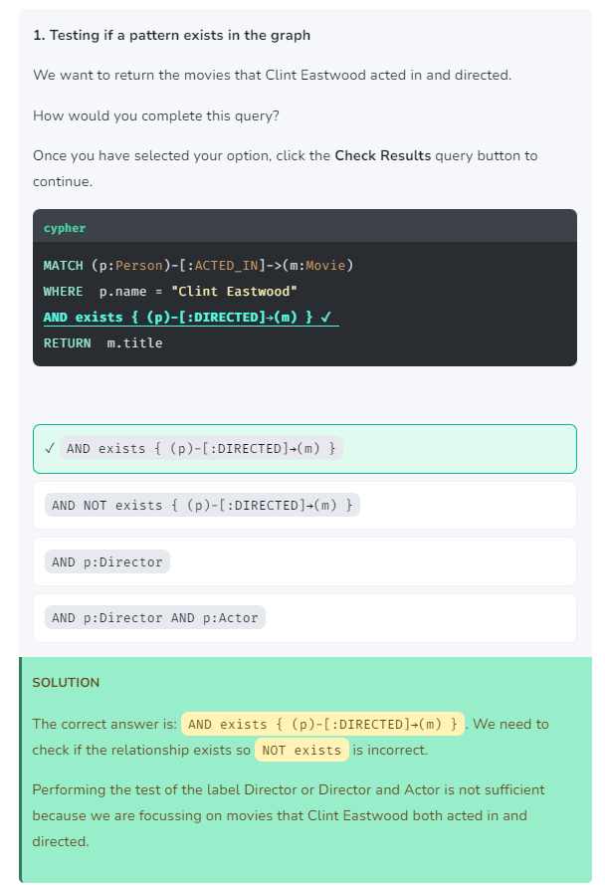

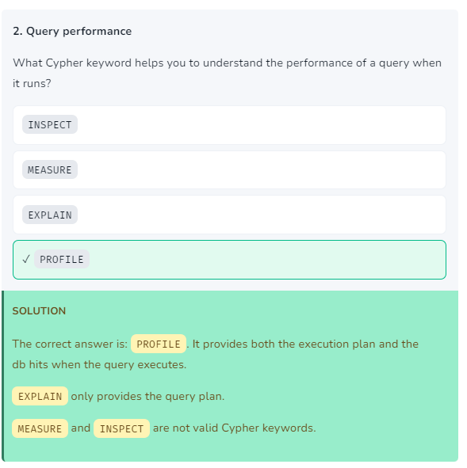

# Testing Patterns (challenge)

## Rob Reiner directed

Write and execute a query to return the titles of all movies that Rob Reiner directed, but did not act in.

How many Movie titles are returned?

## Solution-

MATCH (p:Person)-[:DIRECTED]->(m:Movie)

WHERE p.name = 'Rob Reiner'

AND NOT exists {(p)-[:ACTED_IN]->(m)}

RETURN DISTINCT m.title

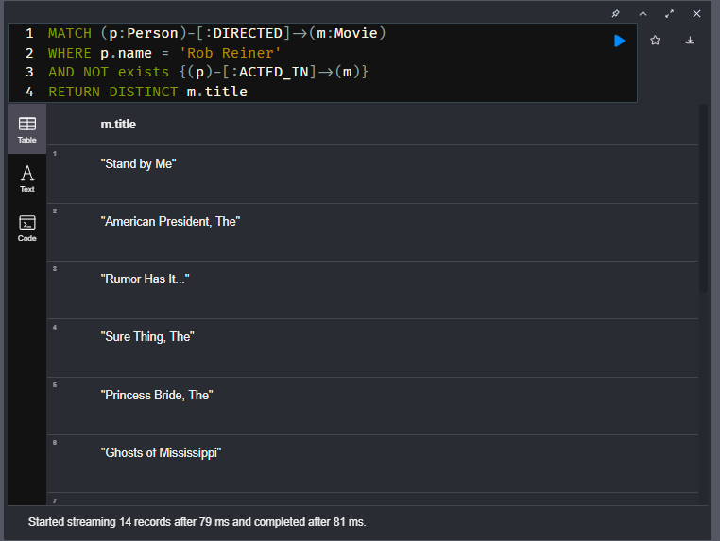

# Profiling (challenge)

## Profiling a query

Run this query:

**cypher**

Copy to ClipboardRun in Sandbox

PROFILE MATCH (p:Person)-[:ACTED_IN]->(m:Movie)

WHERE p.name = 'Clint Eastwood'

AND NOT exists {(p)-[:DIRECTED]->(m)}

RETURN m.title

What is the total number of db hits when this query executes?

## Solution-

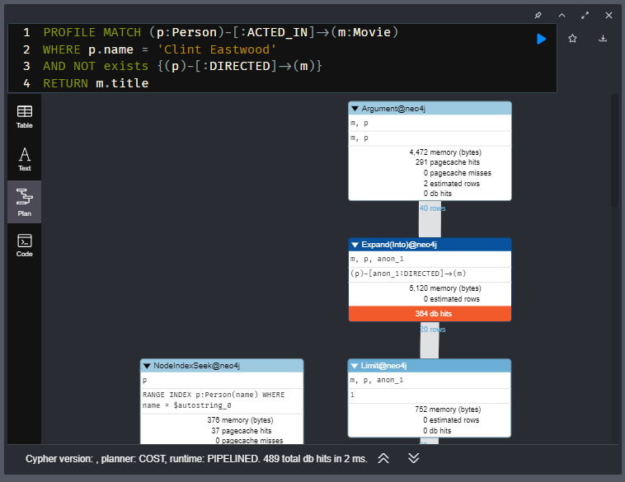

# Multiple MATCH Clauses

Youtube video: <https://youtu.be/MQJZqfwysLo>

Transcript-

## Using multiple **MATCH** clauses

Here is an example of a query that contains two explicit MATCH clauses:

**cypher**

Copy to ClipboardRun in Sandbox

MATCH (a:Person)-[:ACTED_IN]->(m:Movie)

WHERE m.year > 2000

MATCH (m)<-[:DIRECTED]-(d:Person)

RETURN a.name, m.title, d.name

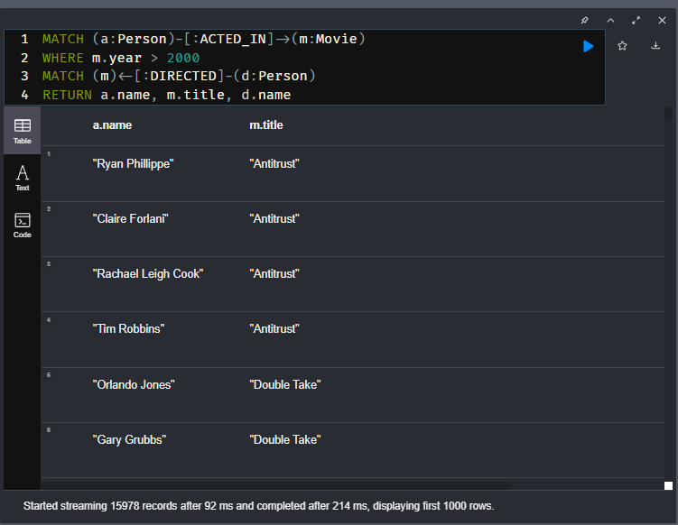

This query:

1. Retrieves the anchor nodes (movies released after the year 2000) and the set of actors for each movie.
2. It then follows the :DIRECTED relationships to each Movie node to retrieve the director of each movie.
3. It returns the triple of actor name, movie title, director name.

Notice that actors, movie titles, directors are repeated in the rows returned.

## Using multiple patterns in the **MATCH** clause

An alternative to using multiple MATCH clauses is to specify multiple patterns:

**cypher**

Copy to ClipboardRun in Sandbox

MATCH (a:Person)-[:ACTED_IN]->(m:Movie),

(m)<-[:DIRECTED]-(d:Person)

WHERE m.year > 2000

RETURN a.name, m.title, d.name

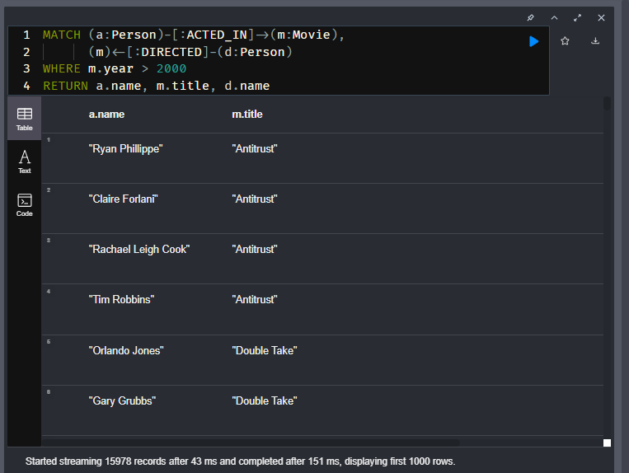

In this query, multiple patterns are specified. In the second pattern, the variable m is used from the first pattern.

In general, using a single MATCH clause will perform better than multiple MATCH clauses. This is because relationship uniquness is enforced so there are fewer relationships traversed.

## Using a single pattern

And finally, the same query can be written as follows:

**cypher**

Copy to ClipboardRun in Sandbox

MATCH (a:Person)-[:ACTED_IN]->(m:Movie)<-[:DIRECTED]-(d:Person)

WHERE m.year > 2000

RETURN a.name, m.title, d.name

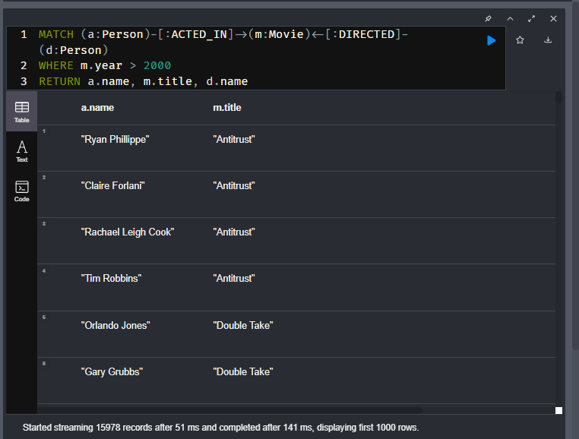

In most cases, specifying a single pattern will yield the best performance.

The performance of your queries will depend greatly upon your data model and the size of the graph.

## Optionally matching rows

Cypher has a clause that allows you to return rows that contain null values for some properties.

Here is an example of a query that we will start with:

**cypher**

Copy to ClipboardRun in Sandbox

MATCH (m:Movie) WHERE m.title = "Kiss Me Deadly"

MATCH (m)-[:IN_GENRE]->(g:Genre)<-[:IN_GENRE]-(rec:Movie)

MATCH (m)<-[:ACTED_IN]-(a:Actor)-[:ACTED_IN]->(rec)

RETURN rec.title, a.name 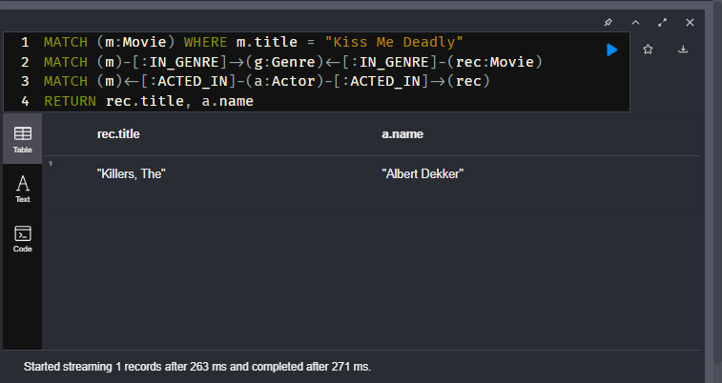

In this query:

1. We find the movie node for Kiss Me Deadly.
2. Then we find all movies, rec that are in the same genre as Kiss Me Deadly.
3. Then we find the actors that acted in both rec and Kiss Me Deadly.

The result is one actor who acted in both Kiss Me Deadly and The Killers.

What if we wanted to expand the results returned to return all movies that are in the same genre, and the actor that acted in both movies.

OPTIONAL MATCH matches patterns with your graph, just like MATCH does. The difference is that if no matches are found, OPTIONAL MATCH will use nulls for missing parts of the pattern. OPTIONAL MATCH could be considered the Cypher equivalent of the outer join in SQL.

Here is how you specify OPTIONAL MATCH in Cypher:

**cypher**

Copy to ClipboardRun in Sandbox

MATCH (m:Movie) WHERE m.title = "Kiss Me Deadly"

MATCH (m)-[:IN_GENRE]->(g:Genre)<-[:IN_GENRE]-(rec:Movie)

OPTIONAL MATCH (m)<-[:ACTED_IN]-(a:Actor)-[:ACTED_IN]->(rec)

RETURN rec.title, a.name

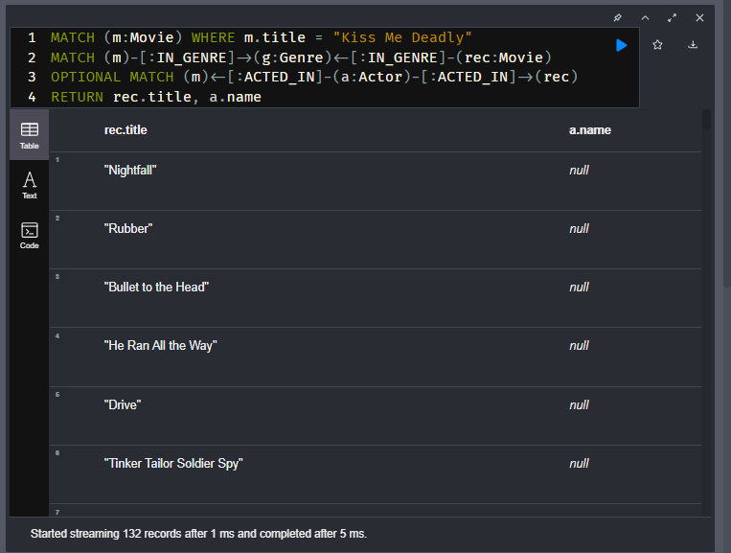

This query returns rows where the pattern where an actor acted in both movies is optional and a null value is returned for any row that has no value. In general, and depending on your graph, an optional match will return more rows.

## Quiz-

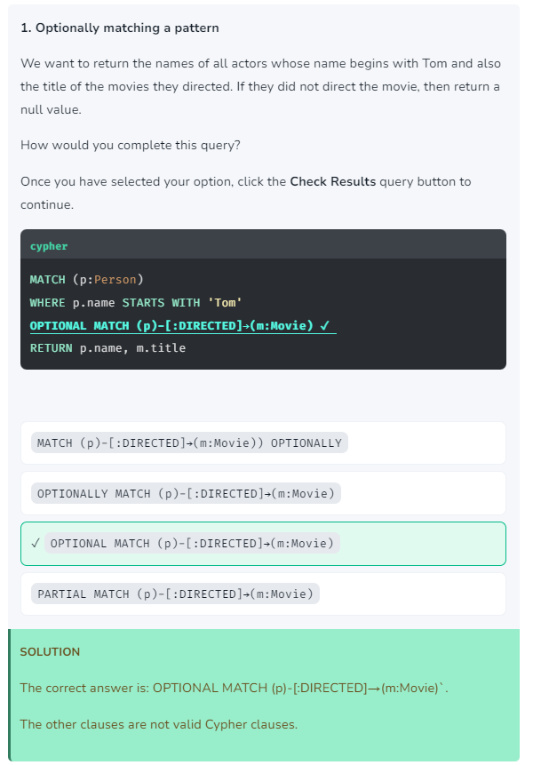

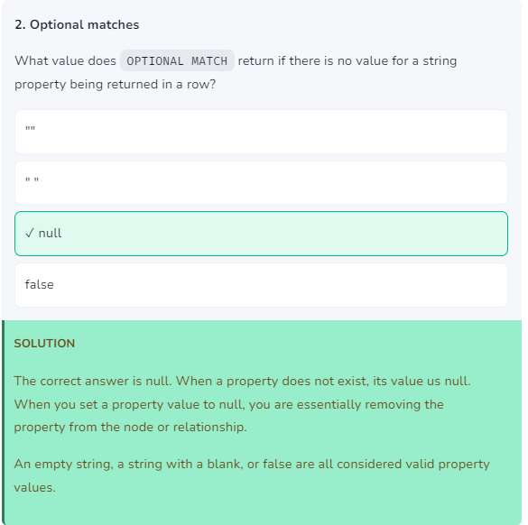

# Retrieve Movies and Reviewers (challenge)

## Retrieving movies in a genre with their reviewers

Here is a query that returns the titles of all Film Noir movies and the users who rated them. How many rows are returned?

## Solution-

Execute this query:

**cypher**

Copy to ClipboardRun in Sandbox

MATCH (m:Movie)-[:IN_GENRE]->(g:Genre)

WHERE g.name = 'Film-Noir'

MATCH (m)<-[:RATED]-(u:User)

RETURN m.title, u.name

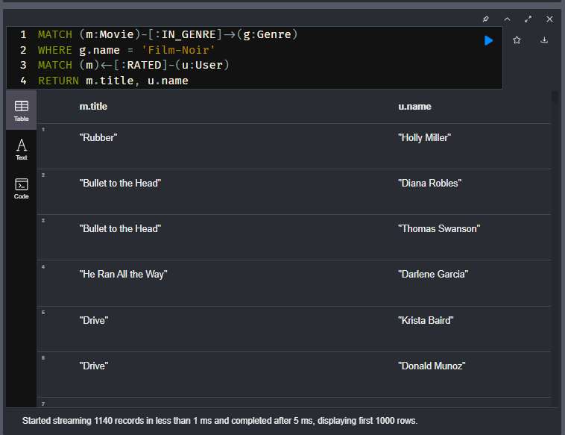

# OPTIONAL MATCH (challenge)

## Optionally returning rows

Here is the query you previously executed.

**cypher**

Copy to ClipboardRun in Sandbox

MATCH (m:Movie)-[:IN_GENRE]->(g:Genre)

WHERE g.name = 'Film-Noir'

MATCH (m)<-[:RATED]-(u:User)

RETURN m.title, u.name

Modify and execute this query so that the test for users who rated the movie are optional.

How many rows are returned?

## Solution-

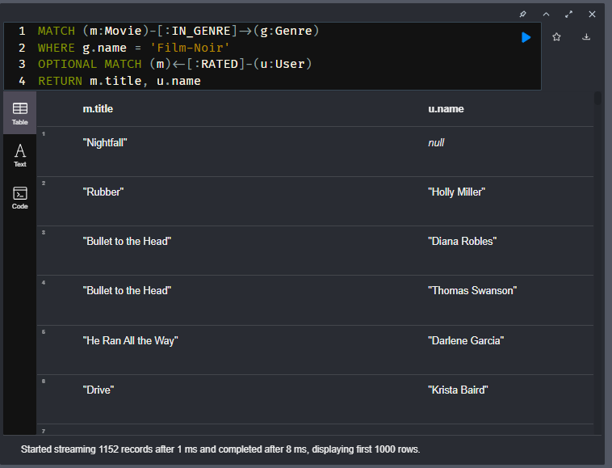

# Module 2: Controlling Results Returned

## **Module Overview**

Thus far, you have seen that you can return nodes/relationships in Neo4j Browser or you can return properties. In both cases, the results returned are rows of data.

In this module, you will learn how to:

* Order results returned.
* Limit the number of results returned.
* Add properties to returned nodes.
* Conditionally test results before returning them.

# Ordering results

Youtube video: <https://youtu.be/GlnYWWfiOAc>

Transcript-

Whether you return results as nodes or as properties of nodes, you can specify a property value for the ordering. Strings are ordered by their text values. Boolean true comes before false when ordered. Numeric data (including date and datetime properties) are ordered by their numeric value.

You specify ORDER BY in the RETURN clause where you specify the property for the ordering.

Here is an example:

**cypher**

Copy to ClipboardRun in Sandbox

MATCH (p:Person)

WHERE p.born.year = 1980

RETURN p.name AS name,

p.born AS birthDate

ORDER BY p.born

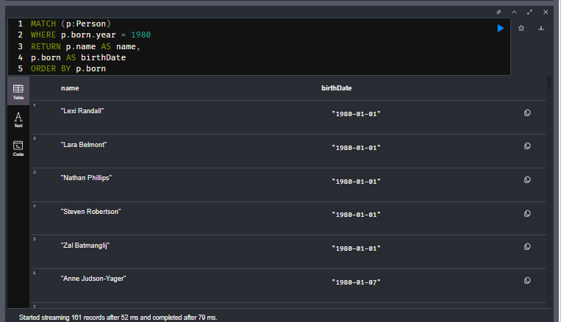

In this query, we find all Person nodes with a born year of 1980. The born property of Person nodes is a Cypher Date type, so we can use the year method to test the year value. Notice that is this code we are specifying aliases for the column headers for each row. The rows will be ordered by the value of the born property.

The default ordering is ascending, but you can specify descending as follows:

**cypher**

Copy to ClipboardRun in Sandbox

MATCH (p:Person)

WHERE p.born.year = 1980

RETURN p.name AS name, p.born AS birthDate

ORDER BY p.born DESC

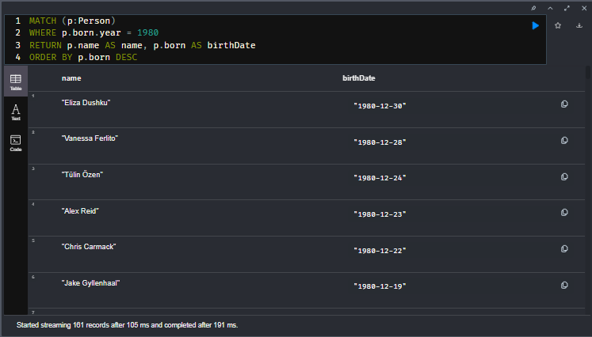

## Eliminating null values returned

For some queries, you may want to not return null values, especially if you are ordering the data.

Here is an example:

**cypher**

Copy to ClipboardRun in Sandbox

MATCH (p:Person)

RETURN p.name AS name, p.born AS birthDate

ORDER BY p.born DESC

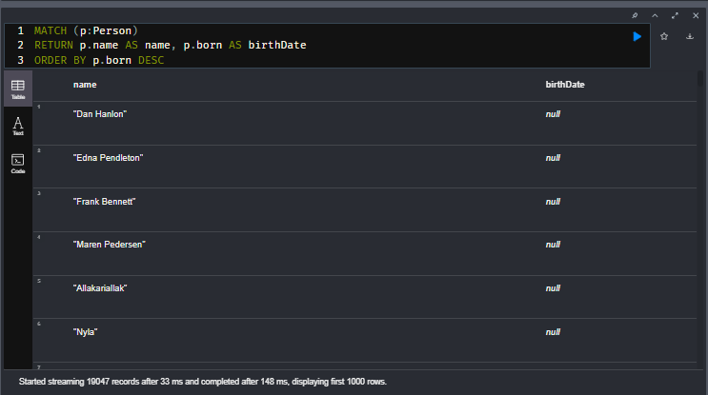

This query returns many rows at the beginning of result set that have a null value for the born property. In this case, we don’t want those nodes to be retrieved. We adjust the query as follows:

**cypher**

Copy to ClipboardRun in Sandbox

MATCH (p:Person)

WHERE p.born IS NOT NULL

RETURN p.name AS name, p.born AS birthDate

ORDER BY p.born DESC

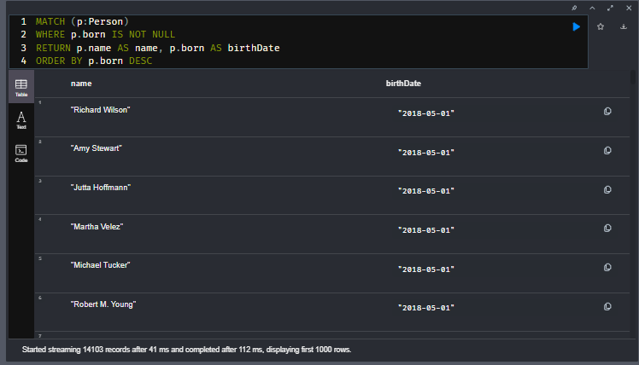

## Ordering multiple results

You can provide multiple sort expressions and the result will be sorted in that order.

**cypher**

Copy to ClipboardRun in Sandbox

MATCH (p:Person)-[:DIRECTED | ACTED_IN]->(m:Movie)

WHERE p.name = 'Tom Hanks'

OR p.name = 'Keanu Reeves'

RETURN m.year, m.title

ORDER BY m.year DESC , m.title

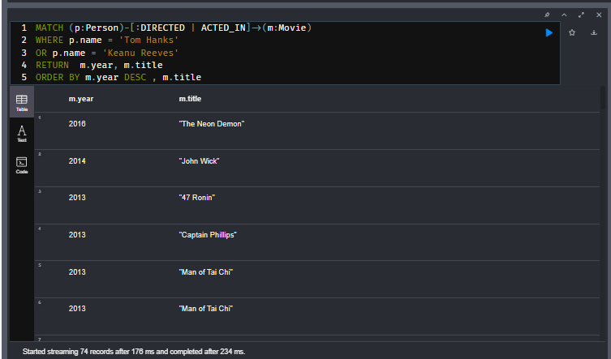

In this query we return the movies in descending year order and then the movie titles in ascending order.

There is no limit to the number of properties you can order by.

You can order by any property or expression that is within scope of the query. The ordering property or need not be explicitly returned, but can be used for the ordering.

# Ordering Results

## Movies with ratings

Write and execute a query to return the movie titles where they are ordered from the highest to the lowest imdbRating value. In your query, only return movies that have a value for the imdbRating property.

How many Movie titles are returned?

## Solution-

**cypher**

CopyRun

MATCH (m:Movie)

WHERE m.imdbRating IS NOT NULL

RETURN m.title, m.imdbRating

ORDER BY m.imdbRating DESC

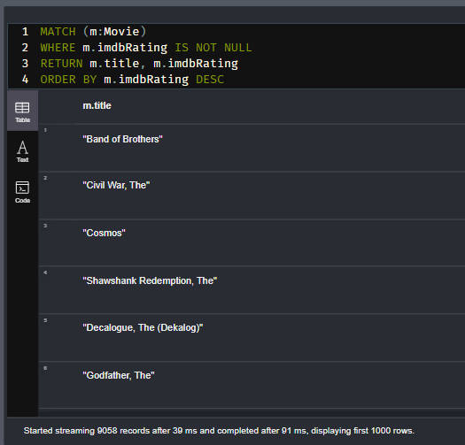

# Viewing the Ordered Results (challenge)

## Problem And Solution-

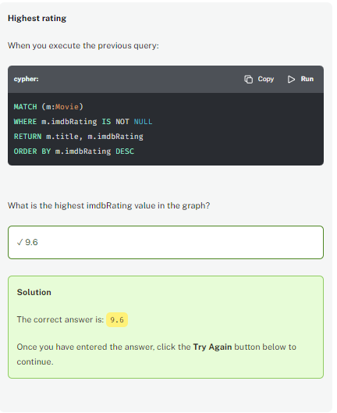

# Ordering Multiple Values (challenge)

## Youngest actor in highest rated movie

Modify the query you just executed to:

1. Match the people that acted in the movies.
2. Return the names of people sorted by the born property

**cypher**

CopyRun

MATCH (m:Movie)

WHERE m.imdbRating IS NOT NULL

RETURN m.title, m.imdbRating

ORDER BY m.imdbRating DESC

The question you want to answer is:

What is the youngest actor that acted in the most highly-rated movie?

Enter the name (case-sensitive!):

## Solution-

MATCH (m:Movie)<-[ACTED_IN]-(p:Person)

WHERE m.imdbRating IS NOT NULL

RETURN m.title, m.imdbRating, p.name, p.born

ORDER BY m.imdbRating DESC, p.born DESC

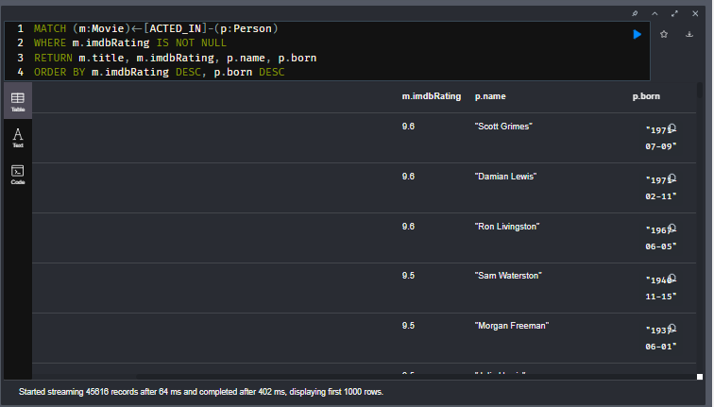

# Limiting or Counting Results Returned

Youtube video: <https://youtu.be/m5UJYU2W3AY>

Transcript-

## Limiting results

Although you can filter queries to reduce the number of results returned, you may also want to limit the number of results returned. This is useful if you have very large result sets and you only need to see the beginning or end of a set of ordered results. You can use the LIMIT keyword to specify the number of results returned.

**cypher**

CopyRun

MATCH (m:Movie)

WHERE m.released IS NOT NULL

RETURN m.title AS title,

m.released AS releaseDate

ORDER BY m.released DESC LIMIT 100

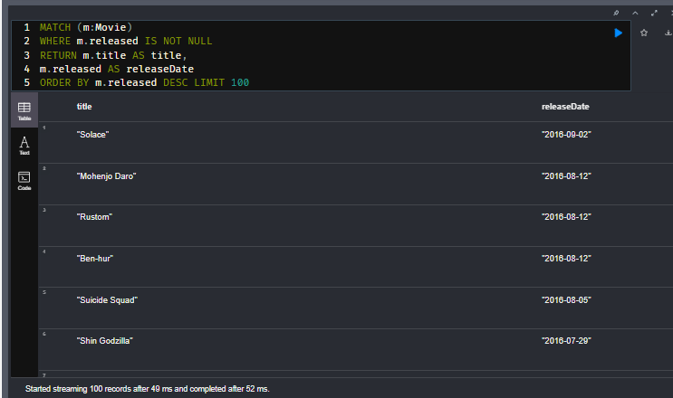

In this query we filter out movie nodes that have no value for the released property. Then we return the 100 most-recently released movies in our graph.

Or, we may want to determine the youngest person in the graph:

**cypher**

CopyRun

MATCH (p:Person) WHERE

p.born IS NOT NULL

RETURN p.name as name,

p.born AS birthDate

ORDER BY p.born DESC LIMIT 1

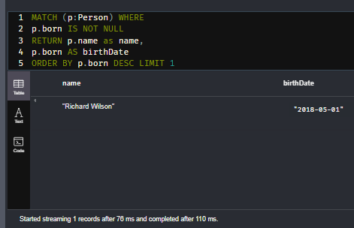

## Skipping some results

In an ordered result set, you may want to control what results are returned. This is useful in an application where pagination is required.

In this query we are returning the names of people born in 1980 ordered by their birth date.

**cypher**

CopyRun

MATCH (p:Person)

WHERE p.born.year = 1980

RETURN p.name as name,

p.born AS birthDate

ORDER BY p.born

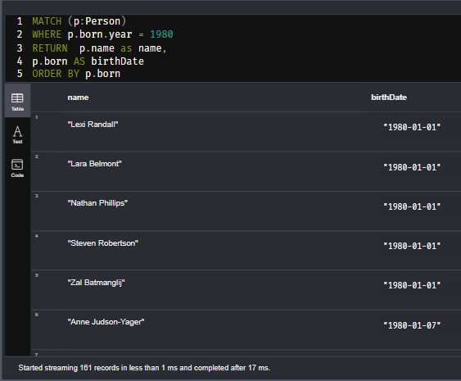

You can add a SKIP and LIMIT keyword to control what page of results are returned.

**cypher**

CopyRun

MATCH (p:Person)

WHERE p.born.year = 1980

RETURN p.name as name,

p.born AS birthDate

ORDER BY p.born SKIP 40 LIMIT 10

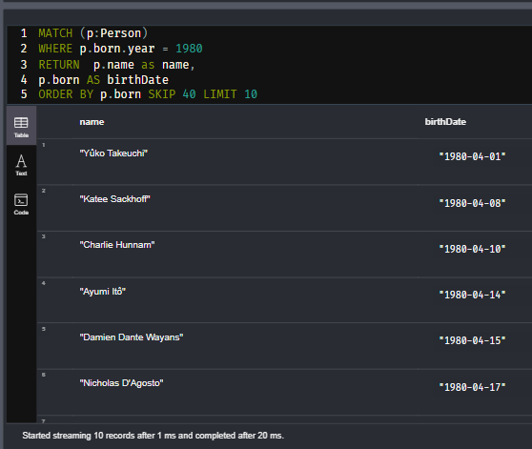

In this query, we return 10 rows representing page 5, where each page contains 10 rows.

## Eliminating duplicate records

You have seen a number of query results where there is duplication in the results returned. In some cases, you may want to eliminate duplicated results. You do so by using the DISTINCT keyword.

Here is a simple example where duplicate data is returned.

**cypher**

CopyRun

MATCH (p:Person)-[:DIRECTED | ACTED_IN]->(m:Movie)

WHERE p.name = 'Tom Hanks'

RETURN m.title, m.released

ORDER BY m.title

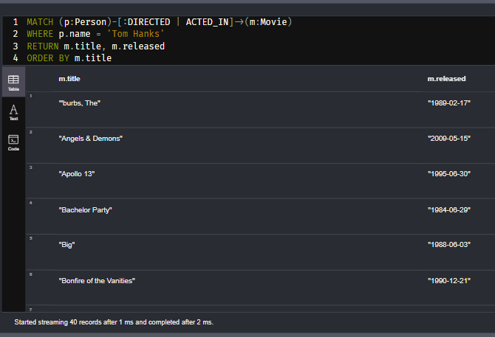

Tom Hanks both acted in and directed the movie, Larry Crowne, so the movie is returned twice in the result stream.

We can eliminate the duplication by specifying the DISTINCT keyword as follows:

**cypher**

CopyRun

MATCH (p:Person)-[:DIRECTED | ACTED_IN]->(m:Movie)

WHERE p.name = 'Tom Hanks'

RETURN DISTINCT m.title, m.released

ORDER BY m.title

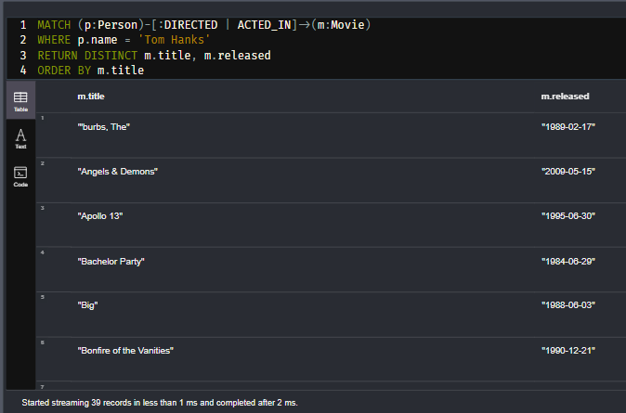

Using DISTINCT in the RETURN clause here means that rows with identical values will not be returned.

## Uses of DISTINCT

You can use DISTINCT to eliminate duplication of:

* rows returned (you have just learned this)
* property values
* nodes

Here is an example where we eliminate duplicate property values:

**cypher**

CopyRun

MATCH (m:Movie)

RETURN DISTINCT m.year

ORDER BY m.year

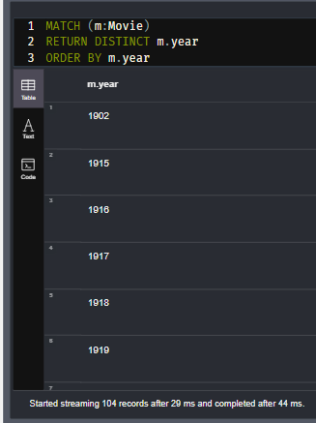

In the above query, only a single value will be returned for each Movie year. If you were to not use DISTINCT, all Movie year values would be returned.

And here is an example where we eliminate duplicate nodes:

**cypher**

CopyRun

MATCH (p:Person)-[:DIRECTED | ACTED_IN]->(m:Movie)

WHERE p.name = 'Tom Hanks'

RETURN DISTINCT m

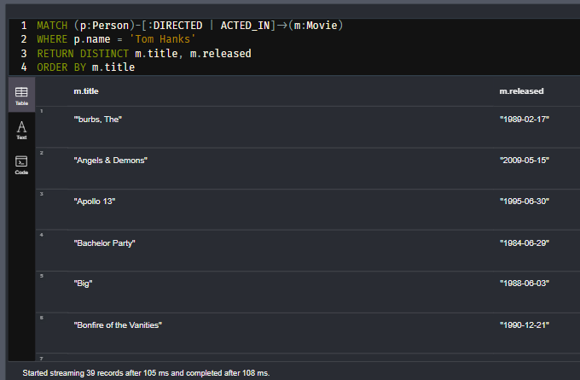

If we do not specify DISTINCT in the above query, the query returns a duplicate movie node.

# Limiting Results (challenge)

## Limiting results by movie rating

## Lowest rated movie

A movie has a property, imdbRating. Not all movies have a value for this property. Write and execute a query to determine the lowest imdbRating that a movie has in our graph.

What is the lowest imdbRating?

## Solution-

MATCH (m:Movie)

WHERE m.imdbRating IS NOT NULL

RETURN m.title, m.imdbRating

ORDER BY m.imdbRating LIMIT 1

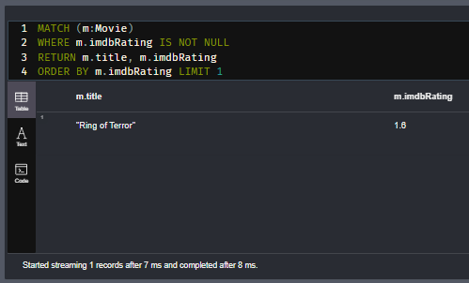

# Eliminating Duplicates (challenge)

## Eliminate Duplicate Names in Rows

Here is a query that returns the names people who acted or directed the movie Toy Story and then retrieves all people who acted in the same movie.

Execute this query. It will return 183 rows, some of which are duplicates.

**cypher**

CopyRun

MATCH (p:Person)-[:ACTED_IN| DIRECTED]->(m)

WHERE m.title = 'Toy Story'

MATCH (p)-[:ACTED_IN]->()<-[:ACTED_IN]-(p2:Person)

RETURN p.name, p2.name

Modify the query to eliminate duplicate rows.

How many rows are now returned?

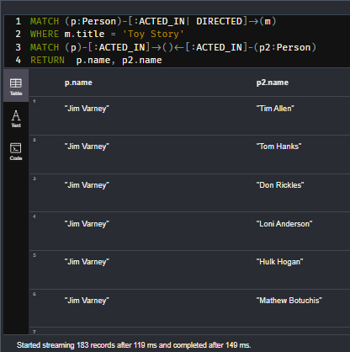

## Solution-

MATCH (p:Person)-[:ACTED_IN| DIRECTED]->(m)

WHERE m.title = 'Toy Story'

MATCH (p)-[:ACTED_IN]->()<-[:ACTED_IN]-(p2:Person)

RETURN DISTINCT p.name, p2.name

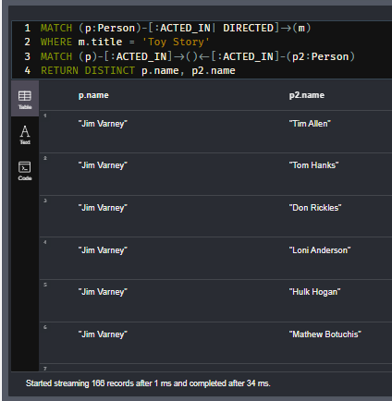

# Map Projections to Return Data

Youtube video: <https://youtu.be/0xoKYKFSDLY>

Transcript-

## Map projections

Many applications that access Neo4j via their drivers use Cypher to retrieve data from the graph as objects that will be used by the application. In Neo4j Browser, when nodes are returned, you can either view them as a graph, or you can view them in table view where all properties for a node are a single row. The data is returned as rows of data where each row represents a JSON-style object for a node.

**cypher**

CopyRun

MATCH (p:Person)

WHERE p.name CONTAINS "Thomas"

RETURN p AS person

ORDER BY p.name ASC

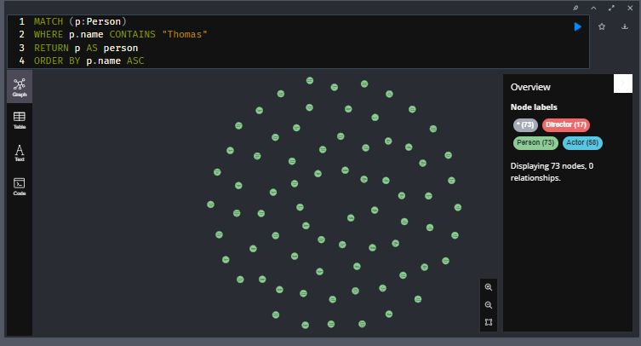

This query returns all Person nodes that contain the string "Thomas". If you view the data returned as a table, it returns internal node information such as labels and identity, along with the property values.

Another way that you can return data is without the internal node information, that is, only property values.

**cypher**

CopyRun

MATCH (p:Person)

WHERE p.name CONTAINS "Thomas"

RETURN p { .* } AS person

ORDER BY p.name ASC

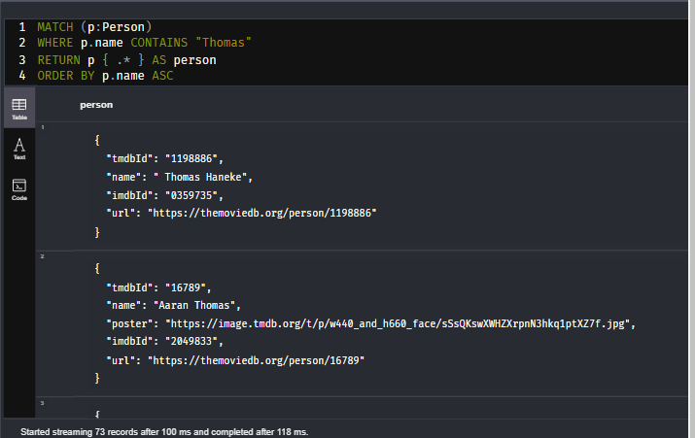

This query returns an object named person that contains all of the property values for the node. It does not contain any of the internal information for the node such as its labels or id.

Additionally, you can customize what properties you return in the objects.

**cypher**

CopyRun

MATCH (p:Person)

WHERE p.name CONTAINS "Thomas"

RETURN p { .name, .born } AS person

ORDER BY p.name

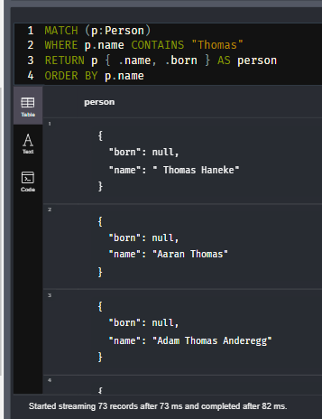

Here the person objects returned will include the name and born properties.

Being able to customize how data is returned is useful, especially if you are using a programming language that can work with JSON-style objects.

Here is an example, where we are adding information to the objects returned that are not part of the data in the graph.

**cypher**

CopyRun

MATCH (m:Movie)<-[:DIRECTED]-(d:Director)

WHERE d.name = 'Woody Allen'

RETURN m {.*, favorite: true} AS movie

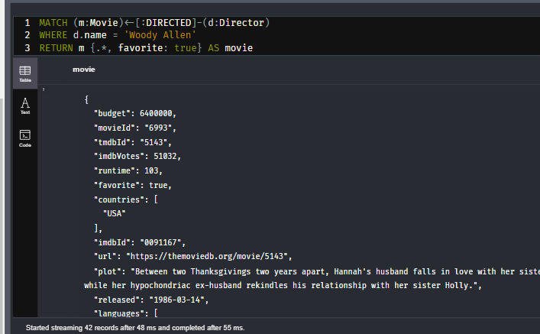

In addition to returning all property values for each Woody Allen movie, we are returning a property of favorite with a value of true for each Movie object returned.

## Quiz-

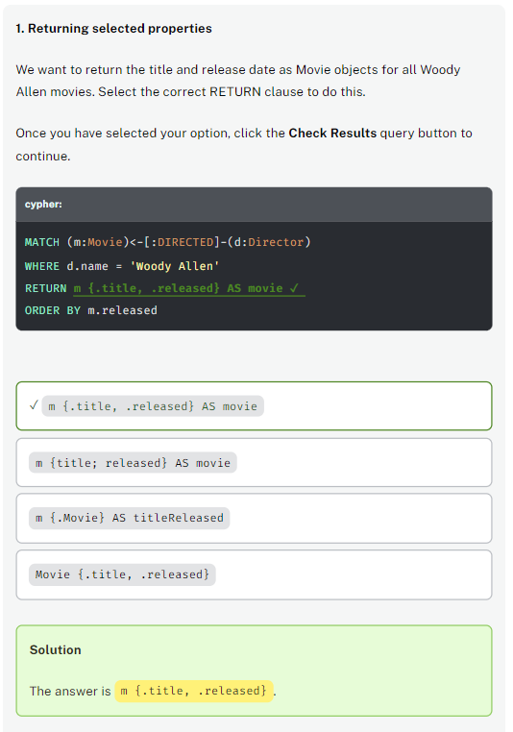

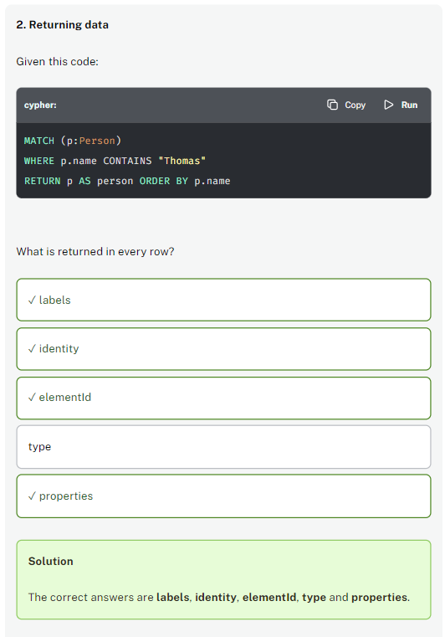

# Changing Results Returned

Youtube video: <https://youtu.be/eZ4WZIKcxwU>

Transcript-

## **Changing data returned**

You can always change the data that is returned by performing string or numeric operations on the data.

For example:

**cypher**

CopyRun

MATCH (m:Movie)<-[:ACTED_IN]-(p:Person)

WHERE m.title CONTAINS 'Toy Story' AND

p.died IS NULL

RETURN m.title AS movie,

p.name AS actor,

p.born AS dob,

date().year - p.born.year AS ageThisYear

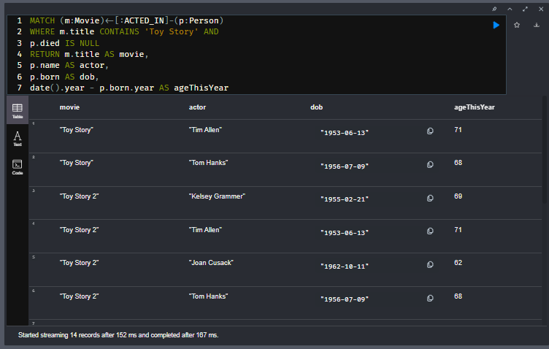

This query returns the actors in each Toy Story movie and their age if they are still living according to our graph. We add data to each line by calculating the actor’s age.

Here is an example where we concatenate string data returned:

**cypher**

CopyRun

MATCH (m:Movie)<-[:ACTED_IN]-(p:Person)

WHERE m.title CONTAINS 'Toy Story' AND

p.died IS NULL

RETURN 'Movie: ' + m.title AS movie,

p.name AS actor,

p.born AS dob,

date().year - p.born.year AS ageThisYear

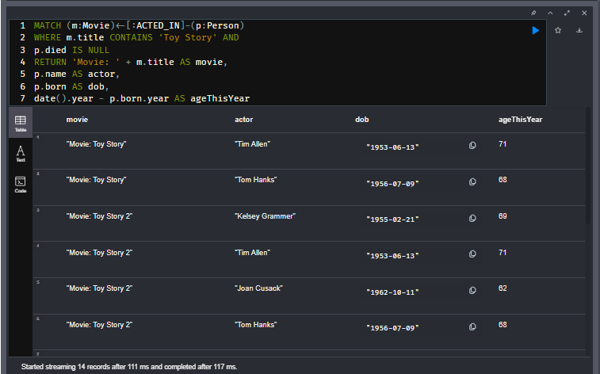

### Conditionally changing data returned

Cypher has a CASE clause that you can specify to compute the data returned which may be different from what is in the graph.

Here is an example:

**cypher**

CopyRun

MATCH (m:Movie)<-[:ACTED_IN]-(p:Person)

WHERE p.name = 'Henry Fonda'

RETURN m.title AS movie,

CASE

WHEN m.year < 1940 THEN 'oldies'

WHEN 1940 <= m.year < 1950 THEN 'forties'

WHEN 1950 <= m.year < 1960 THEN 'fifties'

WHEN 1960 <= m.year < 1970 THEN 'sixties'

WHEN 1970 <= m.year < 1980 THEN 'seventies'

WHEN 1980 <= m.year < 1990 THEN 'eighties'

WHEN 1990 <= m.year < 2000 THEN 'nineties'

ELSE 'two-thousands'

END

AS timeFrame

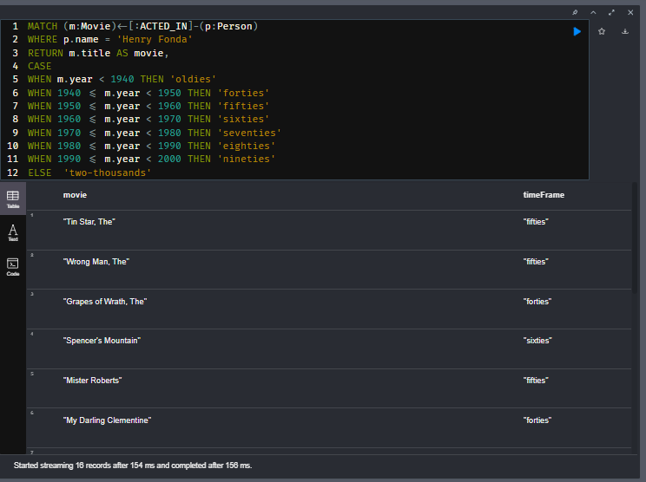



In this query we transform the data returned to reflect the timeframe for the movie.

## Quiz-

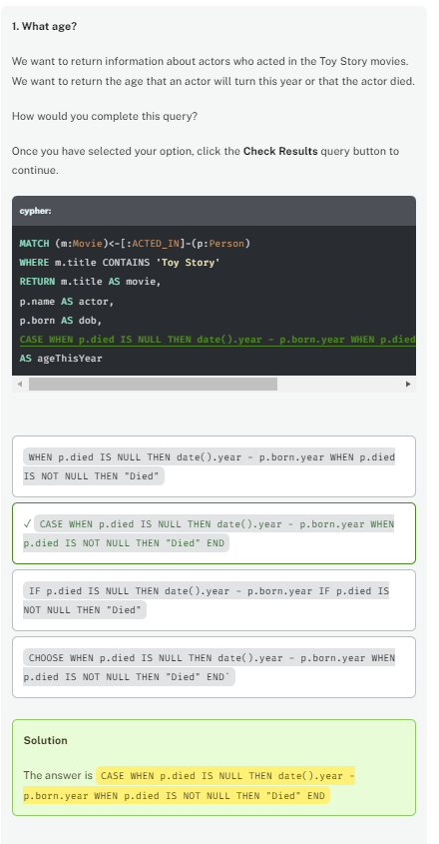

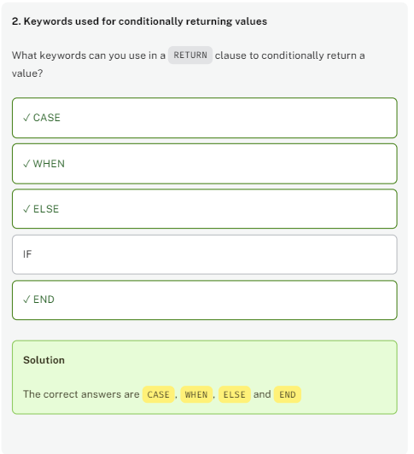

# Conditionally Returning Data (challenge)

## Conditionally returning values for rows

Here is a query that returns the movies that Charlie Chaplin has acted in and the runtime for the movie.

**cypher**

CopyRun

MATCH (m:Movie)<-[:ACTED_IN]-(p:Person)

WHERE p.name = 'Charlie Chaplin'

RETURN m.title AS movie,

*// Add CASE clause code here*

m.runtime AS runtime

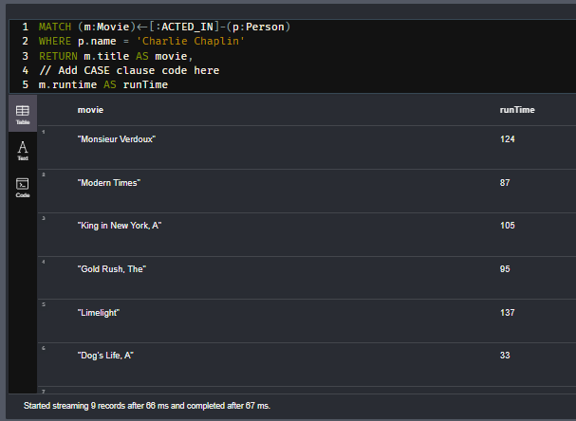

Modify this query to return "Short" for runTime if the movie’s runtime is < 120 (minutes) and "Long" for runTime if the movie’s runtime is >= 120.

## Solution-

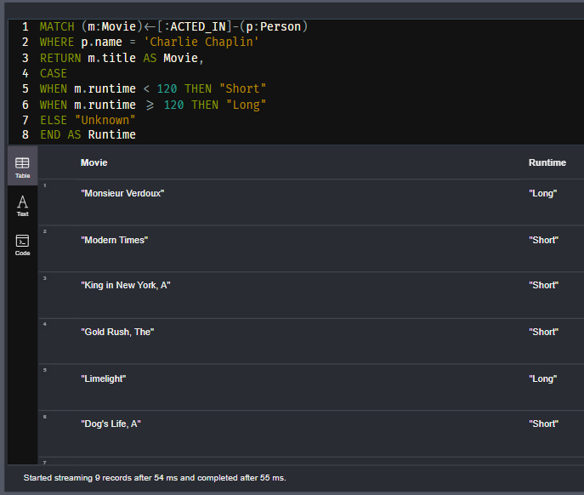

# Module 3: Working with Cypher Data

## Module Overview

You have learned more about filtering queries and some ways that you can control how results are returned. In the queries you have written, you have seen numeric, string, date, and list types of data in the graph. You have used both string and numeric Cypher functions and methods to modify results returned.

In this module, you will learn:

* How aggregation works.
* How to create and work with lists.
* How to work with dates and times.

# Aggregating Data

Youtube video: <https://youtu.be/TFz20_OFZ_s>

Transcript-

## Aggregation in Cypher

In this lesson you will learn how aggregation works in a Cypher statement and how to work with properties that contain multiple values.

## Using **count()** to aggregate data

Cypher has a count() function that you can use to perform a count of nodes, relationships, paths, rows during query processing. When you aggregate in a Cypher statement, this means that the query must process all patterns in the MATCH clause to complete the aggregation to either return results or perform the next part of the query.

Here is an example:

**cypher**

CopyRun

MATCH (a:Person)-[:ACTED_IN]->(m:Movie)

WHERE a.name = 'Tom Hanks'

RETURN a.name AS actorName,

count(*) AS numMovies

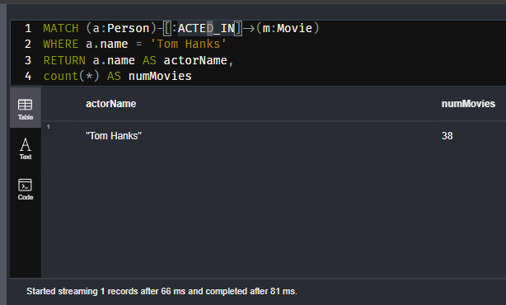

This query returns the number of movies Tom Hanks acted in.

Here is another example:

**cypher**

CopyRun

MATCH (a:Person)-[:ACTED_IN]->(m:Movie)<-[:DIRECTED]-(d:Person)

RETURN a.name AS actorName,

d.name AS directorName,

count(*) AS numMovies

ORDER BY numMovies DESC

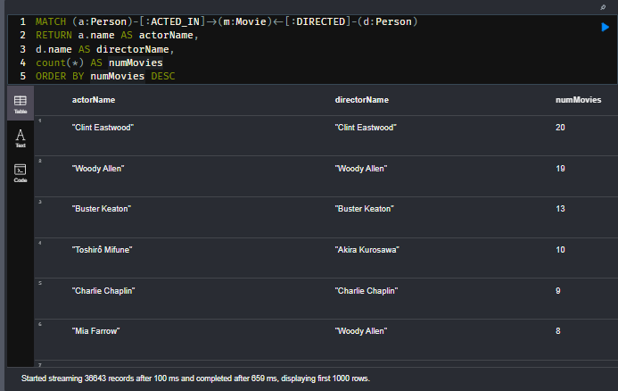

In this query we can see that actors and directors worked together in the same movie and how many collaborations there were.

## Eager aggregation

When you aggregate in a Cypher statement, the query must process all patterns in the MATCH clause to complete the aggregation to return results. This is called eager aggregation.

Here is an example:

**cypher**

CopyRun

MATCH (a:Person)-[:ACTED_IN]->(m:Movie)<-[:DIRECTED]-(d:Person)

RETURN a.name, d.name,

count(*) AS numMovies

ORDER BY numMovies DESC

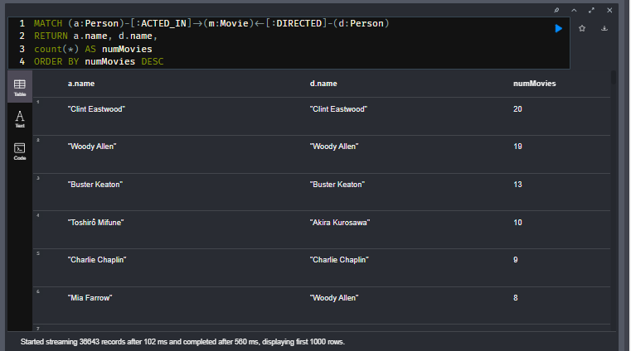

The query engine processes all nodes and relationships in the pattern so that it can perform a count of all movies for a particular actor/director pair in the graph. Then, it returns the results grouped by the name of the director and actor pair.

For this query:

* Clint Eastwood acted in and directed 20 movies.
* Woody Allen acted in and directed 19 movies.
* Adam Sandler acted in the same 8 movies that Dennis Dugan directed.

Aggregation in Cypher is different from aggregation in SQL. In Cypher, you need not specify a grouping key. As soon as an aggregation function like count() is used, all non-aggregated result columns become grouping keys.

The grouping is implicitly done, based upon the fields in the RETURN clause.

### Note about the count() function-

If you specify count(n), the graph engine calculates the number of non-null occurrences of n. If you specify count(*), the graph engine calculates the number of rows retrieved, including those with null values.

## Lists in the graph

You have already seen data in the graph that is stored as lists:

**cypher**

CopyRun

MATCH (m:Movie)

RETURN m.languages AS languages,

m.countries AS countries

LIMIT 10

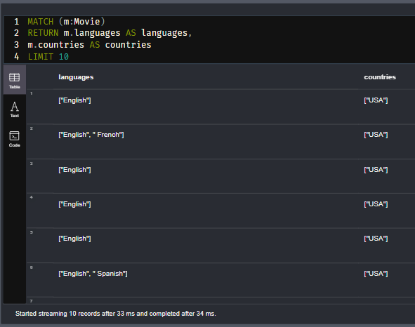

For this query, notice that these lists are shown in square brackets and each element of the list is separated by a comma. These lists contain a set of strings.

## Returning a list

You can return a list by specifying the square brackets:

**cypher**

CopyRun

MATCH (p:Person)

RETURN p.name, [p.born, p.died] AS lifeTime

LIMIT 10

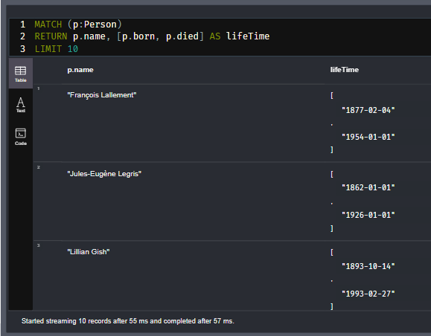

This query returns the name, and the lifeTime list that includes the born and died values for each person.

## Using collect() to create a list

Cypher has a built-in aggregation function, collect() that enables you to aggregate values into a list. The value can be any expression, for instance a property value, a node, or result of a function or operation.

**cypher**

CopyRun

MATCH (a:Person)-[:ACTED_IN]->(m:Movie)

RETURN a.name AS actor,

count(*) AS total,

collect(m.title) AS movies

ORDER BY total DESC LIMIT 10

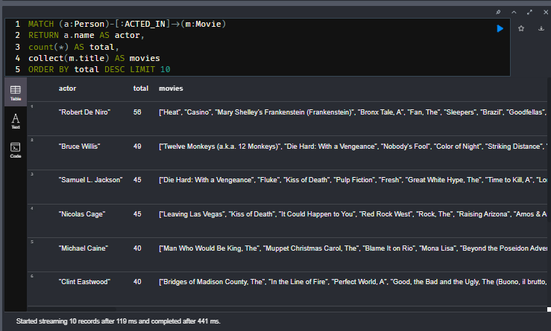

This query returns a list of movie titles associated with each actor. The rows are presented such that actors with the greatest number of titles are returned first.

## Eliminating duplication in lists

Just as you have learned to eliminate duplication in data returned using DISTINCT, you can also eliminate duplication in a list.

Here is a query that has duplication in its result:

**cypher**

CopyRun

MATCH (a:Person)-[:ACTED_IN]->(m:Movie)

WHERE m.year = 1920

RETURN collect(m.title) AS movies,

collect( a.name) AS actors

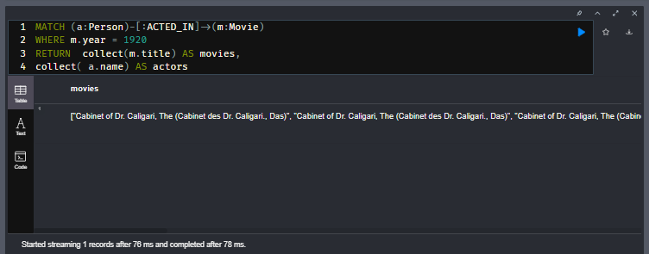

When this query executes, it returns duplicate titles in the Movies list.

You can eliminate duplication in the list as follows:

**cypher**

CopyRun

MATCH (a:Person)-[:ACTED_IN]->(m:Movie)

WHERE m.year = 1920

RETURN collect( DISTINCT m.title) AS movies,

collect( a.name) AS actors

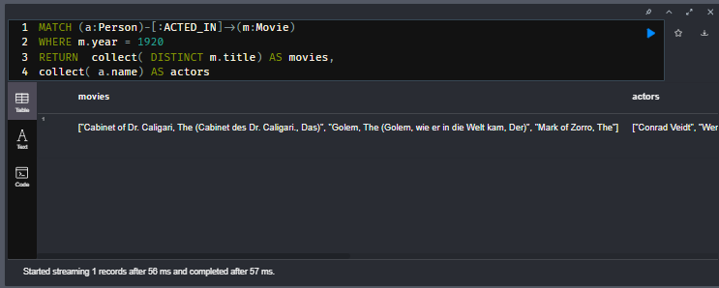

## Collecting nodes

Rather than collecting the values of the title properties for movies, you can collect the nodes. For this simple query, it is the same visual result as returning m, but for more complex queries, you will learn later in this course that collecting nodes and using them for a later step of the query is useful.

**cypher**

CopyRun

MATCH (p:Person)-[:ACTED_IN]->(m:Movie)

WHERE p.name ='Tom Cruise'

RETURN collect(m) AS tomCruiseMovies

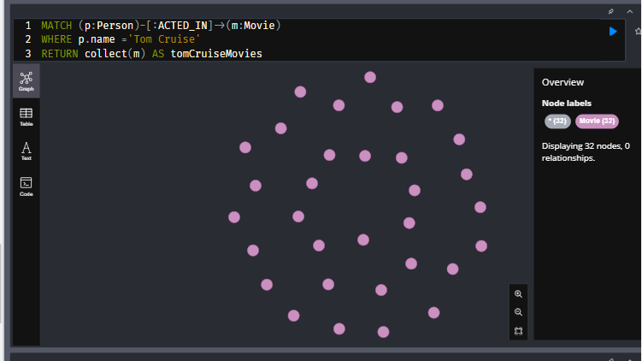

This query returns a list of all Movie nodes for Tom Cruise. In table view, you can see that the returned data is a list.

If you were to replace RETURN collect(m) AS `tomCruiseMovies clause with RETURN m, you would see that in table view the returned data is no longer a list.

## Accessing elements of a list

You can access particular elements of the list using the [index-value] notation where a list begins with index 0.

In this example we return the first cast member for each movie.

**cypher**

CopyRun

MATCH (a:Person)-[:ACTED_IN]->(m:Movie)

RETURN m.title AS movie,

collect(a.name)[0] AS castMember,

size(collect(a.name)) as castSize

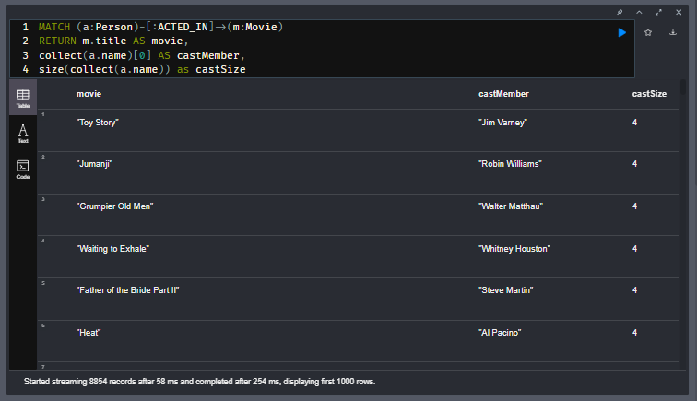

You can also return a slice of a collection.

**cypher**

CopyRun

MATCH (a:Person)-[:ACTED_IN]->(m:Movie)

RETURN m.title AS movie,

collect(a.name)[2..] AS castMember,

size(collect(a.name)) as castSize

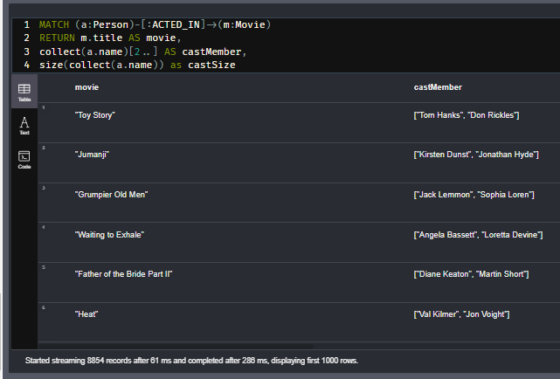

This query returns the second to the end of the list names of actors.

You can read about the many ways you can access and work with lists in Cypher such as using head(), tail(), etc. in the [**Neo4j Cypher Manual**](https://neo4j.com/docs/cypher-manual/current/functions/list/).

## Other aggregating functions

There are more aggregating functions that may be useful for your application such as:

* min()
* max()
* avg()
* stddev()
* sum()

These are described in the [**Aggregating Functions section of the Neo4j Cypher Manual**](https://neo4j.com/docs/cypher-manual/current/functions/aggregating/).

## **count()** versus **size()**

You can either use count() to count the number of rows, or alternatively, you can return the size of the collected results. The size() function returns the number of elements in a list.

Here we use size() to return the number of elements in the list:

**cypher**

CopyRun

MATCH (actor:Person)-[:ACTED_IN]->(m:Movie)<-[:DIRECTED]-(director:Person)

RETURN actor.name, director.name,

size(collect(m)) AS collaborations,

collect(m.title) AS movies

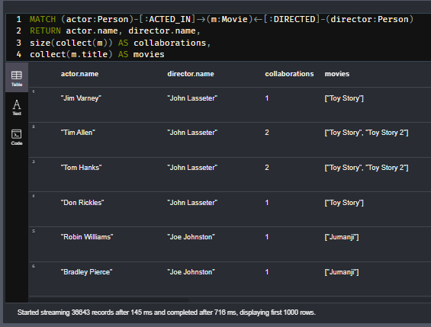

As you gain more experience with query tuning, you will learn that count() may be more efficient because it gets its values for node counts or relationships from a node from the internal count store of the graph.

If we profile this query (run it at least twice):

**cypher**

CopyRun

*//Query 1*

PROFILE MATCH (g:Genre)<-[:IN_GENRE]-(m)

RETURN g.name AS genre,

size(collect(m)) AS numMovies

ORDER BY size(collect(m)) DESC

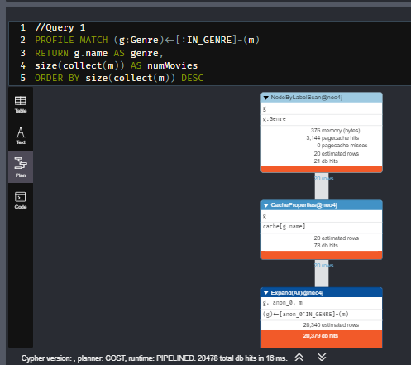

It returns the same results (table view) as this query. This query uses count():

**cypher**

CopyRun

*//Query 2*

PROFILE MATCH (g:Genre)<-[:IN_GENRE]-(m:Movie)

RETURN g.name AS genre,

count(m) AS numMovies

ORDER BY count(m) DESC

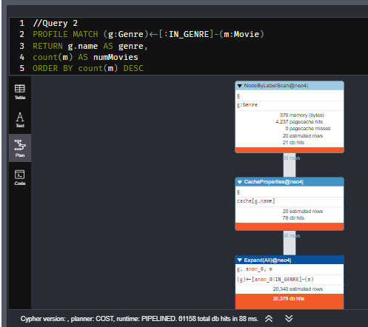

The Query 1 has different performance characteristics. You should always test the performance of your queries before you deploy your application.

And you can answer the question, What genre of movies is the highest and how many movies are in that genre?

**cypher**

CopyRun

MATCH (g:Genre)<-[:IN_GENRE]-(m:Movie)

RETURN g.name AS genre,

count(m) AS numMovies

ORDER BY count(m) DESC LIMIT 1

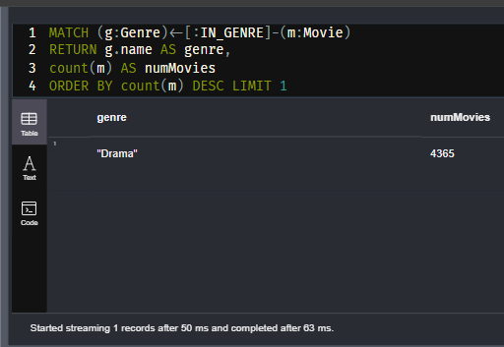

## List comprehension

You can create a list by evaluating an expression that tests for list inclusion.

Here is an example:

**cypher**

CopyRun

MATCH (m:Movie)

RETURN m.title as movie,

[x IN m.countries WHERE x CONTAINS 'USA' OR x CONTAINS 'Germany']

AS country LIMIT 500

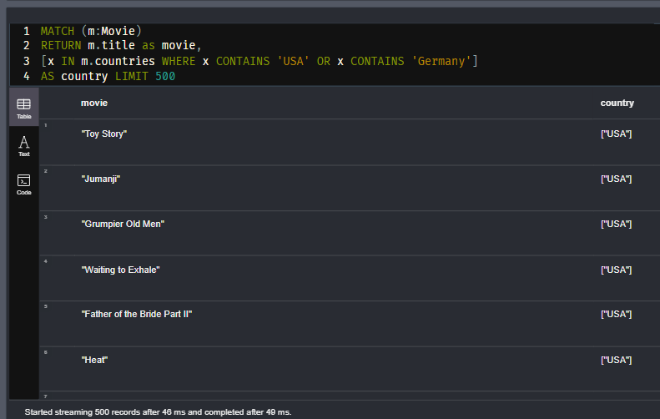

## Pattern comprehension

Pattern comprehension is a very powerful way to create lists without changing the cardinality of the query. It behaves like an OPTIONAL MATCH combined with collect().

Here is an example:

**cypher**

CopyRun

MATCH (m:Movie)

WHERE m.year = 2015

RETURN m.title,

[(dir:Person)-[:DIRECTED]->(m) | dir.name] AS directors,

[(actor:Person)-[:ACTED_IN]->(m) | actor.name] AS actors

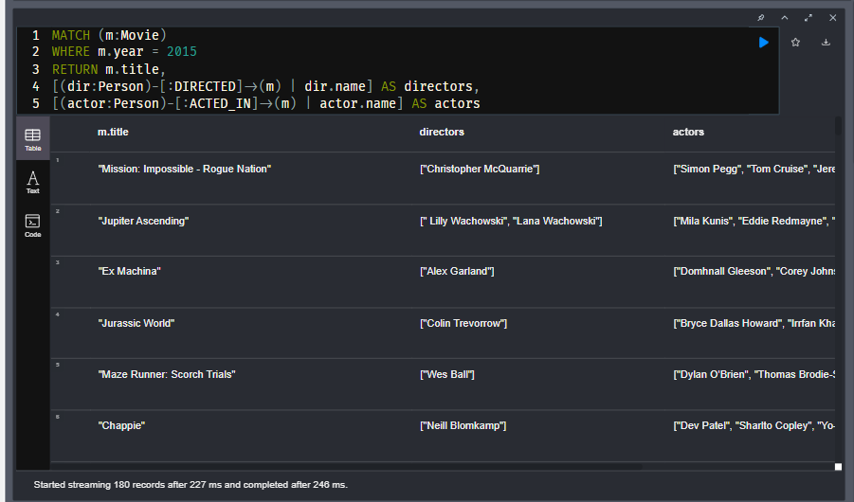

Notice that for pattern comprehension we specify the list with the square braces to include the pattern followed by the pipe character to then specify what value will be placed in the list from the pattern.

[<pattern> | value]

This query returns the movies released in 2015. Each row contains the title of the movie, the list of director names, and the list of actor names.

Here is another example of using pattern comprehension to create a list where we specify a filter for the pattern.

**cypher**

CopyRun

MATCH (a:Person {name: 'Tom Hanks'})

RETURN [(a)-->(b:Movie)

WHERE b.title CONTAINS "Toy" | b.title + ": " + b.year]

AS movies

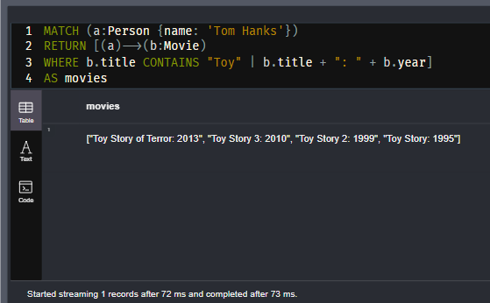

For this pattern comprehension, the title of the movie is concatenated with the year of the movie as a value to add as an element of the list returned.

## Working with maps

A Cypher map is list of key/value pairs where each element of the list is of the format 'key': value. A node or relationship can have a property that is a map.

For example, a map of months and the number of days per month could be:

{Jan: 31, Feb: 28, Mar: 31, Apr: 30 , May: 31, Jun: 30 , Jul: 31, Aug: 31, Sep: 30, Oct: 31, Nov: 30, Dec: 31}

Using this map, we can return the value for one of its elements:

**cypher**

CopyRun

RETURN {Jan: 31, Feb: 28, Mar: 31, Apr: 30 ,

May: 31, Jun: 30 , Jul: 31, Aug: 31, Sep: 30,

Oct: 31, Nov: 30, Dec: 31}['Feb'] AS daysInFeb

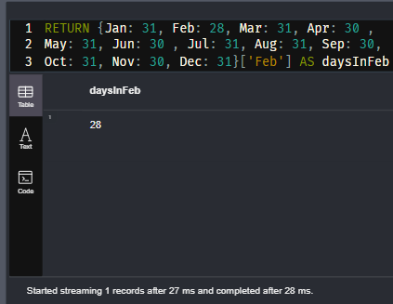

Here we use the key, 'Feb' to access its value.

Alternatively, you can access a value with the '.' notation:

**cypher**

CopyRun

RETURN {Jan: 31, Feb: 28, Mar: 31, Apr: 30 ,

May: 31, Jun: 30 , Jul: 31, Aug: 31, Sep: 30,

Oct: 31, Nov: 30, Dec: 31}.Feb AS daysInFeb

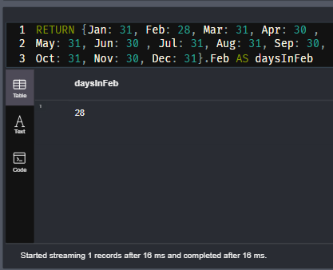

And you can return a list of keys of a map as follows:

**cypher**

CopyRun

RETURN keys({Jan: 31, Feb: 28, Mar: 31, Apr: 30 ,

May: 31, Jun: 30 ,Jul: 31, Aug: 31, Sep: 30,

Oct: 31, Nov: 30, Dec: 31}) AS months

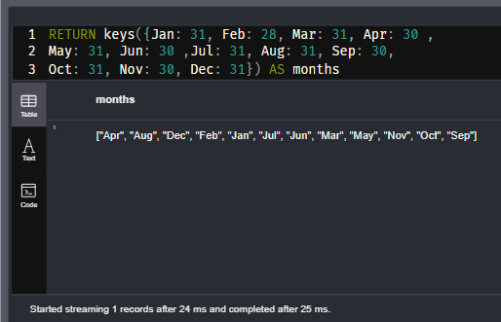

A node in the graph, when returned in Neo4j Browser is a map, when displayed as table rows. For example, a Movie node:

**cypher**

CopyRun

MATCH (m:Movie)

RETURN m LIMIT 1

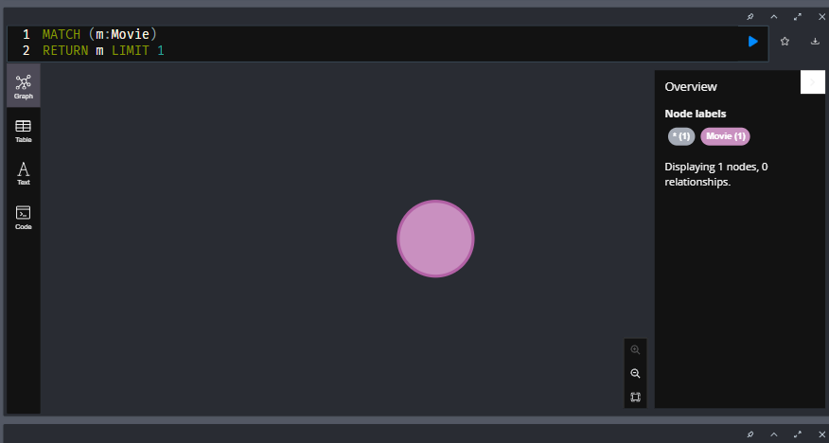

Read more in the [**Neo4j Cypher Manual**](https://neo4j.com/docs/cypher-manual/current/values-and-types/maps/) about maps.

## Map projections

Map projections are when you can use retrieved nodes to create or return some of the information in the nodes. A Movie node can have the properties title, released, and tagline. Suppose we want to return the Movie node information, but without the tagline property? You can do so using map projections:

**cypher**

CopyRun

MATCH (m:Movie)

WHERE m.title CONTAINS 'Matrix'

RETURN m { .title, .released } AS movie

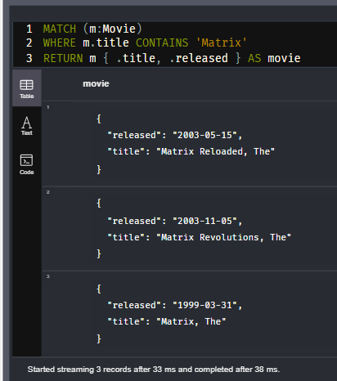

## Quiz-

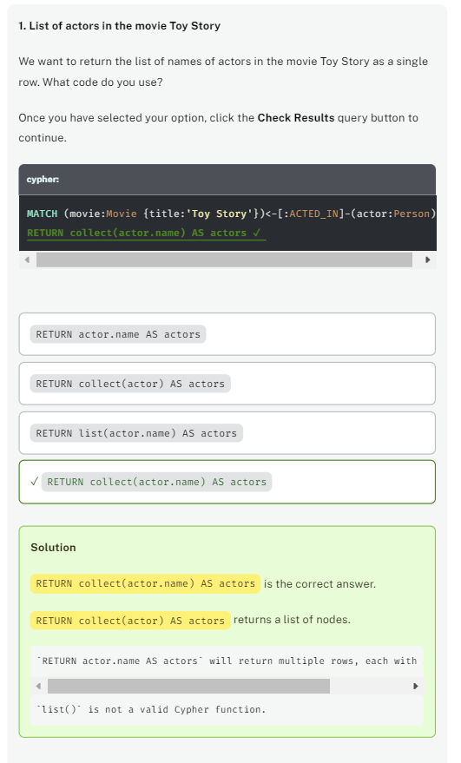

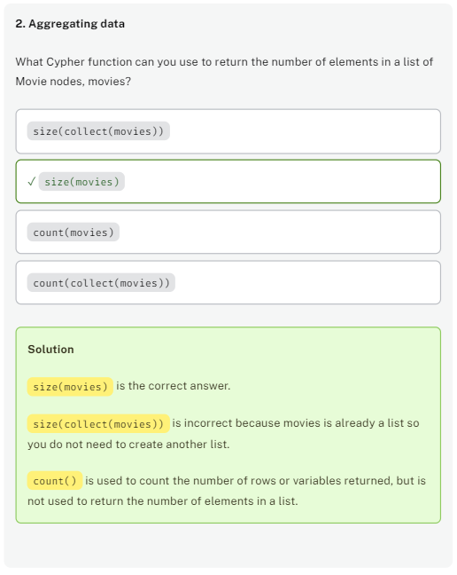

# Counting Results (challenge)

## Counting results

## Most active director?

Using count() write a query to return the number of movies a person directed.

What is the highest number of movies a director directed in our graph?

## Solution-

**cypher**

CopyRun

MATCH (d:Director)-[:DIRECTED]-(m)

RETURN d.name AS Director,

count(*) AS numMovies

ORDER BY numMovies DESC LIMIT 5

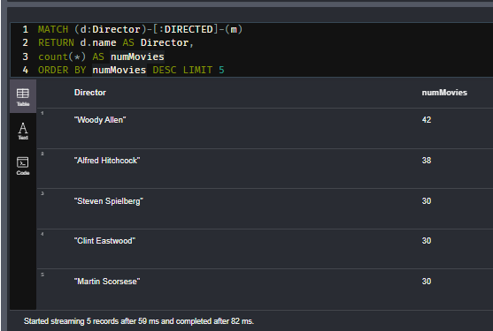

## Alternate Solution (less efficient)-

MATCH (p:Person)-[:DIRECTED]->(m:Movie)

RETURN p.name, count(m.movieId)

ORDER BY count(m.movieId) DESC LIMIT 10

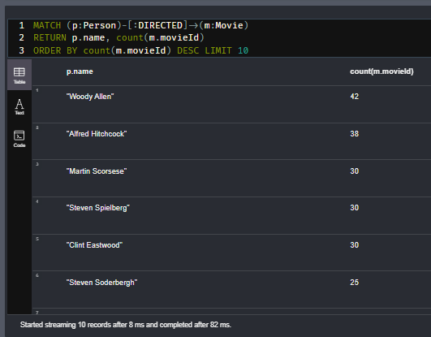

# Creating Lists (challenge)

## Largest Number of Actors

Write and execute a query to return the list of actors for a movie with a given title. Order and limit the results so that the movie title with the largest number of actors is returned.

**Hin**t: There are multiple movies with the same title so you are aggregating by the movie title and not the movieID.

What movie title had the largest number of actors? (Enter a case-sensitive string for the movie title.)

## Solution-

**cypher**

CopyRun

MATCH (a:Actor)-[:ACTED_IN]->(m:Movie)

RETURN m.title AS movie,

collect(a.name) AS actors,

size(collect(a.name)) AS num

ORDER BY num DESC LIMIT 1

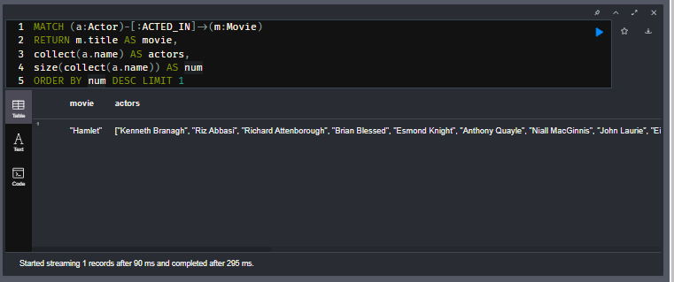

## Alternate Solution-

MATCH (a:Actor)-[:ACTED_IN]-(m:Movie)

RETURN m.title, COLLECT(a.name) AS actors_list

ORDER BY SIZE(actors_list) DESC LIMIT 1

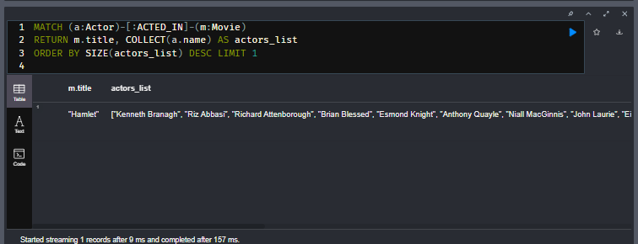

# How Many Actors? (challenge)

## Another question

Using the query you just wrote, answer this question:

## How Many Actors?

Use the query you just wrote. For the largest cast, how many actors were in the movies with the title "Hamlet"?

## Solution-

MATCH (a:Actor)-[:ACTED_IN]->(m:Movie)

RETURN m.title AS movie,

collect(a.name) AS actors,

size(collect(a.name)) AS num

ORDER BY num DESC LIMIT 1

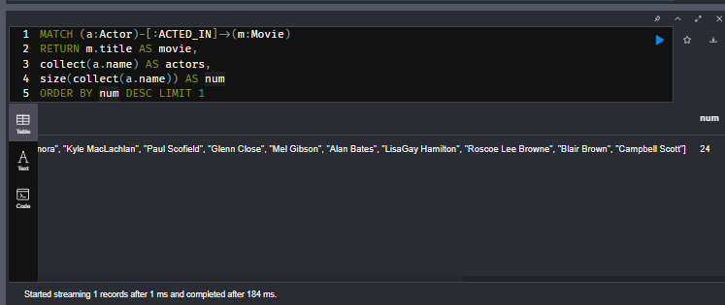

# Working with Dates and Times

Youtube video: <https://youtu.be/x5Q63tnk6hU>

Transcript-

## Date and Time data in Cypher

Cypher has these basic formats for storing date and time data.

**cypher**

CopyRun

RETURN date(), datetime(), time()

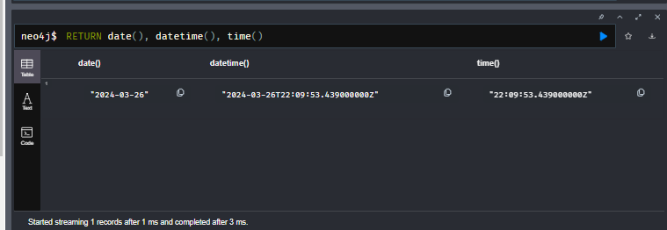

There are a number of other types of data such as Time, LocalTime, LocalDateTime, Timestamp, and Duration which are described in the [**Temporal Functions section of the Neo4j Cypher Manual**](https://neo4j.com/docs/cypher-manual/current/functions/temporal/).

For training purposes we will create some date/time properties. Execute the following code to create a node in the graph containing these types:

**cypher**

CopyRun

MERGE (x:Test {id: 1})

SET x.date = date(),

x.datetime = datetime(),

x.time = time()

RETURN x

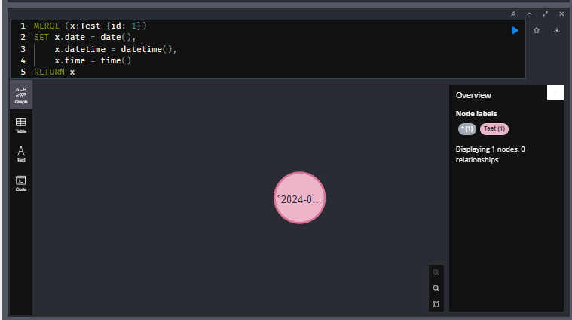

Next, execute this code that will show the types of the properties in the graph:

**cypher**

CopyRun

CALL apoc.meta.nodeTypeProperties()

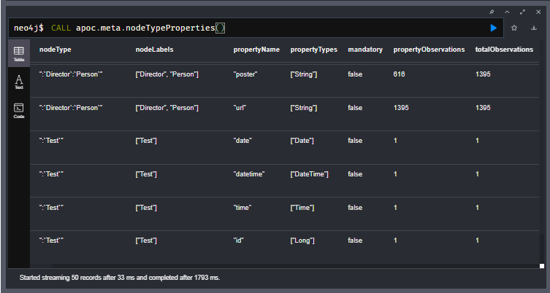

Notice the types for properties stored in the graph.

The graph has Person data of type Date and you have added properties of type DateTime and Time.

## Extracting components of a date or datetime

You can access the components of a date or datetime property:

**cypher**

CopyRun

MATCH (x:Test {id: 1})

RETURN x.date.day, x.date.year,

x.datetime.year, x.datetime.hour,

x.datetime.minute

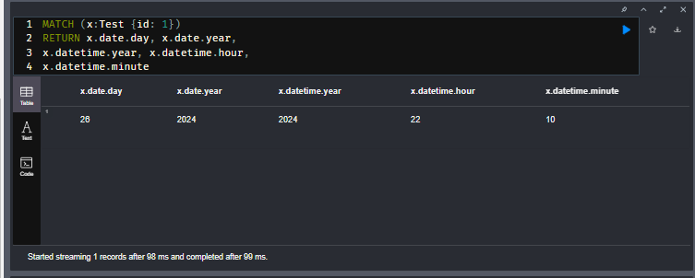

## Setting date values

You can use a string to set a value for a date:

**cypher**

CopyRun

MATCH (x:Test {id: 1})

SET x.date1 = date('2022-01-01'),

x.date2 = date('2022-01-15')

RETURN x

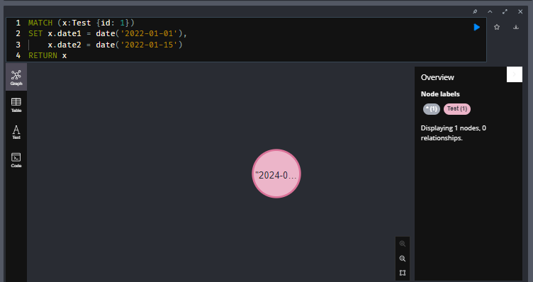

You can set a Date property using a <ISO-date> string.

## Setting datetime values

You can use a string to set a value for a datetime:

**cypher**

CopyRun

MATCH (x:Test {id: 1})

SET x.datetime1 = datetime('2022-01-04T10:05:20'),

x.datetime2 = datetime('2022-04-09T18:33:05')

RETURN x

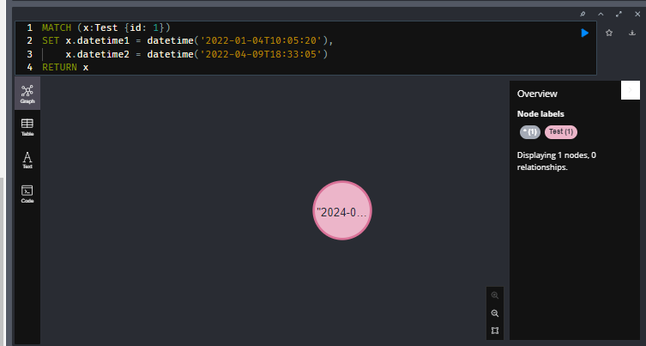

You can set a Datetime property using a <ISO-datetime> string.

## Working with durations

A duration is used to determine the difference between two date/datetime values or to add or subtract a duration to a value.

This code returns the duration between date1 and date2 in the graph:

**cypher**

CopyRun

MATCH (x:Test {id: 1})

RETURN duration.between(x.date1,x.date2)

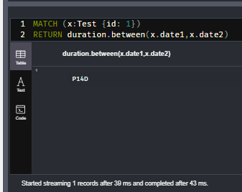

It returns a duration value that represents the days and months and times between the two values. In this case, the duration between date1 and date2 is 14 days.

We can return the duration in days between two datetime values:

**cypher**

CopyRun

MATCH (x:Test {id: 1})

RETURN duration.inDays(x.datetime1,x.datetime2).days

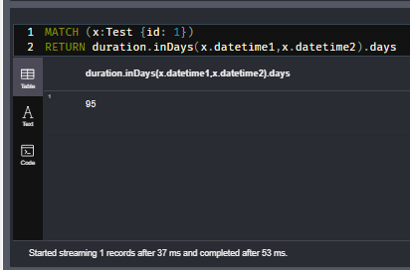

We can add a duration of 6 months:

**cypher**

CopyRun

MATCH (x:Test {id: 1})

RETURN x.date1 + duration({months: 6})

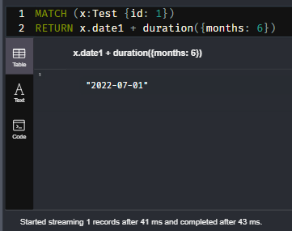

## Using APOC to format dates and times

The APOC library has many useful functions for working with all types of data.

Here is one way you can use APOC to format a datetime:

**cypher**

CopyRun

MATCH (x:Test {id: 1})

RETURN x.datetime as Datetime,

apoc.temporal.format( x.datetime, 'HH:mm:ss.SSSS')

AS formattedDateTime

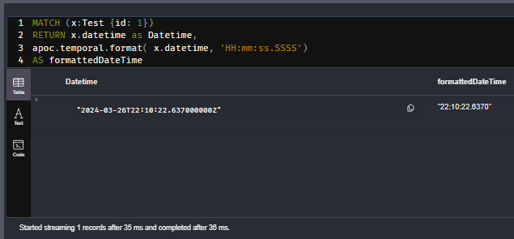

Here is another example:

**cypher**

CopyRun

MATCH (x:Test {id: 1})

RETURN apoc.date.toISO8601(x.datetime.epochMillis, "ms")

AS iso8601

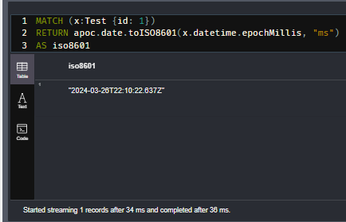

You can also use apoc.temporal.toZonedTemporal() for parsing arbitrary formatted temporal values with a format string.

## Quiz-

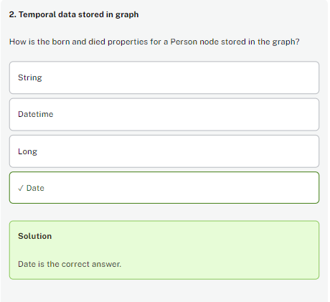

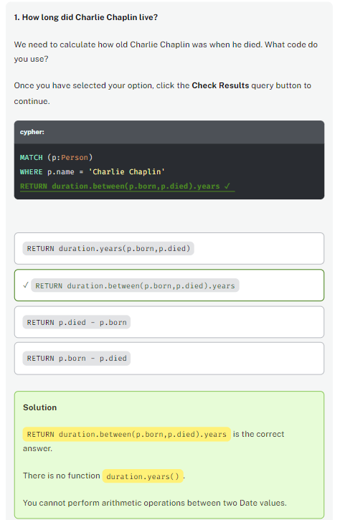

# Duration (challenge)

## Working with dates and times

In the previous lesson, you executed code to create a Test node.

Execute this code to create or update the Test node with these date and datetime values:

**cypher**

CopyRun

MERGE (x:Test {id: 1})

SET

x.date = date(),

x.datetime = datetime(),

x.timestamp = timestamp(),

x.date1 = date('2022-04-08'),

x.date2 = date('2022-09-20'),

x.datetime1 = datetime('2022-02-02T15:25:33'),

x.datetime2 = datetime('2022-02-02T22:06:12')

RETURN x

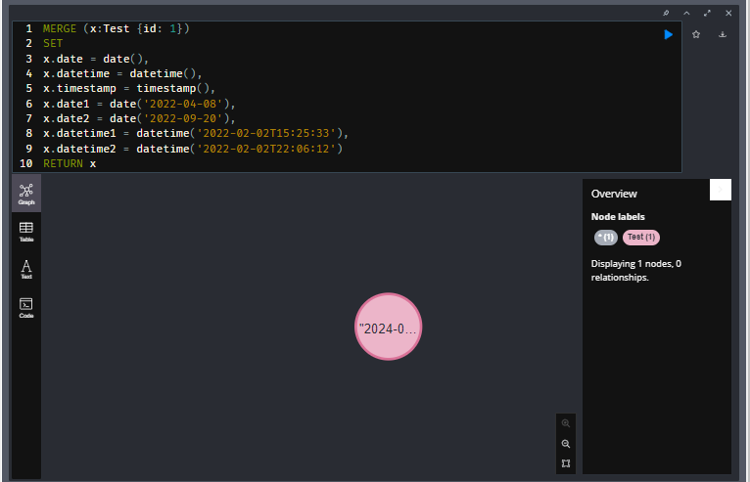

## Calculate days between two dates

Write a query to retrieve this Test node and calculate the number of days between date1 and date2.

Enter the number of days:

## Solution

// calculate the duration

MATCH (x:Test)

RETURN duration.inDays(x.date1,x.date2).days

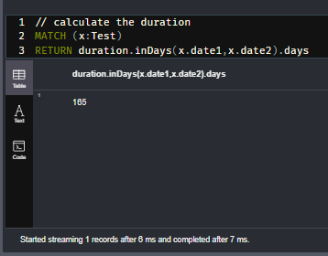

# Duration in Minutes

## Working with dates and times

## Calculate minutes between two datetime values

Write a query to retrieve this Test node and calculate the number of minutes between datetime1 and datetime2.

Enter the number of minutes:

## Solution

// calculate the duration in minutes

MATCH (x:Test)

RETURN duration.between(x.datetime1,x.datetime2).minutes

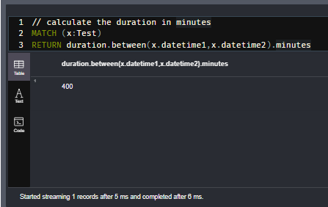

# Module 4: Graph Traversal

## Module Overview

You have learned how to write queries that use multiple MATCH clauses as well as multiple patterns. You have also learned that you can use EXPLAIN and PROFILE to gain more insight into the steps that occur during a query.

In this module, you will learn:

* How the graph engine traverses the graph during a query.
* How traversal works for variable-length patterns.

Youtube video: <https://youtu.be/LY5g1-ibqNk>

Transcript-

# Graph Traversal

As a developer, you must understand what an execution plan is, how to interpret it, and most importantly, how to make it performant. To understand the execution plan, you must understand how a query starts and then how it is processed as the nodes are traversed in the graph.

## Anchor of a query

When the execution plan is created, it determines the set of nodes that will be the starting points for the query. The anchor for a query is often based upon a MATCH clause. The anchor is typically determined by meta-data that is stored in the graph or a filter that is provided inline or in a WHERE clause. The anchor for a query will be based upon the fewest number of nodes that need to be retrieved into memory.

Next, we will look at some examples of how queries are anchored based upon the hueristics used by the graph engine.

**cypher**

CopyRun

PROFILE MATCH (p:Person)-[:ACTED_IN]->(m)

RETURN p.name, m.title LIMIT 100

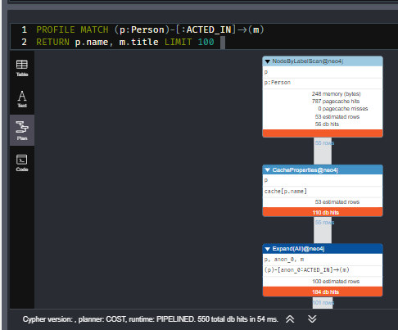

In the above query, the Person nodes are the anchor for the query. This is because there are a total of 28,863 nodes in the graph which is what m represents. There are only 19,047 Person nodes so the execution will retrieve fewer nodes if it anchors with the Person nodes.

**cypher**

CopyRun

PROFILE MATCH (p:Person)-[:ACTED_IN]->(m:Movie)

RETURN p.name, m.title LIMIT 100

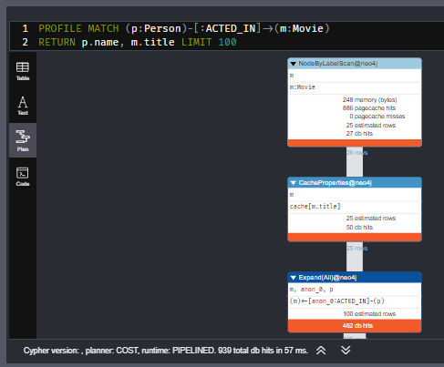

In the above query the Movie nodes will be the anchor for the query because there are fewer Movie nodes (9,125) than Person nodes (19,047).

**cypher**

CopyRun

PROFILE MATCH (p:Person)-[:ACTED_IN]->(m:Movie)

WHERE p.name = 'Eminem'

RETURN p.name, m.title

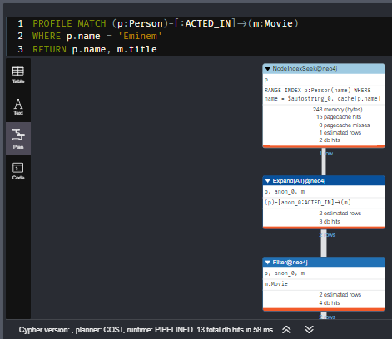

In the above query, a filter is specified which reduces the number of nodes that will be retrieved for the Person node. Satisfying the filter is the anchor for the query. If the Person nodes has an index on name, it only retrieves one record. If there is no index, it needs to scan/filter all Person nodes for the name property.

## Multiple anchors

By default, an anchor set of nodes is determined by the metadata related to the query path and WHERE clauses to filter the query. In some cases you may have more than one set of anchor nodes.

**cypher**

CopyRun

PROFILE

MATCH (p1:Person)-[:ACTED_IN]->(m1)

MATCH (m2)<-[:ACTED_IN]-(p2:Person)

WHERE p1.name = 'Tom Hanks'

AND p2.name = 'Meg Ryan'

AND m1 = m2

RETURN m1.title

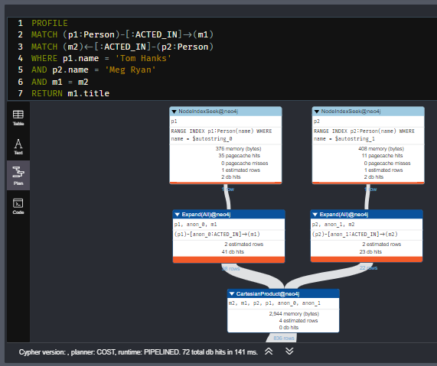

In this query, all p1 nodes are retrieved as well as all p2 nodes. This query has two sets of anchor nodes. It retrieves the anchor nodes before the equality filter is applied. The query planner tries to apply filters as early as possible to reduce cardinality (number of rows).

## Expand to follow paths

After the anchor nodes have been retrieved, the next step if the query specifies a path is to follow the path. The loaded, initial nodes that are part of the anchor set have pointers to relationships that point to nodes on the other end of the relationships.

The goal here is to eliminate paths from the nodes in memory to nodes that will need to be retrieved. This is where specificity in the relationship types is important in your data model.

**cypher**

CopyRun

PROFILE MATCH (m:Movie)<--(p:Person)

WHERE p.name = 'Clint Eastwood'

RETURN m.title

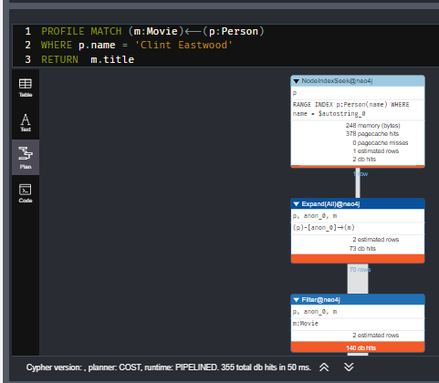

This query expands to 70 rows because Clint Eastwood has 70 relationships to movies.

**cypher**

CopyRun

PROFILE MATCH (m:Movie)<-[:DIRECTED]-(p:Person)

WHERE p.name = 'Clint Eastwood'

RETURN m.title

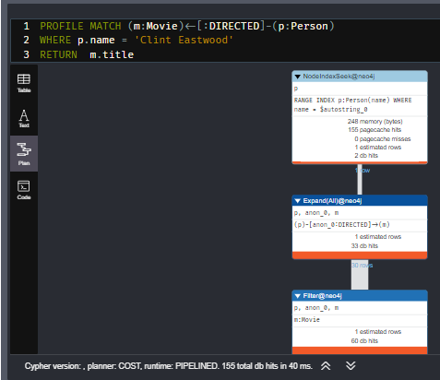

This query expands to fewer rows because Clint Eastwood has fewer DIRECTED relationships to movies.

In addition, the expansion may lead to the need to inspect properties of the relationship and/or the properties of the Movie node. This inspection means that the nodes are brought into memory and possibly eliminated from the nodes in memory after they have been retrieved.

Cypher queries with multiple MATCH statements may execute differently than what you may expect. You should always profile your queries to understand how the graph is traversed.

## Basic query traversal

Now let’s learn a little more about how traversal works in Neo4j.

With this query:

**cypher**

CopyRun

MATCH (p:Person)-[:ACTED_IN]->(m:Movie)

WHERE p.name = 'Eminem'

RETURN m.title AS movies

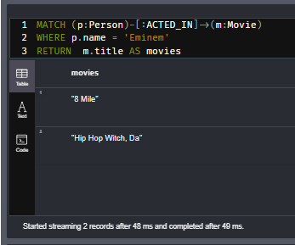

Here is what happens when this query executes:



1. The Eminem Person node is retrieved.
2. Then the first ACTED_IN relationship is traversed to retrieve the Movie node for 8 Mile.
3. Then the second ACTED_IN relationship is traversed to retrieve the Movie node for Hip Hop Witch, Da.
4. The title property is retrieved so that the results can be returned.

## Query traversal using multiple patterns

Here is another query that contains two patterns:

**cypher**

CopyRun

MATCH (p:Person)-[:ACTED_IN]->(m:Movie),

(coActors:Person)-[:ACTED_IN]->(m)

WHERE p.name = 'Eminem'

RETURN m.title AS movie ,collect(coActors.name) AS cofactors

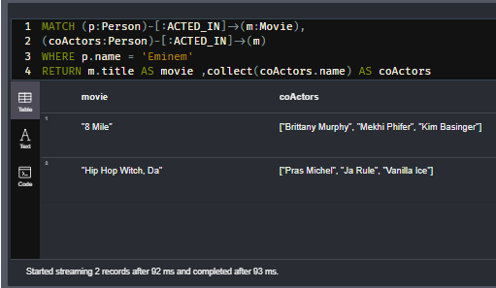

Here is what happens when this query executes:



1. For the first pattern in the query, the Eminem Person node is retrieved.
2. Then the first ACTED_IN relationship is traversed to retrieve the Movie node for 8 Mile.
3. The second pattern in the query is then used.
4. Each ACTED_IN relationship to the same 8 Mile movie is traversed to retrieve three co-actors.
5. If the ACTED_IN relationship has been traversed already, it is not traversed again.
6. Then the second ACTED_IN relationship is traversed to retrieve the Movie node for Hip Hop Witch, Da.
7. Each ACTED_IN relationship to the same Hip Hop Witch, Da movie is traversed to retrieve three co-actors.
8. The title property for the Movie node is retrieved so that the results can be returned.

Notice that for this query, a depth-first traversal occurs.

## Query traversal using multiple **MATCH** clauses

Here is another query that contains two MATCH clauses:

**cypher**

CopyRun

MATCH (p:Person)-[:ACTED_IN]->(m:Movie)

WHERE p.name = 'Eminem'

MATCH (allActors:Person)-[:ACTED_IN]->(m)

RETURN m.title AS movie, collect(allActors.name) AS allActors

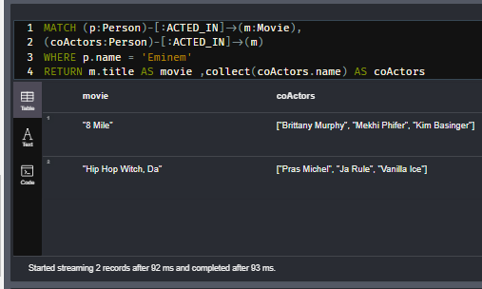

Here is what happens when this query executes:



1. For the first MATCH clause in the query, the Eminem Person node is retrieved.
2. Then the first ACTED_IN relationship is traversed to retrieve the Movie node for 8 Mile.
3. The second MATCH clause in the query is then executed.
4. Each ACTED_IN relationship to the same 8 Mile movie is traversed to retrieve all actors, including the relationship to the Eminem node.
5. Then the query returns back to the first MATCH clause to traverse the ACTED_IN relationship to the Hip Hop Witch, Da movie.
6. The second MATCH clause in the query is then executed.
7. Each ACTED_IN relationship to the same Hip Hop Witch, Da movie is traversed to retrieve all actors.

Notice that for this query, a depth-first traversal occurs just as it did for the previous query. The one difference in the outcome, however is that the Eminem node is added as a result of the second MATCH.

## Avoiding labels for better performance

Another graph optimization that you can take advantage of is to reduce labels used in your query patterns. Having a label for the anchor nodes in a pattern is good:

**cypher**

CopyRun

PROFILE MATCH (p:Person)-[:ACTED_IN]->(m:Movie)

WHERE p.name = 'Tom Hanks'

RETURN m.title AS movie

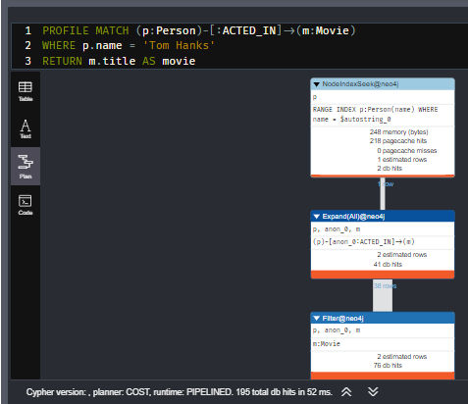

The Person label for the anchor node retrieval is good here, but the label for the other side of the pattern is unnecessary. Having the label on the non-anchor node forces a label check, which is really not necessary.

Here is a more performant way to do this query:

**cypher**

CopyRun

PROFILE MATCH (p:Person)-[:ACTED_IN]->(m)

WHERE p.name = 'Tom Hanks'

RETURN m.title AS movie

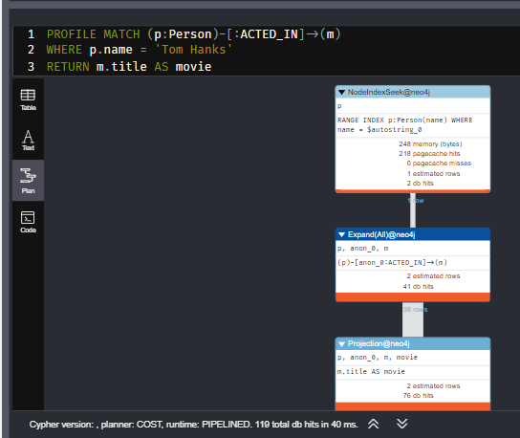

With this second query, you see that there are fewer db hits.

## Returning paths

In Neo4j Browser, when you return nodes, by default the relationships are visualized. For example, this query is visualized with its associated paths that were traversed for the query:

**cypher**

CopyRun

MATCH (person:Person)-[]->(movie)

WHERE person.name = 'Walt Disney'

RETURN person, movie

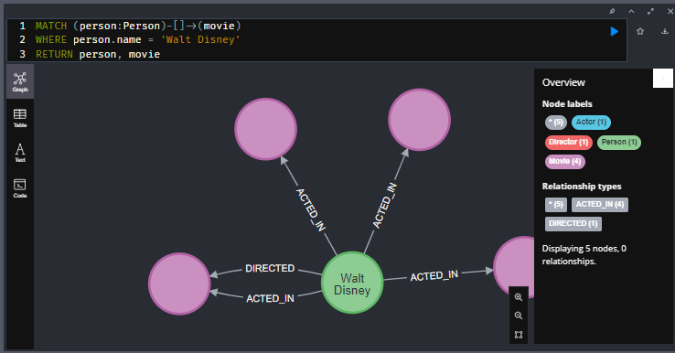

The visualization includes one Person node that is connected to four Movie nodes using five relationships. The objects that are returned (table view), are five rows where the Person node values are in each row and the one Movie node is repeated. There is no relationship information returned.

You can return paths in your query as follows:

**cypher**

CopyRun

MATCH p = ((person:Person)-[]->(movie))

WHERE person.name = 'Walt Disney'

RETURN p

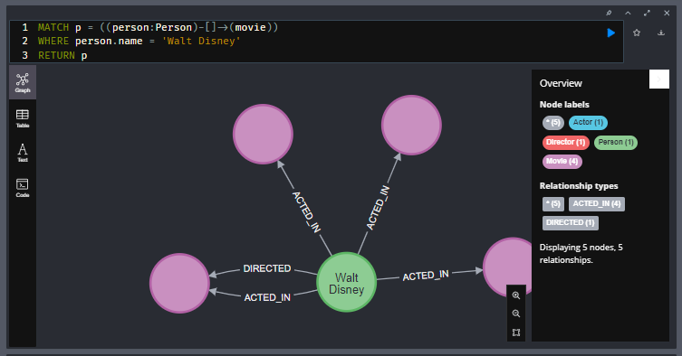

This query returns 5 paths. If you view the objects (table view in Neo4j Browser), you will see that each row returned represents the Person node, the Movie node, and the relationship.

In some applications, it may be useful to work with path objects. Cypher has some useful functions that can be used to analyze paths:

* length(p) returns the length of a path.
* nodes(p) returns a list containing the nodes for a path.
* relationships(p) returns a list containing the relationships for a path.

## Quiz-

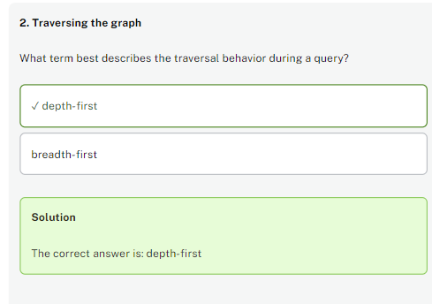

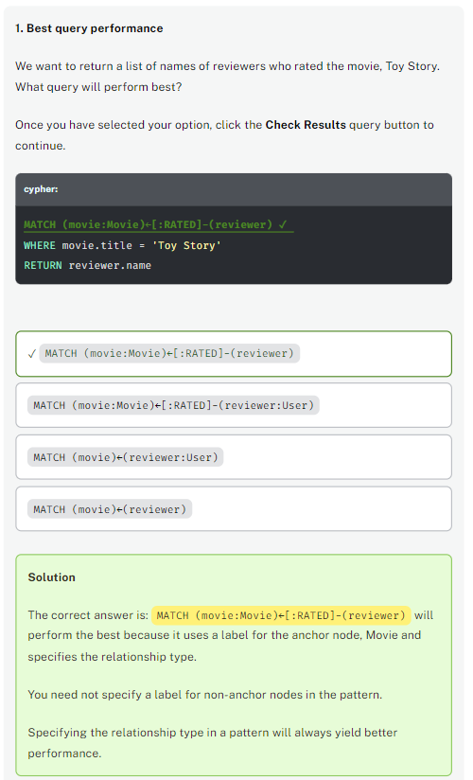

# Traversing the Graph (challenge)

## Finding co-actors

## Co-actors of Robert Blake

Given this query and what you have learned about graph traversal:

**cypher**

CopyRun

MATCH (p:Person {name: 'Robert Blake'})-[:ACTED_IN]->(m:Movie),

(coActors:Person)-[:ACTED_IN]->(m)

RETURN m.title, collect(coActors.name)

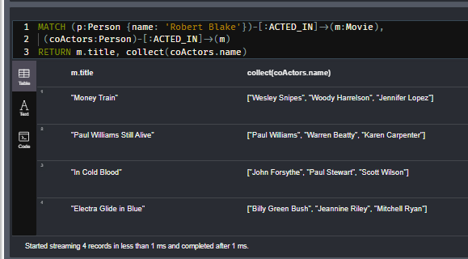

How many relationships are traversed to return the result?

## Solution-

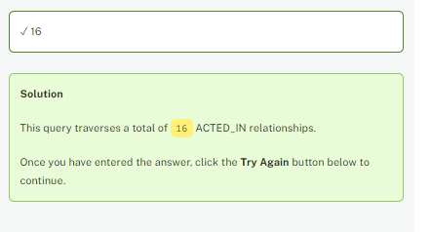

16 because 4 traversals from Robert Blake and the remaining 12 traversals from counting the number of co actors returned

# Relationships Traversed (challenge)

## Finding more co-actors

## Actors in movies that Robert Blake acted in

Given this query and what you have learned about graph traversal:

**cypher**

CopyRun

MATCH (p:Person {name: 'Robert Blake'})-[:ACTED_IN]->(m:Movie)

MATCH (allActors:Person)-[:ACTED_IN]->(m)

RETURN m.title, collect(allActors.name)

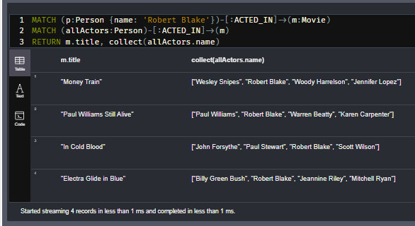

How many relationships are traversed to return the result?

## Solution-

Same logic as previous challenge

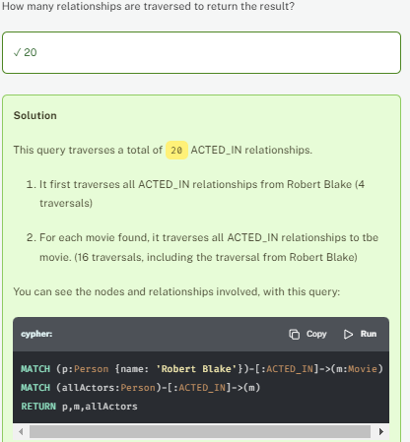

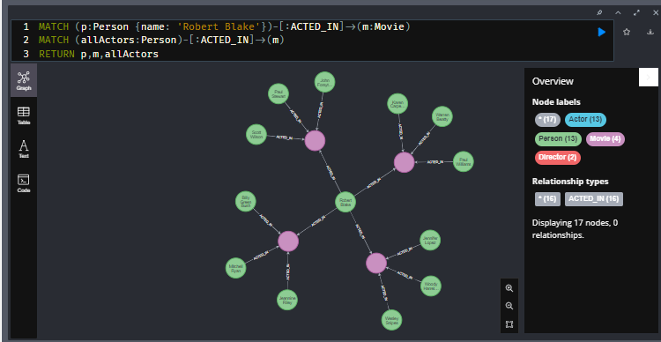

# Varying Length Traversal

Youtube video: <https://youtu.be/eS2nsu7qPh8>

Transcript-

Any graph that represents social networking, hierarchies, transport, flow, or dependency networks will most likely have multiple paths of varying lengths. Think of the connected relationship in LinkedIn and how connections are made by people connected to more people.

Here are two use cases for this type of traversal:

* Finding the shortest path between two nodes.
* Finding out how "close" nodes are to each other in the graph.

The [**Neo4j Graph Data Science Library**](https://neo4j.com/docs/graph-data-science/current/) has many methods you can call to discover these characteristics and patterns of the graph. In this training, we cover the basic connectedness between nodes that you can query with Cypher.

In Neo4j uniqueness of relationships is always adhered to. That is, there will never be two relationships of the same type and direction between two nodes. This enables Neo4j to avoid cycles or infinite loops in graph traversal.

## Shortest path

Cypher has a built-in function that returns the shortest path between any two nodes, if one exists.

**cypher**

CopyRun

MATCH p = shortestPath((p1:Person)-[*]-(p2:Person))

WHERE p1.name = "Eminem"

AND p2.name = "Charlton Heston"

RETURN p

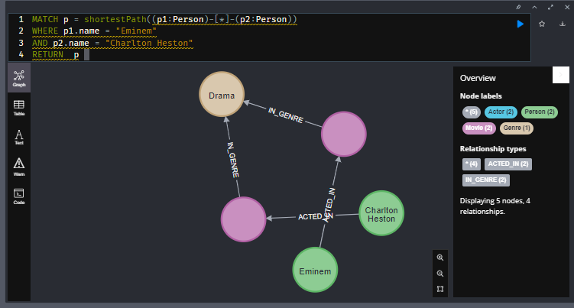

This query calculates and returns the shortest path between the Eminem node and the Charlton Heston node in the graph. Because nothing is specified for the relationship type, it finds the shortest path regardless of the relationship type. That is, Eminem is four hops away from Charlton Heston using the ACTED_IN and RATED relationships.

You can also limit the relationship types to a specific relationship:

**cypher**

CopyRun

MATCH p = shortestPath((p1:Person)-[:ACTED_IN*]-(p2:Person))

WHERE p1.name = "Eminem"

AND p2.name = "Charlton Heston"

RETURN p

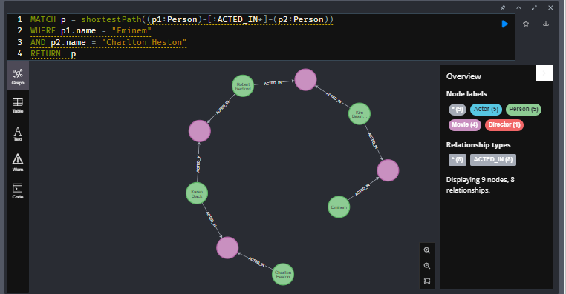

This query returns a longer path because the relationship must be ACTED_IN.

For shortestPath() and allShortestPaths() you can provide an upper bound on the length of the path(s), but not a lower bound.

## Varying length traversal

Suppose you want to retrieve all Person nodes that are exactly two hops away from Eminem using the ACTED_IN relationship.

**cypher**

CopyRun

MATCH (p:Person {name: 'Eminem'})-[:ACTED_IN*2]-(others:Person)

RETURN others.name

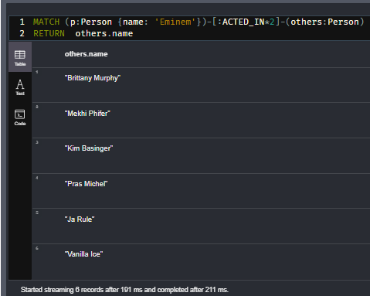

Here is what happens when this query executes:



1. The Eminem Person node is retrieved.
2. Then the two ACTED_IN relationship are traversed through the Movie node for 8 Mile to return the three Person nodes.
3. Then the two ACTED_IN relationships are traversed through the Movie node for Hip Hop Witch, Da to return the three Person nodes.

## Four hops away

Suppose you want to retrieve all Person nodes that are exactly four hops away from Eminem using the ACTED_IN relationship.

**cypher**

CopyRun

MATCH (p:Person {name: 'Eminem'})-[:ACTED_IN*4]-(others:Person)

RETURN others.name

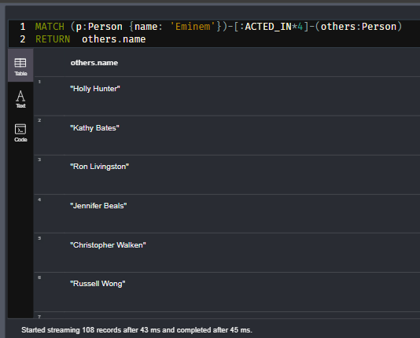

Here is what happens when this query executes:



1. The Eminem Person node is retrieved.
2. Then the ACTED_IN relationships are traversed through the Movie node where Brittany Murphy for 8 Mile is retrieved and Little Black Book to return the two Person nodes.
3. Then the four ACTED_IN relationships are traversed through the Movie node for 8 Mile and The Prophecy II to return the two Person nodes.

Only Person nodes that are exactly 4 hops from Eminem are returned.

## Up to four hops away

Suppose you want to retrieve all Person nodes that are up to four hops away from Eminem using the ACTED_IN relationship.

**cypher**

CopyRun

MATCH (p:Person {name: 'Eminem'})-[:ACTED_IN*1..4]-(others:Person)

RETURN others.name

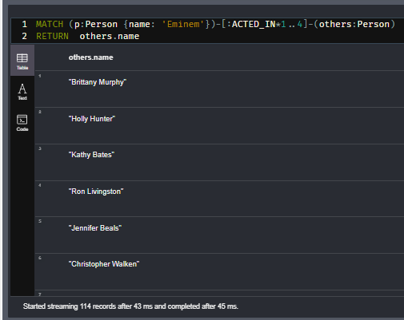

Here is what happens when this query executes:



1. The Eminem Person node is retrieved.
2. Then the ACTED_IN relationships are traversed through the Movie node for 8 Mile and for the Little Black Book.
3. During this traversal we retrieve the Person node two hops away and the two Person nodes that are four hops away.
4. Then the ACTED_IN relationships are traversed through the Movie node for 8 Mile and for The Prophecy II.
5. We have already retrieved Brittany Murphy who is four hops away, but we add two more Person nodes.

This depth-first traversal and retrieval continues until all Person nodes that are two hops away and four hops away are retrieved.

## Quiz-

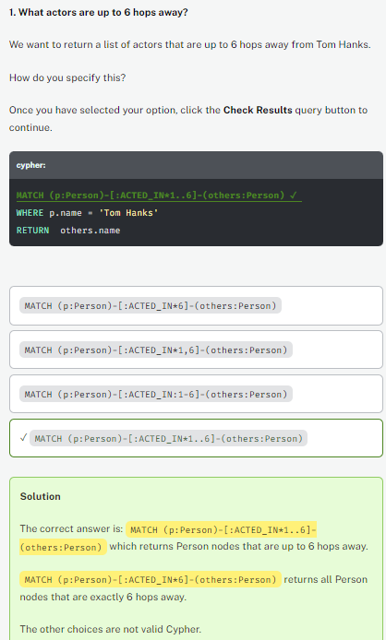

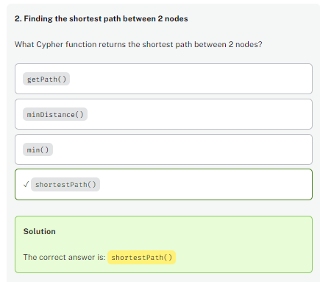

# Actors 2 Hops Away (challenge)

## Actors 2 hops away from Robert Blake.

Write and execute the query to return the names of actors that are 2 hops away from Robert Blake using the ACTED_IN relationship.

How many actors are returned in the result?

## Solution-

MATCH (p:Person {name: 'Robert Blake'})-[:ACTED_IN*2]-(others:Person)

RETURN  others.name

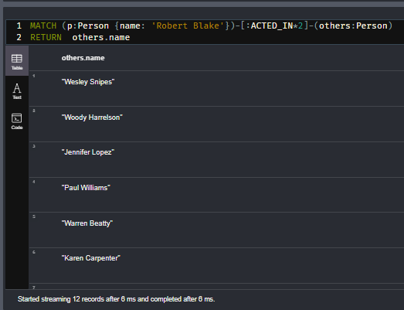

# Actors 4 Hops Away (challenge)

## Actors 4 hops away from Robert Blake.

Write and execute the query to return the distinct names of actors that are 4 hops away from Robert Blake using the ACTED_IN relationship.

How many actor names are returned in the result?

## Solution-

MATCH (p:Person {name: 'Robert Blake'})-[:ACTED_IN*4]-(others:Person)

RETURN  DISTINCT others.name

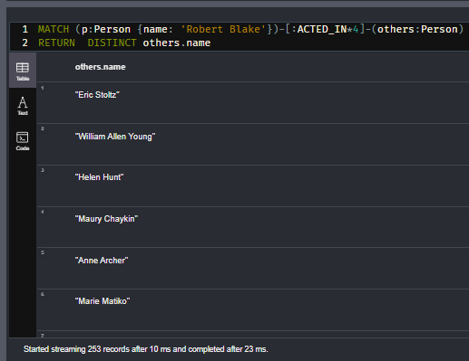

# Actors Up to 8 Hops Away (challenge)

## Actors up to 4 hops away from Robert Blake.

Write and execute the query to return the unique names of actors that up to 4 hops away from Robert Blake using the ACTED_IN relationship.

How many unique actors are returned in the result?

## Solution-

MATCH (p:Person {name: 'Robert Blake'})-[:ACTED_IN*1..4]-(others:Person)

RETURN  DISTINCT others.name

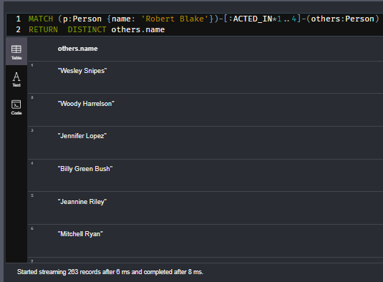

# Module 5: Pipelining Queries

## Module Overview

You have learned much thus far about many of the Cypher clauses you can use to query the graph. In this module, you will learn how to use the Cypher WITH clause to set values and control query processing.

In this module, you will learn how to use WITH to:

* Initialize data for a MATCH clause.
* Define and name a subset of data for a query.
* Limit data that is processed.
* Pass data from one part of a query to the next part of the query (pipelining).
* Unwind a temporary list for processing in a later part of a query.

# Scoping Variables

Youtube video: <https://youtu.be/KZdm4K4tNnM>

Transcript-

## Scoping variables for a query

You have already learned how you can specify a variable for a node or relationship in a query:

**cypher**

CopyRun

MATCH (p:Person)-[:ACTED_IN]->(m:Movie)

WHERE p.name = 'Tom Hanks'

RETURN m.title AS movies

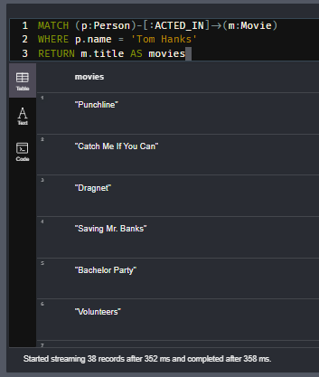

In this query the variable p is used to test each Person node against the value Tom Hanks. The variable m is used to return the movie titles.

You can define and initialize variables to be used in the query with a WITH clause.

**cypher**

CopyRun

WITH 'Tom Hanks' AS actorName

MATCH (p:Person)-[:ACTED_IN]->(m:Movie)

WHERE p.name = actorName

RETURN m.title AS movies

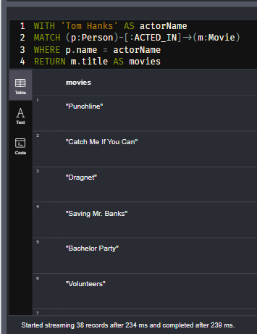

Before the MATCH clause, we define a variable, actorName to have a value of Tom Hanks. The variable, actorName is in the scope of the query, so it can be used like a parameter. The query itself can be reused with a different value for actorName.

You will learn about using parameters in Cypher later in this course.

## Using **WITH** to redefine scope

Let’s look at scoping variables in more detail. Suppose we have this query:

**cypher**

CopyRun

WITH 'toy story' AS mt, 'Tom Hanks' AS actorName

MATCH (p:Person)-[:ACTED_IN]->(m:Movie)

WHERE p.name = actorName

AND toLower(m.title) CONTAINS mt

RETURN m.title AS movies

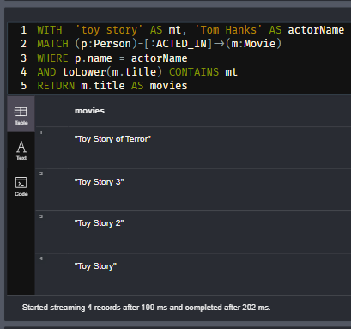

For this query, mt and actorName are within scope of the MATCH clause that also uses the WHERE clause. It retrieves the Person node, then all the movies that Tom Hanks acted in, then it filters and returns the movies that contain mt.

Now, let’s look at this query:

**cypher**

CopyRun

WITH 'toy story' AS mt, 'Tom Hanks' AS actorName

MATCH (p:Person)-[:ACTED_IN]->(m:Movie)

WITH m, toLower(m.title) AS movieTitle

WHERE p.name = actorName

AND movieTitle CONTAINS mt

RETURN m.title AS movies, movieTitle

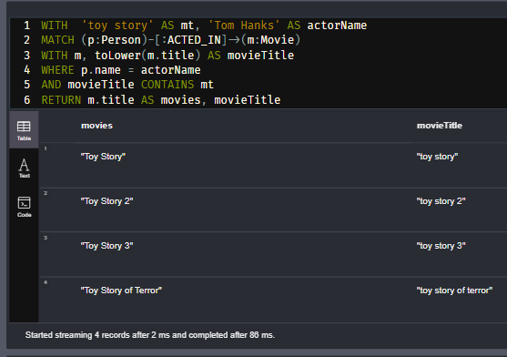

The variables mt, and actorName are available to the MATCH clause and the WHERE clause just like the previous query. What is different here, however, is that we must add the m to the second WITH clause so that the node can be used to return the title of the node. A WITH clause is used to define or redefine the scope of variables. Because we want to redefine what is used for the WHERE clause, we add a new WITH clause. This creates a new scope for the remainder of the query so that m and movieTitle can be used to return values. If you were to remove the m in the second WITH clause, the query would not compile.

Notice also that you can define expressions using WITH. When you define an expression (for example, toLower(m.title), you must specify an alias defined with the AS keyword.

## Limiting results

Suppose we have this query where we want to return only two rows:

**cypher**

CopyRun

WITH 'Tom Hanks' AS theActor

MATCH (p:Person)-[:ACTED_IN]->(m:Movie)

WHERE p.name = theActor

RETURN m.title AS movies LIMIT 2

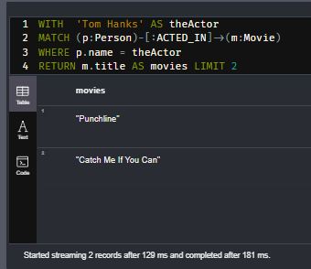

Another way to write this query is:

**cypher**

CopyRun

WITH 'Tom Hanks' AS theActor

MATCH (p:Person)-[:ACTED_IN]->(m:Movie)

WHERE p.name = theActor

WITH m LIMIT 2

*// possibly do more with the two m nodes*

RETURN m.title AS movies

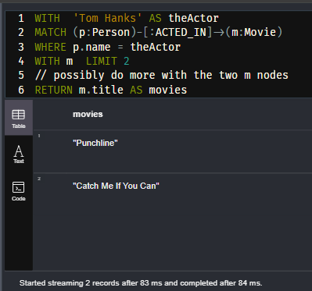

With this query, two Movie nodes are retrieved. What is different here is that you can use WITH to limit how many m nodes are used later in the query. Passing nodes on to the next MATCH clause is called pipelining that you will learn about in the next lesson.

## Ordering results

If you are limiting the nodes to process further on in the query or for the RETURN clause, you can also order them:

**cypher**

CopyRun

WITH 'Tom Hanks' AS theActor

MATCH (p:Person)-[:ACTED_IN]->(m:Movie)

WHERE p.name = theActor

WITH m ORDER BY m.year LIMIT 5

*// possibly do more with the five m nodes in a particular order*

RETURN m.title AS movies, m.year AS yearReleased

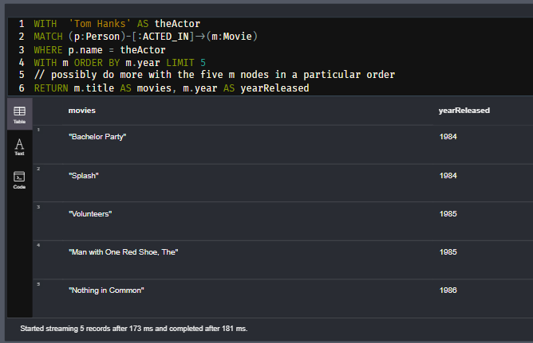

## Using map projections in a **WITH** clause

Here is another example where we want to customize the properties of nodes that are returned. Using a map projection, you can specify which properties are returned. This type of customization of nodes returned is very useful when you are integrating with an application.

**cypher**

CopyRun

MATCH (n:Movie)

WHERE n.imdbRating IS NOT NULL

AND n.poster IS NOT NULL

WITH n {

.title,

.year,

.languages,

.plot,

.poster,

.imdbRating,

directors: [ (n)<-[:DIRECTED]-(d) | d { tmdbId:d.imdbId, .name } ]

}

ORDER BY n.imdbRating DESC LIMIT 4

RETURN collect(n)



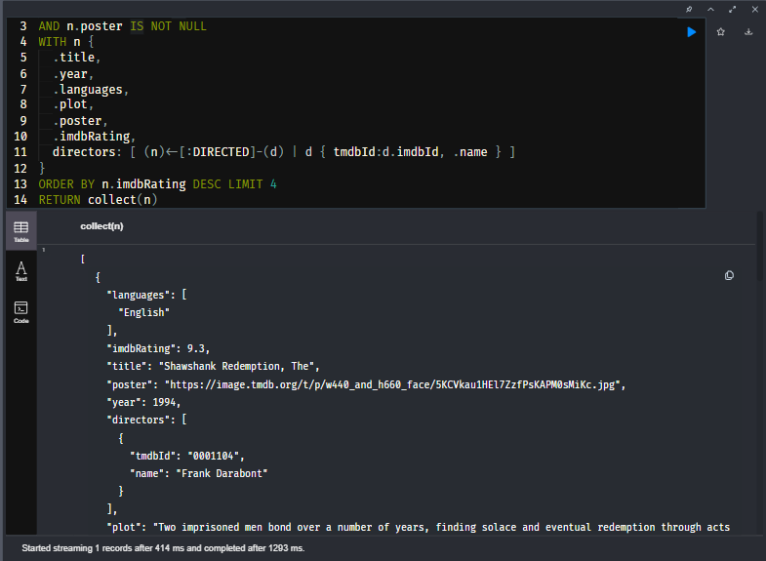

This query returns a subset of the data in a Movie node. It returns the top four rated movies. Because we have specified a limit of four, only 4 objects with the specified properties are added to the list. This type of data returned is commonly used by GraphQL and JavaScript applications.

Although this is nice for processing on the client side, it takes more memory on the server as records cannot be streamed to the client but are collected into the list structure on the server.

## Quiz-

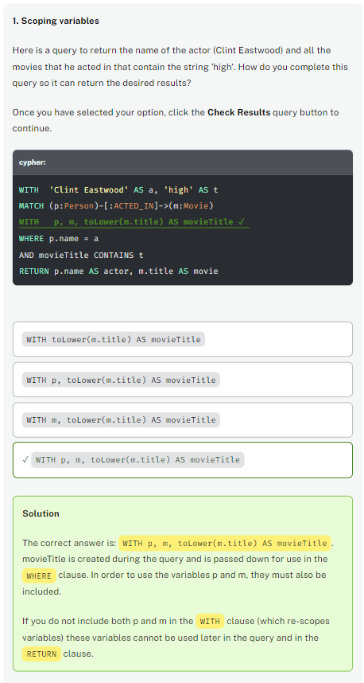

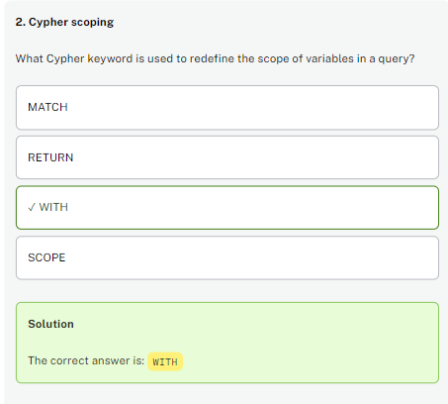

# Highest Revenue Movies (challenge)

Add a WITH clause to this query so that the movie with the highest revenue is returned:

**cypher**

CopyRun

WITH 'Tom Hanks' AS theActor

MATCH (p:Person)-[:ACTED_IN]->(m:Movie)

WHERE p.name = theActor

AND m.revenue IS NOT NULL

*// Use WITH here to limit the movie node to 1 and order it by revenue*

RETURN m.revenue AS revenue, m.title AS title

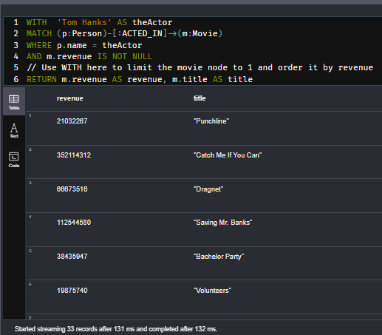

## Solution-

WITH  'Tom Hanks' AS theActor

MATCH (p:Person)-[:ACTED_IN]->(m:Movie)

WHERE p.name = theActor

AND m.revenue IS NOT NULL

WITH m ORDER BY m.revenue DESC LIMIT 1

RETURN m.revenue AS revenue, m.title AS title

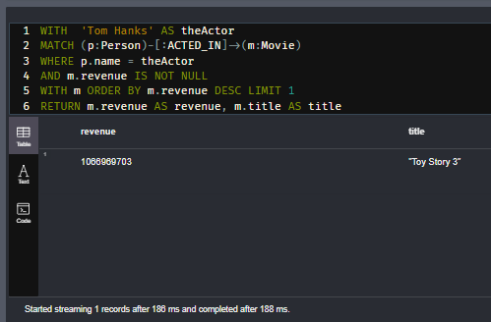

## Alternate Solution (maybe wrong scoping wise or inefficient)-

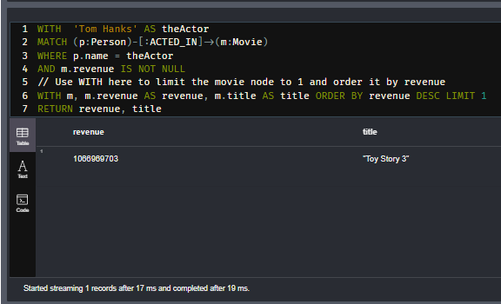

# Highest for Tom Hanks (Challenge)

Using the query you just created, answer this question:

## What is the highest revenue for a movie for Tom Hanks?

## Solution-

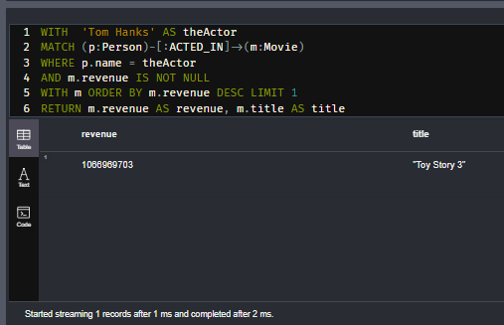

# Top Movies (challenge)

## Using WITH for map projection to limit results

Here is a query, a version of which you saw in the previous lesson:

**cypher**

CopyRun

MATCH (n:Movie)

WHERE n.imdbRating IS NOT NULL and n.poster IS NOT NULL

*// Add WITH clause to return custom data for each movie*

ORDER BY n.imdbRating DESC LIMIT 4

RETURN collect(n)

MATCH (n:Movie)

WHERE n.imdbRating IS NOT NULL and n.poster IS NOT NULL

// Add WITH clause to return custom data for each movie

ORDER BY n.imdbRating DESC LIMIT 4

RETURN collect(n)

Modify this query by adding a WITH clause that customizes the data returned for each Movie node to include:

* title
* imdbRating
* List of actor names
* List of Genre names

Then answer this question:

## Which actor?

What actor acted in more than one of these top four movies? (Name is case-sensitive)

## Solution

MATCH (n:Movie)

WHERE n.imdbRating IS NOT NULL AND n.poster IS NOT NULL

WITH n {

  .title,

  .imdbRating,

  actors: [ (n)<-[:ACTED_IN]-(p) | p { tmdbId:p.imdbId, .name } ],

  genres: [ (n)-[:IN_GENRE]->(g) | g {.name}]

}

ORDER BY n.imdbRating DESC

LIMIT 4

RETURN collect(n)

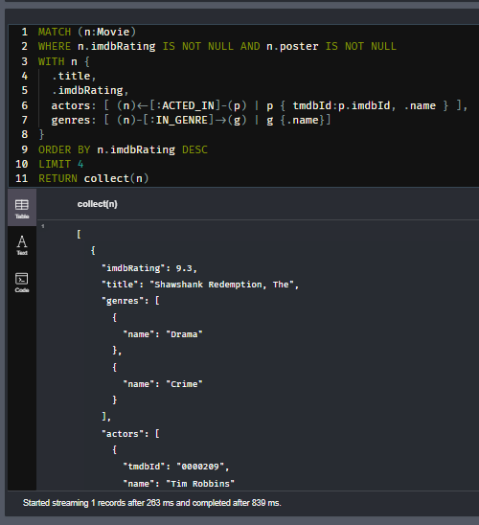

# Unique Genres (Challenge)

## Using WITH for map projection to limit results

Using the query you just wrote, answer this question:

## Genres?

With the previous query:

**cypher**

CopyRun

MATCH (n:Movie)

WHERE n.imdbRating IS NOT NULL AND n.poster IS NOT NULL

WITH n {

.title,

.imdbRating,

actors: [ (n)<-[:ACTED_IN]-(p) | p { tmdbId:p.imdbId, .name } ],

genres: [ (n)-[:IN_GENRE]->(g) | g {.name}]

}

ORDER BY n.imdbRating DESC

LIMIT 4

RETURN collect(n)

How many unique genres are represented in these top four movies?

## Solution

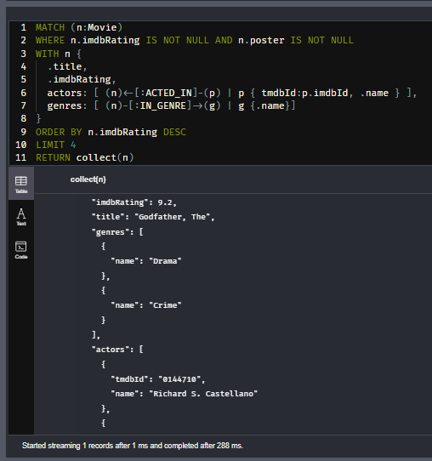

# Pipelining Queries

Youtube video: <https://youtu.be/Tpn_uzwAves>

Transcript-

## What does pipelining mean?

You have learned that you can use the WITH clause to redefine the scope for the query:

**cypher**

CopyRun

WITH 'Tom Hanks' AS theActor

MATCH (p:Person)-[:ACTED_IN]->(m:Movie)

WHERE p.name = theActor

WITH m LIMIT 5

*// possibly do more with the five m nodes*

RETURN m.title AS movies

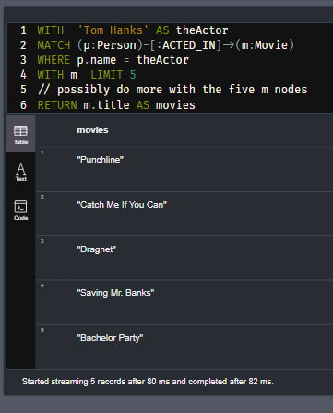

This query limits the query to retrieve five nodes.

You can do something with the five nodes by adding another MATCH clause:

**cypher**

CopyRun

WITH 'Tom Hanks' AS theActor

MATCH (p:Person)-[:ACTED_IN]->(m:Movie)

WHERE p.name = theActor

WITH m LIMIT 5

MATCH (d:Person)-[:DIRECTED]->(m)

RETURN d.name AS director,

m.title AS movies

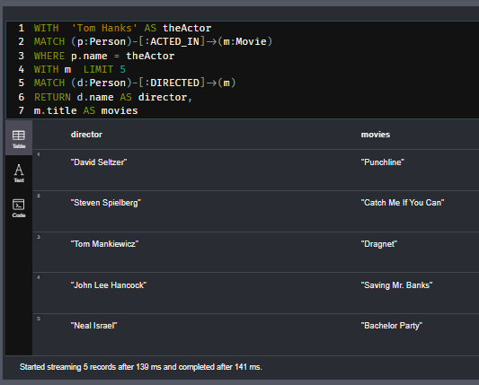

The five Movie nodes are used for the second MATCH clause and five rows are returned. The WITH clause enables us to pipeline the results of the first query into the second query. With this simple query, m need not be redefined or scoped.

Next you will learn how pipelining is really useful.

## Using WITH for aggregation

A very common use of WITH is to aggregate data so that intermediate results can be used to create the final returned data or to pass the intermediate results to the next part of the query.

Here is an example:

**cypher**

CopyRun

MATCH (:Movie {title: 'Toy Story'})-[:IN_GENRE]->(g:Genre)<-[:IN_GENRE]-(m)

WHERE m.imdbRating IS NOT NULL

WITH g.name AS genre,

count(m) AS moviesInCommon,

sum(m.imdbRating) AS total

RETURN genre, moviesInCommon,

total/moviesInCommon AS score

ORDER By score DESC

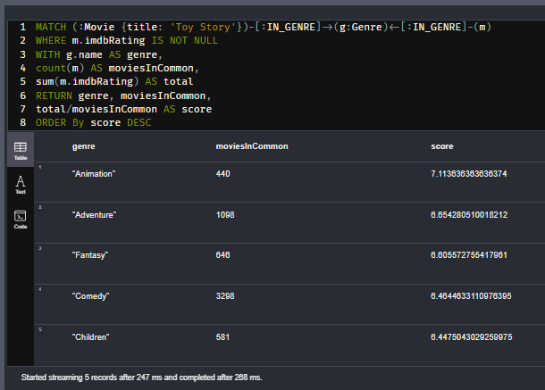

In this query we are counting the number of movies that share the same Genre node. We use count() to count the number of rows and sum() to total the imdbRating for each movie for the Genre. These values are calculated as part of the aggregation and then used to return the data. In the WITH clause we pass on only the values we need to return a row for the Genre.

Here is another example that shows aggregation and pipelining:

**cypher**

CopyRun

MATCH (u:User {name: "Misty Williams"})-[r:RATED]->(:Movie)

WITH u, avg(r.rating) AS average

MATCH (u)-[r:RATED]->(m:Movie)

WHERE r.rating > average

RETURN average , m.title AS movie,

r.rating as rating

ORDER BY rating DESC

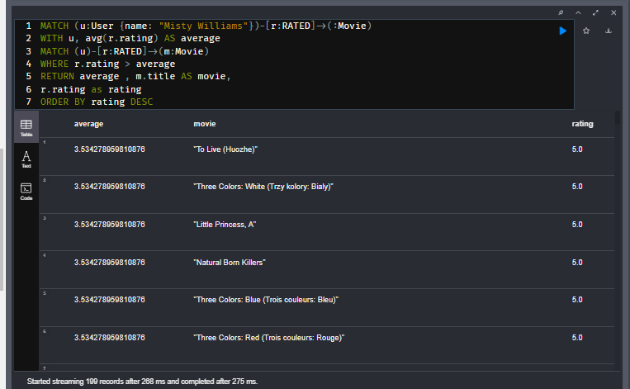

For this query, we first calculate the average rating for all movies that Misty Williams rated. Then we use this calculated value, average as a test for the second MATCH.

## Using WITH for collecting

Another common use for the WITH clause is to collect results into a list that will be returned:

**cypher**

CopyRun

MATCH (m:Movie)--(a:Actor)

WHERE m.title CONTAINS 'New York'

WITH m, collect (a.name) AS actors,

count(*) AS numActors

RETURN m.title AS movieTitle, actors

ORDER BY numActors DESC

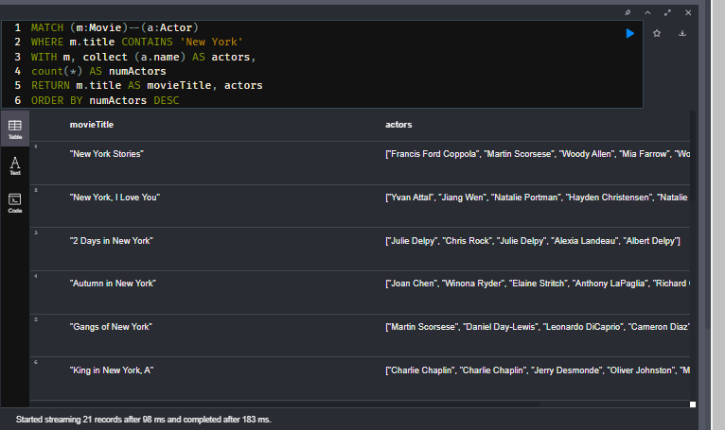

This query collects the names of actors who acted in the movies containing the string 'New York'. This aggregation collects the names and totals the number of actors.

Here is another example where we perform a 2-step aggregation for collecting a list of maps:

**cypher**

CopyRun

MATCH (m:Movie)<-[:ACTED_IN]-(a:Actor)

WHERE m.title CONTAINS 'New York'

WITH m, collect (a.name) AS actors,

count(*) AS numActors

ORDER BY numActors DESC

RETURN collect(m { .title, actors, numActors }) AS movies

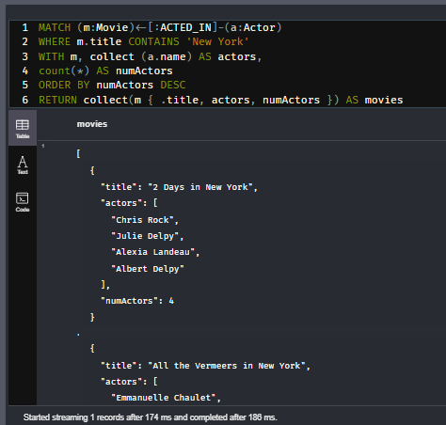

## Using LIMIT early

A best practice is to execute queries that minimize the number of rows processed in the query. One way to do that is to limit early in the query. This also helps in reducing the number of properties loaded from the database too early.

For example, this query limits during the aggregation:

**cypher**

CopyRun

PROFILE MATCH (p:Person)-[:ACTED_IN]->(m:Movie)

WHERE p.born.year = 1980

WITH p,

collect(m.title) AS movies LIMIT 3

RETURN p.name AS actor, movies

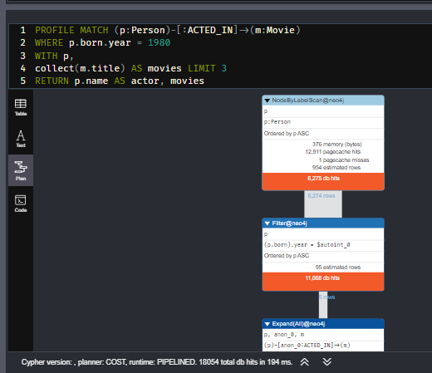

A better way to do this query is to limit early. This query will perform slightly better because LIMIT is moved up in the query:

**cypher**

CopyRun

PROFILE MATCH (p:Actor)

WHERE p.born.year = 1980

WITH p LIMIT 3

MATCH (p)-[:ACTED_IN]->(m:Movie)

WITH p, collect(m.title) AS movies

RETURN p.name AS actor, movies

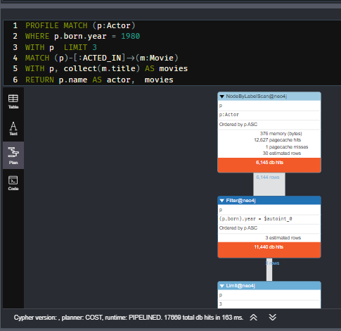

## Use DISTINCT when necessary

Here is an example of a query that retrieves three actors, then collects the names of the genres for the movies that actor acted in.

**cypher**

CopyRun

MATCH (p:Actor)

WHERE p.born.year = 1980

WITH p LIMIT 3

MATCH (p)-[:ACTED_IN]->(m:Movie)-[:IN_GENRE]->(g:Genre)

WITH p, collect(g.name) AS genres

RETURN p.name AS actor, genres

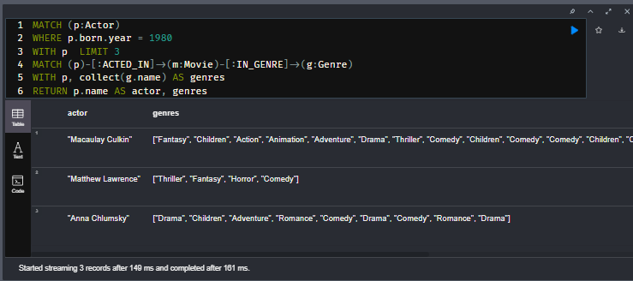

Notice that for this query, the collected genre names are repeated. You would want to ensure that they are not duplicated as follows:

**cypher**

CopyRun

MATCH (p:Actor)

WHERE p.born.year = 1980

WITH p LIMIT 3

MATCH (p)-[:ACTED_IN]->(m:Movie)-[:IN_GENRE]->(g:Genre)

WITH p, collect(DISTINCT g.name) AS genres

RETURN p.name AS actor, genres

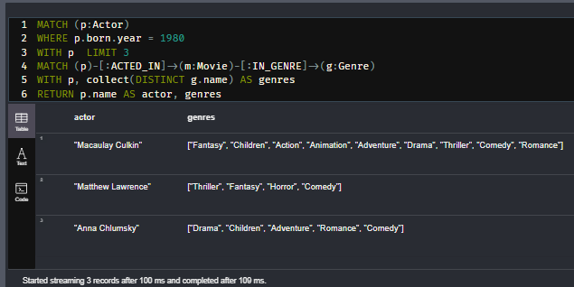

## Quiz-

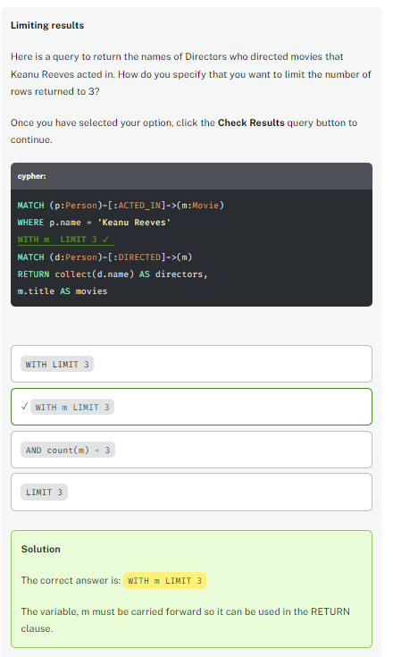

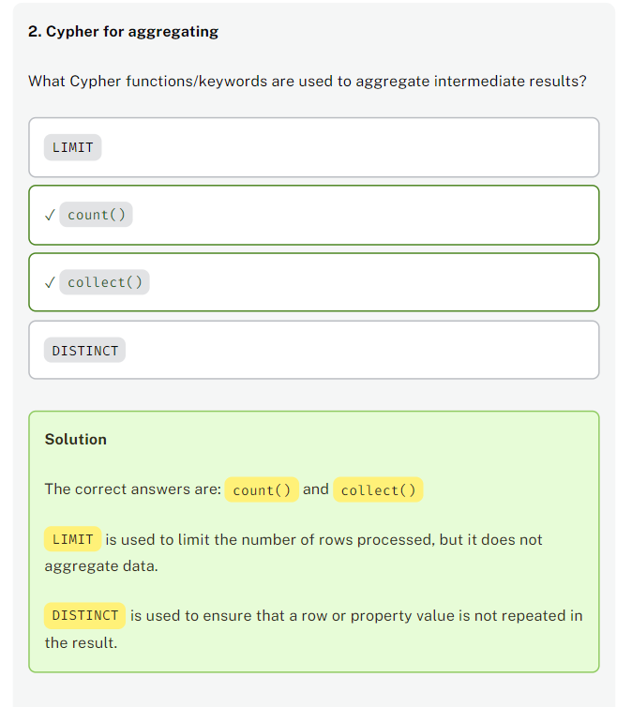

# Highest Rated Tom Hanks Movie (challenge)

## Using WITH to pass on intermediate results

Write and execute a query to determine the highest average rating by a user for a Tom Hanks Movie. Use avg(r.rating) to aggregate the rating values for all movies that Tom Hanks acted in, where you use the pattern (m:Movie)←[r:RATED]-(:User).

Then answer this question:

## What Tom Hanks movie had the highest average rating greater than 4?

Enter the title of the movie. (Note, the answer is case-sensitive).

## Solution-

MATCH (p:Person)-[:ACTED_IN]->(m:Movie)<-[r:RATED]-(:User)

WHERE p.name = 'Tom Hanks'

WITH m, avg(r.rating) AS avgRating

WHERE avgRating > 4

RETURN m.title AS Movie, avgRating AS `AverageRating`

ORDER BY avgRating DESC

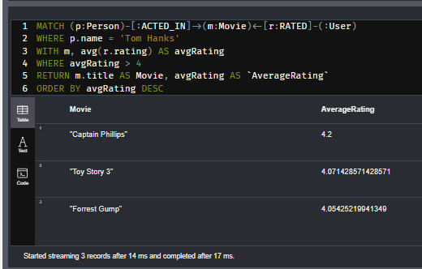

# Highest Average Rating (challenge)

## Using WITH pass on intermediate results

Use the query that you just wrote to answer this question:

## What is the highest average rating for a movie acted in by Tom Hanks?

Based upon the query you just executed, enter the highest average rating.

## Solution

MATCH (p:Person)-[:ACTED_IN]->(m:Movie)<-[r:RATED]-(:User)

WHERE p.name = 'Tom Hanks'

WITH m, avg(r.rating) AS avgRating

WHERE avgRating > 4

RETURN m.title AS Movie, avgRating AS `AverageRating`

ORDER BY avgRating DESC

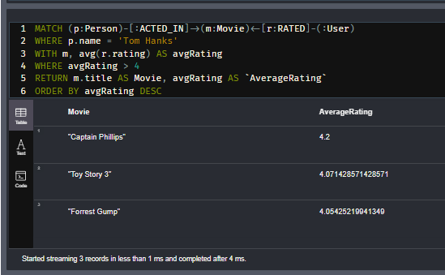

# Unwinding Lists

Youtube video: <https://youtu.be/uV_m3ODoHQk>

Transcript-

## Using UNWIND

You have learned that in a query, you can create lists of nodes, strings, or numbers using collect(). Sometimes it is useful to collect elements as intermediate results that are passed on to a later part of a query. For example, the graph you are working with contains languages and countries lists for each Movie node. If you wanted to refactor the graph to create a Language node and associate it with any Movie node that had that particular language in its languages list, you could unwind the list to access each element in the list.

UNWIND returns a row for each element of a list.

Here is an example:

**cypher**

CopyRun

MATCH (m:Movie)-[:ACTED_IN]-(a:Actor)

WHERE a.name = 'Tom Hanks'

UNWIND m.languages AS lang

RETURN m.title AS movie,

m.languages AS languages,

lang AS language

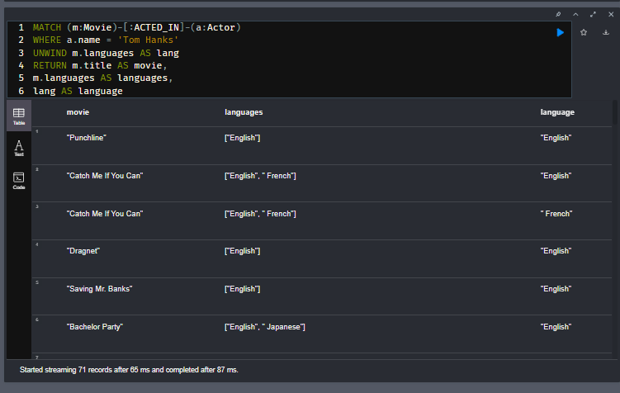

In this query:

1. A Movie is retrieved that Tom Hanks acted in.
2. The languages property, which is a list is unwound and each value is referenced as lang.
3. The rows returned will be the movie title and the languages property repeated for multiple rows and the lang value.

In this code, you could imagine that you could create a Language node with a name property which is lang.

Let’s now look at a more useful example.

**cypher**

CopyRun

MATCH (m:Movie)

UNWIND m.languages AS lang

WITH m, trim(lang) AS language

*// this automatically, makes the language distinct because it's a grouping key*

WITH language, collect(m.title) AS movies

RETURN language, movies[0..10]

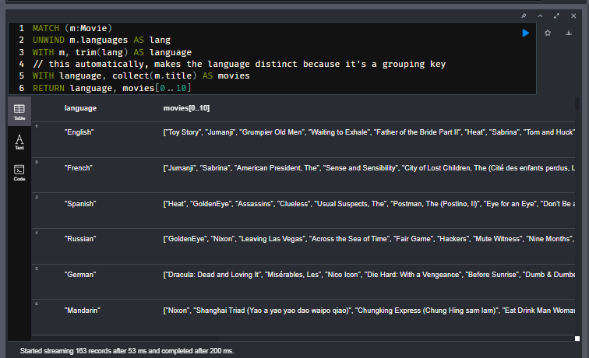

This query:

1. Retrieves all Movie nodes.
2. For each Movie node, it unwinds the languages list to create a list called lang. Notice that we use the trim() function to ensure there are no extraneous whitespace characters in the language name.
3. Then we use the element of the list to find all Movies that use that language.
4. Finally, we return a row that contains each language name and the list of up to 10 movie titles for that language.

## Quiz-

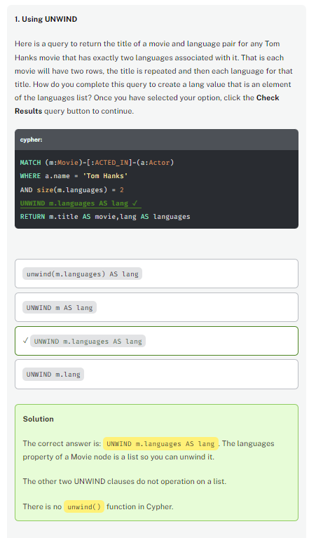

MATCH (m:Movie)-[:ACTED_IN]-(a:Actor)

WHERE a.name = 'Tom Hanks'

AND size(m.languages) = 2

UNWIND m.languages AS lang

RETURN m.title AS movie,lang AS languages

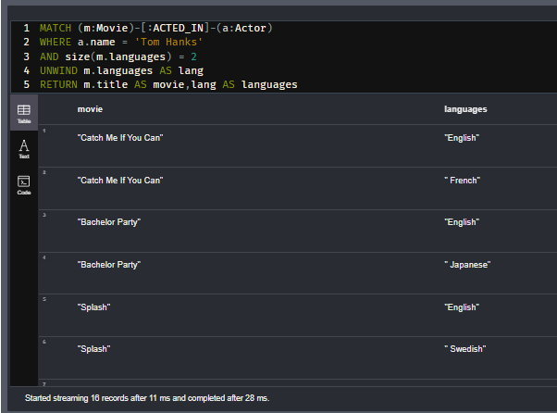

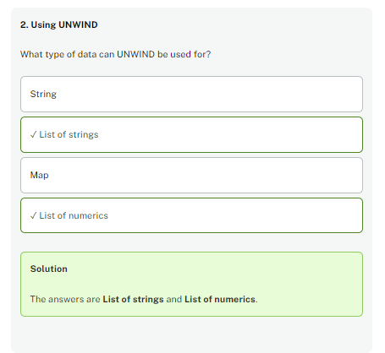

# UK Movies (challenge)

## Using UNWIND pass on intermediate results

You have already seen this query:

**cypher**

CopyRun

MATCH (m:Movie)

UNWIND m.languages AS lang

WITH m, trim(lang) AS language

*// this automatically, makes the language distinct because it's a grouping key*

WITH language, collect(m.title) AS movies

RETURN language, movies[0..10]

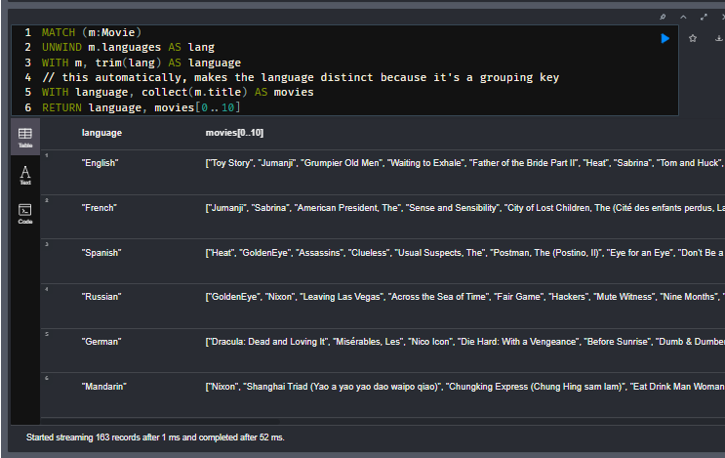

Modify this query to return the number of movies released in each country.

Then answer this question:

## UK movies?

How many movies released in the UK are in the graph?

## Solution-

MATCH (m:Movie)

UNWIND m.countries AS country

WITH m, trim(country) AS trimmedCountry

// this automatically, makes the trimmedCountry distinct because it's a grouping key

WITH trimmedCountry, collect(m.title) AS movies

RETURN trimmedCountry, size(movies)

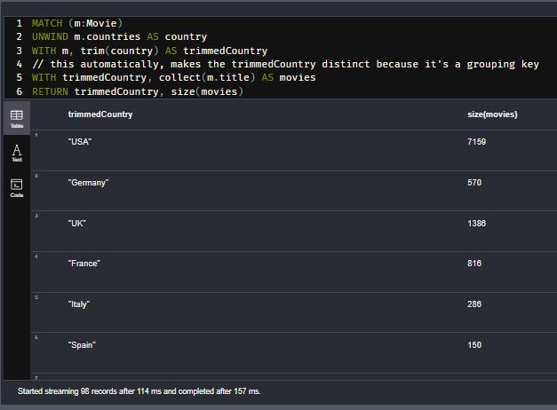

## Alternate Solution-

MATCH (m:Movie)

UNWIND m.countries AS countries

WITH m, trim(countries) AS country

// this automatically, makes the country distinct because it's a grouping key

WITH country, count(m.title) AS count_movies

RETURN country, count_movies

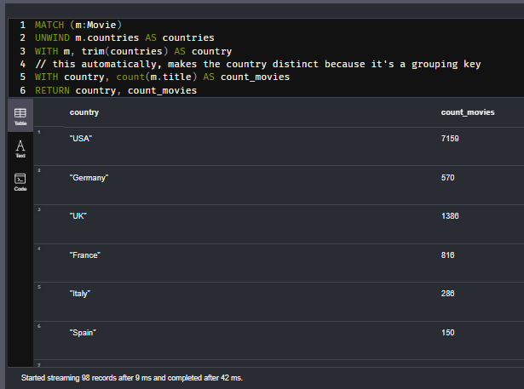

# Taiwan Movies (challenge)

## Using UNWIND pass on intermediate results

Using the query you just created, answer this question:

## Movies released in Taiwan?

How many movies released in Taiwan are in the graph?

## Solution-

MATCH (m:Movie)

UNWIND m.countries AS countries

WITH m, trim(countries) AS country

// this automatically, makes the country distinct because it's a grouping key

WITH country, count(m.title) AS count_movies

WHERE country = "Taiwan"

RETURN country, count_movies

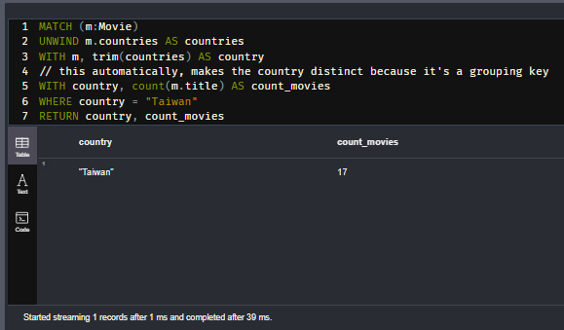

# Module 6: Reducing Memory

## Module Overview

In Cypher, a query represents a single transaction against the graph. Large queries will use more memory and you may need to reduce the amount of memory required for a query. Cypher statement tuning is beyond the scope of this course, but in this lesson, you will learn some techniques for keeping queries smaller. Limiting results and filtering your queries are the easiet ways to reduce memory requirements that you have already learned about.

In this module, you will learn how to reduce memory by:

* Using CALL to perform a subquery.
* Using UNION to combine the results of multiple queries.

# Subqueries

Youtube video: <https://youtu.be/Oj-gVVLrJ_s>

Transcript-

## What is a subquery?

When you execute a series of MATCH clauses, all nodes and relationships retrieved are in memory. If the memory requirements for a set of MATCH clauses exceed the VM configured, the query will fail.

A subquery is a set of Cypher statements that execute within their own scope. A subquery is typically called from an outer enclosing query. Using a subquery, you can limit the number of rows that need to be processed.

Here are some important things to know about a subquery:

* A subquery returns values referred to by the variables in the RETURN clause.
* A subquery cannot return variables with the same name used in the enclosing query.
* You must explicitly pass in variables from the enclosing query to a subquery.

## Performing subqueries with **CALL**

In a CALL clause, you specify a query that can return data from the graph or derived from the graph. A set of nodes returned in the CALL clause can be used by the enclosing query.

Here is a simple example:

**cypher**

CopyRun

CALL {

MATCH (m:Movie) WHERE m.year = 2000

RETURN m ORDER BY m.imdbRating DESC LIMIT 10

}

MATCH (:User)-[r:RATED]->(m)

RETURN m.title, avg(r.rating)

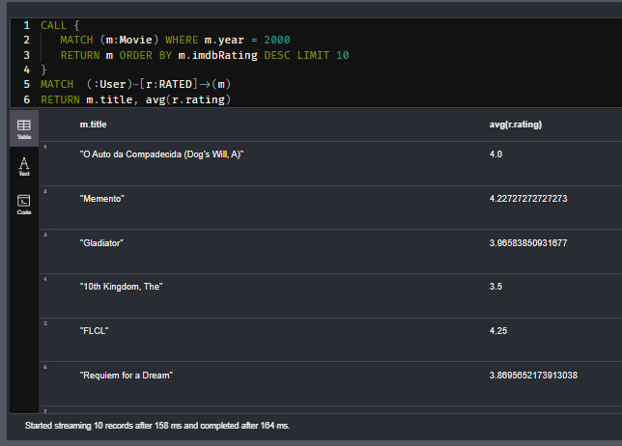

The subquery is demarcated by the {}s here. The subquery returns 10 Movie nodes of movies released in 2000 with the highest imdbRating. Then with these 10 movies, it determines the average rating for each of these 10 movies.

## Passing variables into a subquery

Here is an example where the subquery is executed after the initial query and the enclosing query passes a variable, m into the subquery.

**cypher**

CopyRun

MATCH (m:Movie)

CALL {

WITH m

MATCH (m)<-[r:RATED]-(u:User)

WHERE r.rating = 5

RETURN count(u) AS numReviews

}

RETURN m.title, numReviews

ORDER BY numReviews DESC

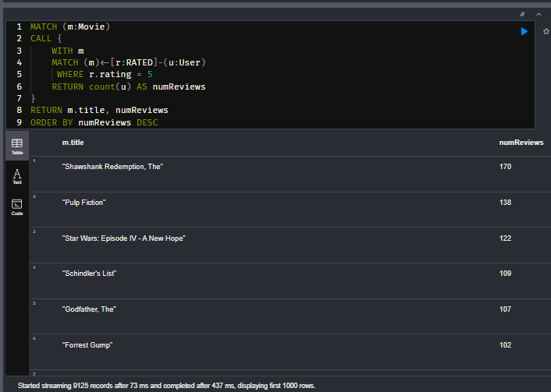

In this query:

1. The first MATCH returns a row for every movie, m in the graph.
2. It passes the Movie node, m to the subquery.
3. Then within the subquery, the query executes to find all users who gave that movie a rating of 5 and counts them.
4. The subquery returns the count.
5. Back in the enclosing query, the title is returned, and the count of the number of rows returned from the subquery.

Using subqueries enables you to reduce the number of rows processed in a query.

## Combining query results with UNION

As your queries become more complex, you may need to combine the results of multiple queries. You can do so with UNION. With UNION, the queries you are combining must return the same number of properties or data

Here is a simple example:

**cypher**

CopyRun

MATCH (m:Movie) WHERE m.year = 2000

RETURN {type:"movies", theMovies: collect(m.title)} AS data

UNION ALL

MATCH (a:Actor) WHERE a.born.year > 2000

RETURN { type:"actors", theActors: collect(DISTINCT a.name)} AS data

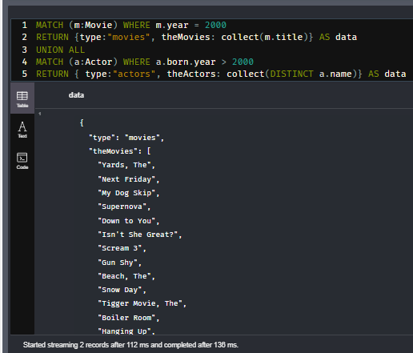

The first query returns an object with a type property of "movies" and a theMovies property that is a list of movies. It returns this object as a variable named Data

The second query returns an object with a type property of "actors" and a theActors property that is a list of actor names. It returns this object as a variable named Data

Because both queries return a variable named Data, we can combine the results using UNION ALL.

## Difference between UNION ALL and UNION-

UNION ALL returns all results which is more efficient on memory but can lead to duplicates. UNION returns distinct results.

## Using UNION with subqueries

Results of a UNION cannot be directly post-processed. But if you wrap a UNION in a subquery, you can then further process the results.

Here is an example that uses UNION within a subquery:

**cypher**

CopyRun

MATCH (p:Person)

WITH p LIMIT 100

CALL {

WITH p

OPTIONAL MATCH (p)-[:ACTED_IN]->(m:Movie)

RETURN m.title + ": " + "Actor" AS work

UNION

WITH p

OPTIONAL MATCH (p)-[:DIRECTED]->(m:Movie)

RETURN m.title+ ": " + "Director" AS work

}

RETURN p.name, collect(work)

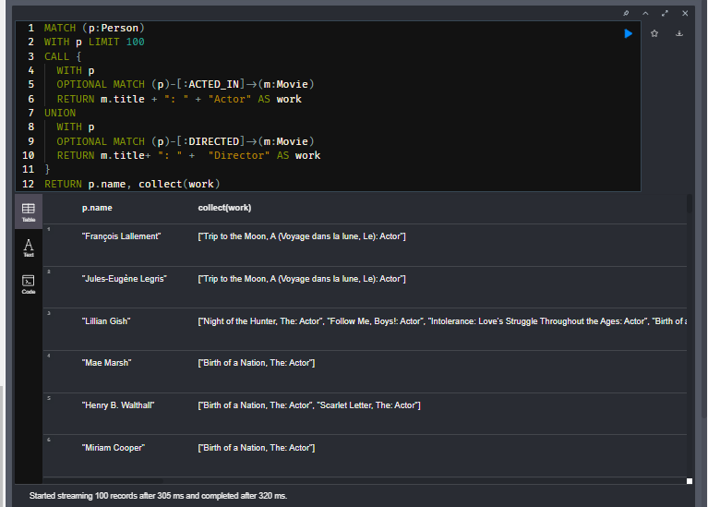

This query:

1. 100 Person nodes are retrieved and passed to the subquery.
2. If that Person acted in the movie, its title with the Actor suffix is returned.
3. The second part of the subquery does the same for the DIRECTED relationships.
4. The work results are combined and collected.
5. The result is the name of the person and their Actor or Director titles.

Note-

In the above query OPTIONAL MATCH fills in null values if matches are not found.

But UNION removes the duplicates so that’s why there are no null values

## Quiz-

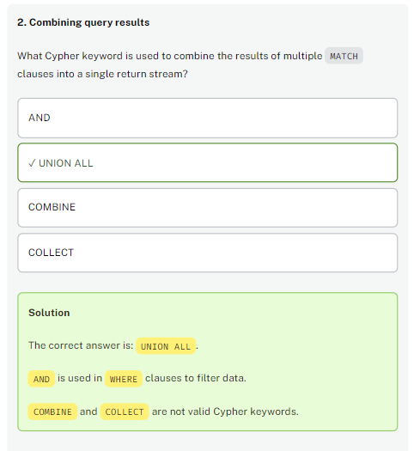

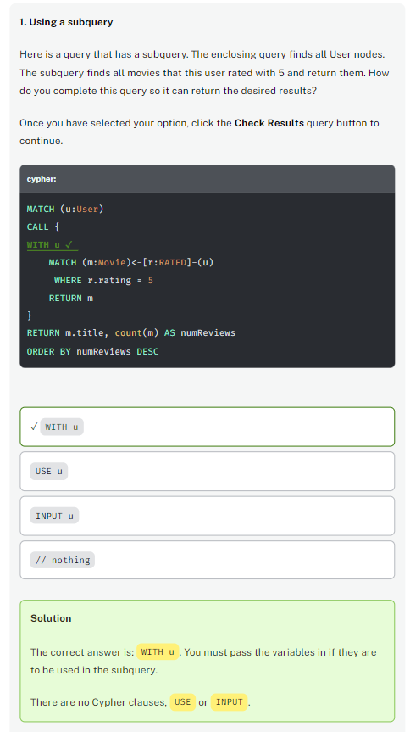

# Using Subqueries (challenge)

## Add a subquery

## Top French movie

Here is your starter code:

**cypher**

CopyRun

MATCH (g:Genre)

*// write subquery*

RETURN g.name AS genre, numMovies

ORDER BY numMovies DESC

Write and execute the subquery to return the movie nodes that have a countries list element of 'France'.

1. You must pass in the g variable to the subquery.
2. You must test if the movie node for that genre was released in France.
3. The subquery must return the count of the movie nodes, numMovies for each Genre passed in.

How many movies were in the largest Genre category for movies released in France? (enter a number)

## Solution-

MATCH (g:Genre)

CALL { WITH g

MATCH (g)<-[:IN_GENRE]-(m) WHERE 'France' IN m.countries

RETURN count(m) AS numMovies

}

RETURN g.name AS Genre, numMovies ORDER BY numMovies DESC

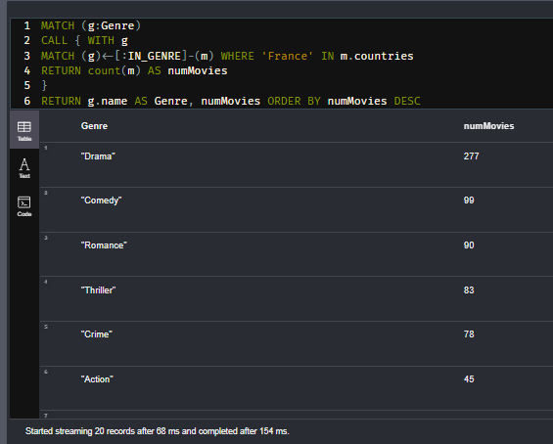

## Alternate Solution-

MATCH (g:Genre)

// write subquery

CALL {

    WITH g

    MATCH (g)<-[:IN_GENRE]-(m:Movie)

    WHERE 'France' in m.countries

    RETURN count(m) AS numMovies

}

RETURN g.name AS genre, numMovies

ORDER BY numMovies DESC

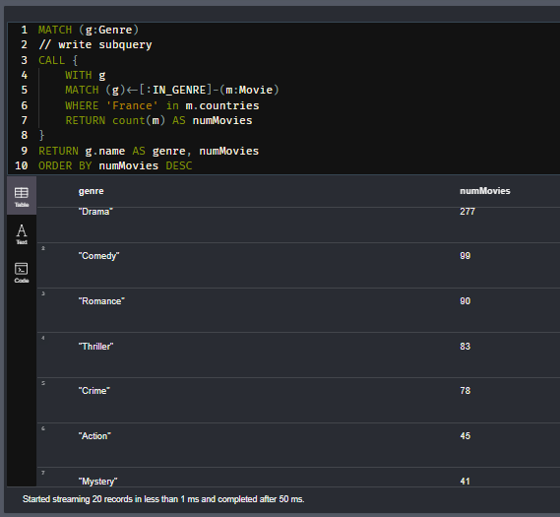

# Combining Results (challenge)

## Combining actors and directors data

## Actors and Directors from 2015

Here is a query that returns actor information for the year 2015:

**cypher**

CopyRun

MATCH (m:Movie)<-[:ACTED_IN]-(p:Person)

WHERE m.year = 2015

RETURN "Actor" AS type,

p.name AS workedAs,

collect(m.title) AS movies

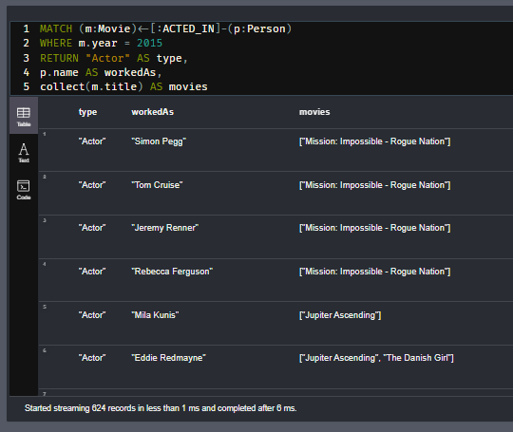

Execute this query to see what it returns.

Now add another query to this code to return the directors for 2015. Use UNION ALL to combine results. The second query will return the string "Director" as Type.

How many rows are returned?

## Solution-

MATCH (m:Movie)<-[:ACTED_IN]-(p:Person)

WHERE m.year = 2015

RETURN "Actor" AS type,

p.name AS workedAs,

collect(m.title) AS movies

UNION ALL

MATCH (m:Movie)<-[:DIRECTED]-(p:Person)

WHERE m.year = 2015

RETURN "Director" AS type,

p.name AS workedAs,

collect(m.title) AS movies

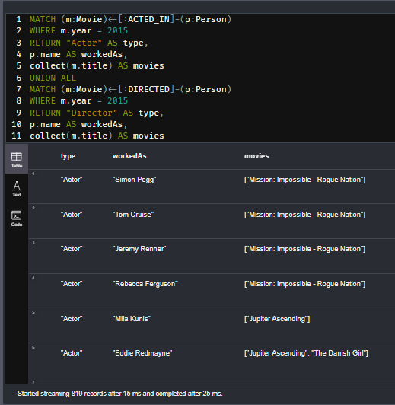

# Module 7: Using Parameters

## Module Overview

Most deployed applications that use Neo4j have client code written in Java, Javascript, Python, .NET, or Go. In a deployed application and in general, you must not **hard code** values in your Cypher code.

In this module, you will learn:

* How to specify parameters in your Cypher code.
* How to set parameters in Neo4j Browser.
* How to pass parameters from your application code.

# Parameters in Cypher

Youtube video: <https://youtu.be/lKQ2k73tBbs>

Transcript-

## Parameters

As you test your Cypher statements, you will use a variety literal values to ensure that your Cypher queries are correct. But you don’t want to change the Cypher statement every time you test. In fact, any change to a Cypher statement requires a recompilation of the Cypher code which is expensive. You create Cypher statements that will not change, except for the substitution of placeholders (parameters) in the query. A best practice is to parameterize values in your Cypher statements.

## Using Cypher parameters

In your Cypher statements, a parameter name begins with the $ symbol.

Here is an example where we have parameterized the query:

**cypher**

CopyRun

MATCH (p:Person)-[:ACTED_IN]->(m:Movie)

WHERE p.name = $actorName

RETURN m.released AS releaseDate,

m.title AS title

ORDER BY m.released DESC

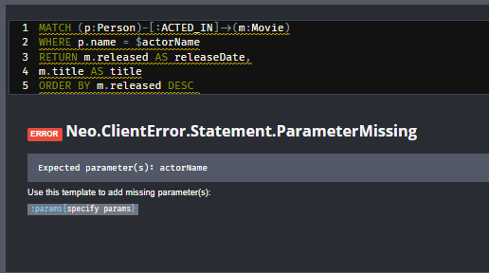

You will not be able to run this code yet in Neo4j Browser because you have not yet set a value for the parameter.

At runtime, if the parameter $actorName has a value, it will be used in the Cypher statement when it runs in the graph engine.

## Setting a parameter

You can set values for Cypher parameters that will be in effect during your Neo4j Browser session.

You can set the value of a single parameter in the query editor pane as shown in this example where the value Tom Hanks is set for the parameter actorName:

**cypher**

CopyRun

:param actorName: 'Tom Hanks'

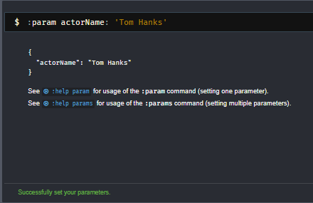

After you have set the parameter, you can then successfully run the Cypher code:

**cypher**

CopyRun

MATCH (p:Person)-[:ACTED_IN]->(m:Movie)

WHERE p.name = $actorName

RETURN m.released AS releaseDate,

m.title AS title

ORDER BY m.released DESC

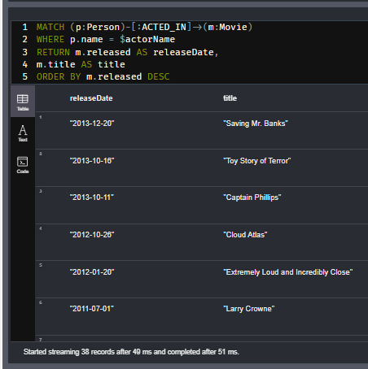

## Setting Integers

Special consideration should be made when setting **integer** values in a Neo4j Browser session. Due to a discrepancy between integers in JavaScript and the Neo4j type system, any integers are converted to floating point values when the parameter is set. This is designed to avoid any data loss on large numbers.

For example, if you run the following code to set the number parameter using colon (:) operator, the number will be converted from 10 to 10.0.

**cypher**

**Numbers and Colons**

CopyRun

:param number: 10

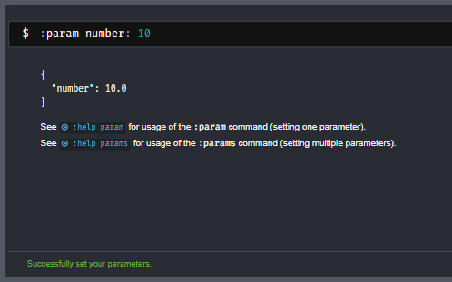

The Browser will output the following result, with number cast as a float.

**json**

**Browser Output**

Copy

{

"number": 10.0

}

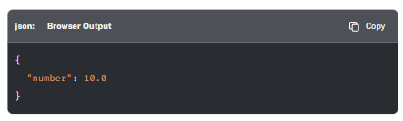

Instead, to force the number to be an integer, you can use the ⇒ operator.

**cypher**

**Correctly setting Integers**

CopyRun

:param number=> 10

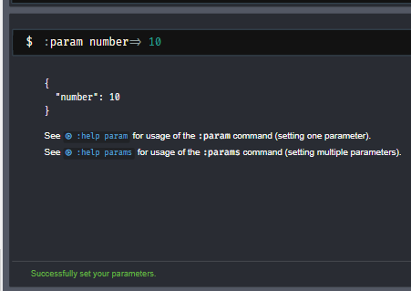

The Browser will output the following result, with the number cast as an integer.

**json**

**Browser Output**

Copy

{

"number": 10

}

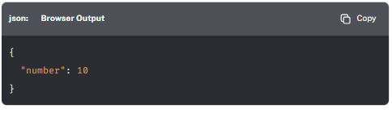

You can learn more about the difference between JavaScript integers and Neo4j Integers in the [**Building Neo4j Applications with Node.js course**](https://graphacademy.neo4j.com/courses/app-nodejs/2-interacting/3-type-system/).

## Setting multiple parameters

You can also use the JSON-style syntax to set all of the parameters in your Neo4j Browser session. The values you can specify in this object are numbers, strings, and booleans. In this example we set two parameters for our session:

**cypher**

CopyRun

:params {actorName: 'Tom Cruise', movieName: 'Top Gun'}

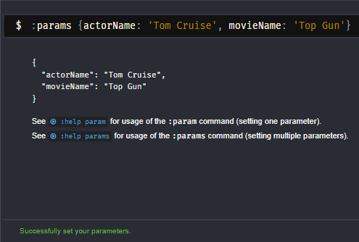

If you have set multiple parameters, you can use the ⇒ operator as seen before to add more parameters to a set of parameters.

**cypher**

CopyRun

:param number=> 10

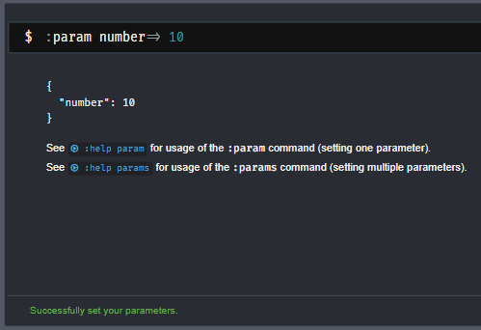

## Using multiple parameters

Here is a different query that uses both parameters:

**cypher**

CopyRun

MATCH (p:Person)-[:ACTED_IN]->(m:Movie)

WHERE p.name = $actorName

AND m.title = $movieName

RETURN p, m

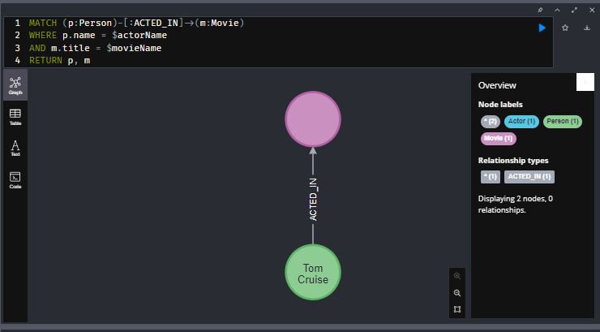

## Viewing parameters

If you want to view the current parameters and their values, simply type:

**cypher**

CopyRun

:params

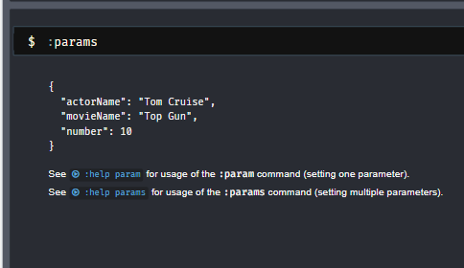

## Removing parameters

If you want to remove an existing parameter from your session, you do so by using the JSON-style syntax and exclude the parameter for your session.

If you want to clear all parameters, you can simply type:

**cypher**

CopyRun

:params {}

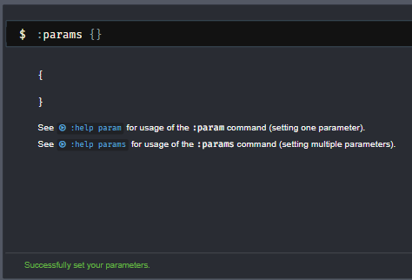

## Quiz-

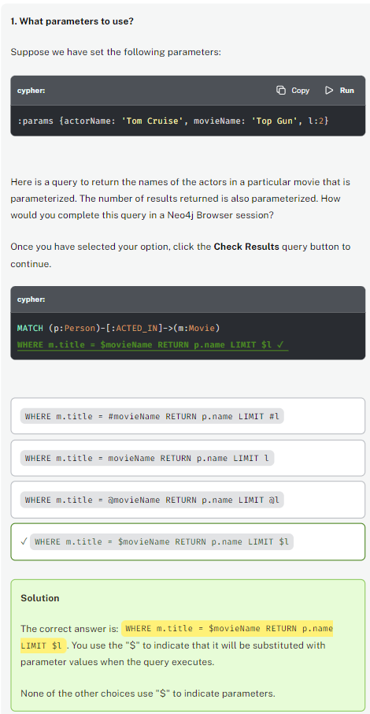

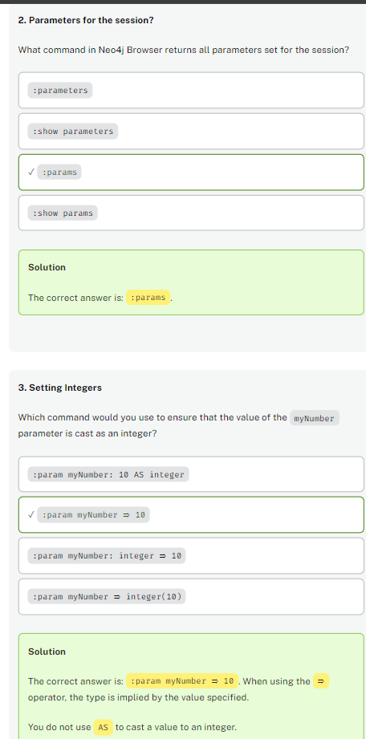

# Setting Parameters (Challenge)

You have been given the following query which finds all users with a name beginning with the string value supplied in the $name parameter.

**cypher**

CopyRun

MATCH (p:Person)-[:ACTED_IN]->(m:Movie)

WHERE p.name STARTS WITH $name

RETURN p.name AS actor,

m.title AS title

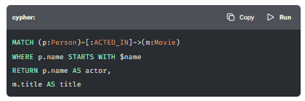

## Set the $name Parameter

What command would you run in Neo4j Browser to set the $name parameter to **Tom**? (use double-quotes for the value of the parameter)

## Solution-

:param name: "Tom"

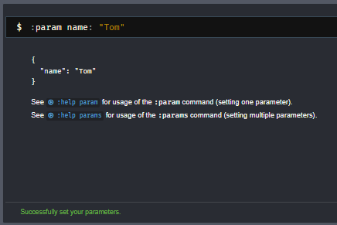

# Using Parameters (challenge)

In the previous challenge, you identified how to set the name parameter within a Neo4j Browser session.

In this challenge, you will need to execute the following query to find all movies acted in by an Actor with a name **starting with** Tom, and that also have the value **UK** within the countries array on the movie.

**cypher**

**Your Query**

CopyRun

MATCH (p:Person)-[:ACTED_IN]->(m:Movie)

WHERE p.name STARTS WITH $name

AND $country IN m.countries

RETURN p.name AS actor,

m.title AS title

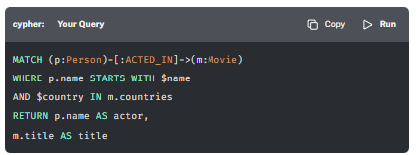

If you run this query without setting any parameters, you will receive an error:

Copy

Expected parameter(s): name, coutry

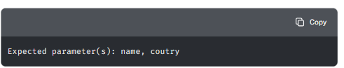

To complete this challenge, complete the following steps:

## 1. Set the **name** Parameter

Using the same format as the previous lesson, set the name parameter to Tom.

## 2. Set the **country** Parameter

Set the country parameter to UK.

## 3. Execute the Query

Hit the **Run in Sandbox** button to the top right of the query window below to execute the query.

**cypher**

**Run this Query**

CopyRun

MATCH (p:Person)-[:ACTED_IN]->(m:Movie)

WHERE p.name STARTS WITH $name

AND $country IN m.countries

RETURN p.name AS actor,

m.title AS title

You should see a message at the bottom of the screen in the following format:

Started streaming ***XXX*** records after Y ms and completed after Z ms.

## How many records?

How many records are returned for actors with a name starting with **Tom** and with **UK** in the list of countries on the Movie node.

## Solution-

:params {name: "Tom", country: "UK"}

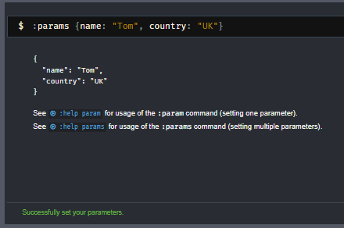

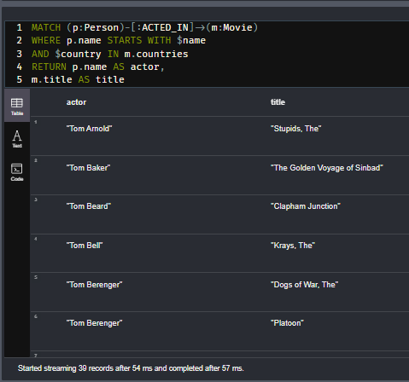

# Application Examples Using Parameters

This lesson is intended to give you a very brief view of how a few of the programming languages that Neo4j supports uses Cypher with parameters.

Although each language has its own distinct syntax, the process for each language is similar. Parameters are sent as an additional argument when a Cypher statement is run through the driver, and are referenced in the same way as covered in this module, by applying the $ prefix.

## Example: Java

Here is a code snippet that illustrates the use of parameters in Java:

**java**

Copy

try (var session = driver.session()) {

Result res = session.readTransaction(tx -> tx.run("""

MATCH (p:Person)-[:ACTED_IN]->(m:Movie)

WHERE m.title = $title

RETURN p

LIMIT 10

""", Values.parameters("title", "Toy Story")));

}

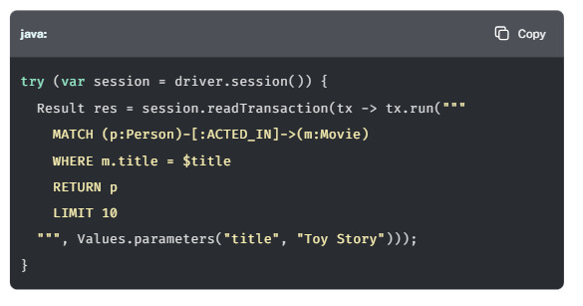

In this example, the parameters are passed to the second argument of the tx.run method using the static parameters function provided by the org.neo4j.driver.Values class.

For more information on using parameters in Java, check out the [**Building Neo4j Applications with Java course**](https://graphacademy.neo4j.com/courses/app-java/).

## Example: JavaScript

Here is a code snippet that illustrates the use of parameters in JavaScript:

**js**

Copy

const session = driver.session()

const res = await session.readTransaction(tx =>

tx.run(`

MATCH (p:Person)-[:ACTED_IN]->(m:Movie)

WHERE m.title = $title

RETURN p

LIMIT 10

`,

{ title: 'Toy Story'})

)

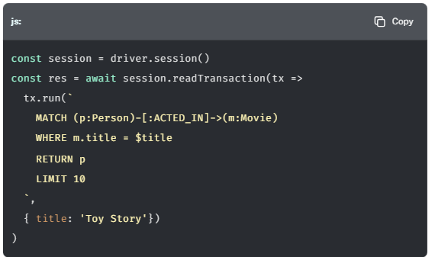

In this example, the parameters are passed to the second argument of the tx.run method as a JavaScript object.

For more information on using parameters in JavaScript, check out the [**Building Neo4j Applications with Node.js course**](https://graphacademy.neo4j.com/courses/app-nodejs/).

## Example: Python

Here is a code snippet that illustrates the use of parameters in Python:

**python**

Copy

def get_actors(tx, movieTitle): *# (1)*

result = tx.run("""

MATCH (p:Person)-[:ACTED_IN]->(m:Movie)

WHERE m.title = $title

RETURN p

""", title=movieTitle)

*# Access the `p` value from each record*

return [ record["p"] for record in result ]

with driver.session() as session:

result = session.read_transaction(get_actors, movieTitle="Toy Story")

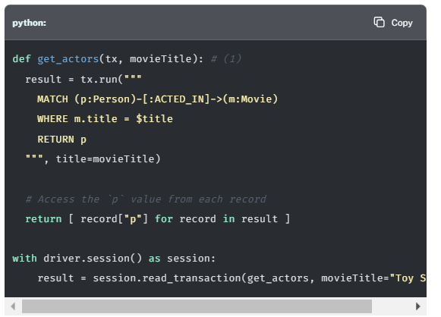

In Python, Cypher parameters are passed as named parameters to the tx.run method. In this example, title has been passed as a named parameter.

For more information on using parameters in Python, check out the [**Building Neo4j Applications with Python course**](https://graphacademy.neo4j.com/courses/app-python/).

# Course Summary

In this course, you learned how to:

* Filter Queries using pattern matching and the WHERE clause
* Order results using the ORDER clause
* Paginate results using SKIP and LIMIT
* Eliminate duplicates using DISTINCT
* Produce Map Productions
* Perform Aggregations
* Work with Dates and Times
* Perform variable length traversals
* Process data using pipelines
* Use the UNWIND command to turn a list into multiple rows
* Optimise memory usage using Subqueries
* Use parameters within your Cypher queries

## Resources

* **There are many resources available to you for learning more about Neo4j**  
  [**https://neo4j.com/developer/resources/**](https://neo4j.com/developer/resources/)
* **Neo4j Community Site where you can ask or answer questions about Neo4j and discuss with other users:**  
  [**https://community.neo4j.com**](https://community.neo4j.com/)
* **Neo4j documentation:**  
  [**https://neo4j.com/docs/**](https://neo4j.com/docs/)
* **Neo4j Sandboxes for experimenting with graphs:**  
  [**https://sandbox.neo4j.com/?ref=graph-academy**](https://sandbox.neo4j.com/?ref=graph-academy)
* **Videos on the Neo4j YouTube channel:**  
  [**https://www.youtube.com/channel/UCvze3hU6OZBkB1vkhH2lH9Q**](https://www.youtube.com/channel/UCvze3hU6OZBkB1vkhH2lH9Q)
* **Become a Neo4j certified developer:**  
  [**https://graphacademy.neo4j.com/categories/certification/**](https://graphacademy.neo4j.com/categories/certification/)
* **GitHub repository:**  
  [**https://github.com/neo4j-contrib**](https://github.com/neo4j-contrib)
* **Neo4j events all over the world:**  
  [**https://neo4j.com/events/world/all/**](https://neo4j.com/events/world/all/)
* **Graph Gists for learning more use cases for Neo4j:**  
  [**https://neo4j.com/graphgists/**](https://neo4j.com/graphgists/)
* **Attend a Neo4j meetup:**  
  [**https://www.meetup.com/topics/neo4j/**](https://www.meetup.com/topics/neo4j/)
* **View questions/answers raised about Neo4j:**  
  [**https://stackoverflow.com/tags/neo4j/hot**](https://stackoverflow.com/tags/neo4j/hot)